SIGNAL BULB INSPECTION PROCESS

The following is the recommended procedure for inspecting signal bulbs.

SAMPLE SIZE:

The recommended sample size is 30 to 40 bulbs (enough to relamp one intersection) out of each 5000 Bulbs (about 42 Cases of 120 Bulbs/Case). Each sample should be from a different case and a different pallet if possible.

VISUAL INSPECTION:

1. Check for proper envelope type. The specs. call for an A-21, Clear envelope. The diameter of the envelope should be 2 5/8". It is not necessary to measure every bulb. One bulb per sample can be measured and the rest visually compared to the measured bulb.

2. Check for proper base type. The specs. call for a medium brass screw base.

3. Check for proper filament and filament supports. The C-11V filament is a "W" shaped filament. The C-9 is a "U" shaped filament. There should be 5 or 6 filament supports plus 2 power leads. There should be an aluminum reflector below the filament.

4. Check markings on the bulb envelope. The following is required:

a. Manufacturer's insignia or trademark
b. Design Voltage
c. Rated Lumens or Wattage

Example of a typical signal bulb (135 Watt shown):

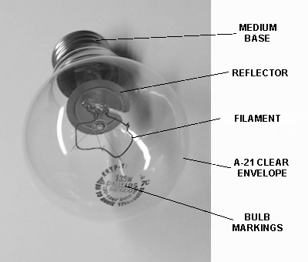

TESTING:

An initial failure test is recommended as follows. Relamp one intersection or install bulbs on a shop test board with each bulb sample taken as soon as possible after bulbs are received. Monitor the intersection or test board for one week. More than one initial failure per sample after one week may indicate a problem. Contact Traffic if there is more than one failure per sample.

DOCUMENTATION:

Document the following:

District
Size of delivery
Brand, Model of bulbs.
Person inspecting the bulbs
Number of samples and sample size.
All visual inspection items from above.
Test location(s)
Test results

For reference, see the current Signal Bulb Specifications.

