Quick Reference Guide – Sample Record - General
Version 01/26/2011
This QRG provides basic instruction for the creation of a Sample Record.

A sample record provides a place for sampling and testing data for materials used by MoDOT. Reporting or assigning of material to a specific Item of a specific Contract is accomplished via a sample record. Sample Information is used to identify all samples shipped to the Central Laboratory for processing or processed within the districts. Basic sample information and the results of all tests performed in the field are entered. The Central Laboratory will enter the results of tests performed in the Central Laboratory.
The owner of a sample record is identified as the individual who obtained the sample. Only the owner of the sample shall make changes, additions, or deletions to the sample record. Ownership of a sample may be transferred to another individual for testing. Ownership of any sample submitted to the Central Laboratory is passed to the Central Laboratory. Central Laboratory ownership of a sample is irrevocable when the Log Date is completed by Central Laboratory Receiving.
Samples submitted to the Central Lab shall have the following information printed directly on the sample, sample container, or sample tag: Sample ID Number, Material Source (where the sample is obtained), Product Name (with grade and size, when necessary to fully describe sample), and any Special Instructions. Additional information is optional.
Some materials need additional information included:
Concrete Cylinders – ID NO.
Date of Pour
Cement Factor (Not water/cement ratio)
TEST ON (a specific date)
Special testing information

Steel Products – ID NO.
Grade
Size
PHONE/FAX RESULTS
Field information

Bituminous Cores – ID NO.
Mix NO.
Special Instructions such as TEST EACH CORE SEPARATELY
PLEASE CONTACT (user @ phone number) BEFORE TESTING

Bituminous Loose – ID NO.
Mix NO.
Special instructions may include information like:
SAMPLED FROM 4th TRUCK
PHONE/FAX RESULTS
POSSIBLE CONTAMINATION
NEED AC CONTENT

Some special instructions can be reduced to the following key words, which are also defined and clarified when appropriate. Special Instructions go on tag and in "Remarks" section of Basic Sample Data tab.
Absorption as Received - For aggregates.
Chemical Analysis – Culvert metal sample being submitted for normal testing that also requires a chemical analysis.
Date of Pour – Date when concrete cylinders were made.
DSR Only – Daily performance graded binder sample taken at an asphalt plant.
Due Date – Date when test results are expected. (Used primarily with soil samples.)
Experimental – Material which is to be retained for an indefinite period. The submitter of this material shall inform the Central Lab when the material is no longer needed so it may be disposed.
Initial – Larger rock samples obtained from ledges prior to crushing.
Material Code – For general materials samples, first four digits of material code would be as useful as the product name.
# of # – for multiple bags or containers for accountability in receiving the material.
Quantity and Length – for bolts, the lot quantity and the length of the bolts.
Production –
Resample – Indication that the sample being submitted is a resample.
Rush – Results needed as soon as possible.

See Remarks – Notification to the laboratory that there are some special circumstances regarding the sample.
Source – Producer production approval sample obtained every two years.
Special Investigative – A sample being submitted for special tests. Normally the laboratory has been contacted by telephone in advance for this type of testing.
Trial Mix – Trial mixture material is submitted for standard processing including that to be stored by the lab for future use.
The Remarks field is filled in accordingly, including special testing instructions. Identification of a sample by marking the lid, or other packaging easily separated from the sample, is not acceptable. Sample tags are available from Headquarters Construction and Materials. The tags are made with a special, very durable paper. For best results, when the tag is wired or tied to the sample, use both holes in the tag. The intent of the tag is to identify the sample. Please attach the tag so the sample data is easily seen. A separate tag may be used as a mailing label. See Exhibit A for mailing tag. These self-sticking cylinder tags are also available from Headquarters Construction and Materials.
Basic Sample DATA tab
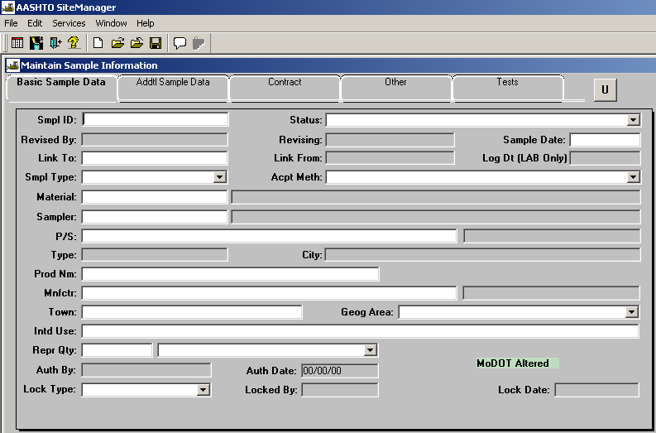
Sample ID. Each sample of material taken for the Department is assigned a unique identification number by the following standard:
Note: Prior to January 1, 2010 The year embedded in the ID was one digit.
1st –2nd Position Last two digits of the year
3rd Position District or Division identifier. Use a digit for the district (using 0 for district 10) or a letter for a sample submitted by a division (non-district) personnel. For division personnel we are suggesting that the following letters be used.
Materials M
Construction C
Bridge B
Maintenance A
General Services G
Photo Lab PL
Preliminary Studies P

Research D & T R

Risk Management K
Non-MoDOT X

4th – 6th Position The user's initials. The initials are assigned by the SiteManager Administrator to assure uniqueness. Use upper case (capitals).
7th – 9th Position Use 3 digits, with leading zeros, which count up sequentially for each additional sample.
10th – 11th Position May be added to the Sample ID if deemed necessary and the sample is not submitted to the Central Lab. Also used to differentiate this sample from a duplicate ID where both Ids have been issued prior to entry in SiteManager.

Examples: 2010 + District 6 + John R. Doe + 001 + X = 106JRD001X
or
2010 + Materials + James D. Smith + 001 = 10MJDS001
(Special instructions for a Non-MoDOT ID)
4th – 5th Position Initials assigned to a non-MoDOT organization by the SiteManager Administrator. Use upper case (capitals).
6th – 9th Position Use 4 digits, with leading zeros, which count up sequentially for each additional sample.

Example: 2010 + Non-MoDOT(X) + Carter Waters + 0001 = 10XCW0001
The PAL unit at headquarters is expressly permitted to use a 4 digit number in lieu of the 3 digit number indicated above, due to the number of records created in a year.
Example: 2010 + Materials + Sally A. Tall + 0001 = 10MSAT0001
Central Office work units have been assigned a further breakdown for sample identification at a group level.
Materials, Field Office MFO
Materials, Physical Lab MPL
Example: 2010 + Materials + Physical Lab + 0001 = 10MPL0001
District Materials, where samples have traditionally been posted to a ledger and identified on a district wide basis, are also allowed the option of submitting samples using the following format. The last two digits of the year plus a digit for the district (using 0 for district 10) plus MA for Materials, plus 4 digits (with leading zeros) is allowed.
Example: 2010 + District 6 + Materials + 0001 = 106MA0001
Both identification options may be used by any district.
If the sequential number reaches 999, then a new sequence is started with A01, when that reaches A99, use B01, and so on. For District wide IDs, if the number reaches 9999, then a new sequence is started with A001, when that reaches A999, use B001, etc.
Status. This is a required field. The sample should not be authorized when this field indicates Pending. This field is used to indicate acceptance, qualified acceptance, rejection, or other sample status. The status of a sample shall be listed as follows (in alphabetical order by code, * means sample Contract Tab quantities will not be counted in materials summary):
CF Compare Favorably/Compliant (IAS only) – for results of testing that compare within allowable range with the companion test or compares favorably with the specifications. *
COMP Accepted/Completed – as appropriate, when all tests are completed to the satisfaction of the sample owner and specifications are met. Counts as a “test”. Complies with the specification regardless of how it got to that point (sample/resample, reconditioned, etc.) or, when the result will not cause rejection because the sample is QA and compares within limits.
DNCF Not Compare Favore/Not Comply (IAS only) – for results of testing that do not compare within the allowable tolerance with the companion sample or with the specification. *
FAIL Failed/Rejected – as appropriate, when all tests are completed to the satisfaction of the sample owner and the material is not acceptable. The remarks will indicate the reason for rejection. * If the disposition of the material is known, consider using the code FAIR or FAIU (below). [ Lab Only – if a resample is appropriate and requested, but the supplier or the district determine that no resample will be submitted, the sample status will be set to FAIL. If additional material is submitted and also fails testing, both sample records will be set to FAIL. ]
FAIR Failed- Material Removed/Never delivered– For example, this could be paving material that was found to be non-compliant and was removed by MoDOT or contractor choice.
FAIU Failed- Matl used "as is" w-w/o deduct - For example, this could be paving material that was used “as is” with some penalty, or with the permission of MoDOT (without deduct). (See FANC, below.) In the special case of stripe that does not meet, but is left in place until re-striped, use Failed/Rejected. Counts as a “test”.
FANC Failed- QC not compare w/QA, used "as is". For QC portion of sample where sample results did not compare favorably with QA test, but the material is incorporated into the project anyway. This triggers additional investigation into the cause of the non-caparison (for example, the required running average of results from a specific source.). Counts as a “test”.
FLAB Failed- LAB questioned sample viability. Failed due to sample being inadequate quantity according to the test method, sample obviously contaminated, sample clearly not the indicated material, sample damaged in transit, etc.
INFO Informational only – as appropriate, when all tests are completed to the satisfaction of the sample owner and the test results are not used to determine acceptance of the material. *
OHCL On Hold/Lab (lab only) – the sample or sample record is not currently being processed * The Lab Section that sets the sample status to “On Hold…” becomes solely responsible for the final disposition of the sample, sample status, and authorization, regardless whether the sample is “shared” and whether the Lab Section is considered primary or secondary.
PEND Pending – until all tests on the sample are completed or it is determined that no additional testing shall be performed. *
RFRA Ready for review/authorization – used primarily in the Lab *
SA Secondary - accepted – used only by the Lab *

SPEC Pending/resample – the Sample Information is related to material where initial testing is to be repeated and a resample has been required *
SR Secondary - rejected – used only by the Lab *
VOID Void – for sample records that are considered invalid. *
Remarks are necessary to explain conditional, informational only, rejected, or void sample status.

Sample Date. This is a required field.
- This is the date when the sample was obtained.
- If no sample was obtained, enter the date of the inspection.
- If no inspection occurred, enter the date of any other activity being documented with the sample record.
Link To. Use this when an existing sample is related to another sample for one of the following reasons:
- Resample
- Additional material submitted to the Central Laboratory
- to report previously tested material to a contract with this sample
- To transfer material to another contract
- When this sample is one of several components to be identified, e.g., two-size paving stone.
The second sample is "linked to" the first sample. A third sample may be "linked to" the second sample by the same means.
Additional information regarding use of a Link for transferred material. A sample record is created for the transferred material. It is linked to the original sample record (which reported the material to the contract). On the new sample record, a Contract tab positive quantity is reported to the desired contract(s) and negative quantity is entered for the contract from which the material was transferred. Include in the remarks why the material was transferred. Make certain unused material exists in the quantity transferred.
Link From. This field is automatically filled when a future sample is linked back to this sample.
Log Date. The date the sample is received at the Central Laboratory. The district must leave this blank.

Sample Type. This is a required field. The reason the sample was taken is entered. Following are Sample Type Definitions (listed alphabetically by code): For samples processed by the district and not sent to the Central Lab, use one of the underlined sample types except that materials that will be posted to a contract must have a sample type that matches the sample type designated in the contract's Sampling and Testing Requirements:
COST Compaction Standard – This is used to represent a sample related to the compaction standard for aggregate or base.
DGEN District Gen – This is to be used for sample processed in the district where no contract or purchase order is involved.
DPOR District Pur Order – This is to be used for sample processed in the district where a purchase order is involved.
DPRO District Proj – This is to be used for sample processed in the district where a contract is involved.
DPRM District Permit – This is for a sample record related to a Permit.
ENVI (Obsolete) Environmental – This is to be used for petroleum and heavy metal contamination, asbestos and samples submitted that have potential environmental concerns.
FAST (Obsolete) Proj F.A.S.T – This is used for samples obtained as part of the Departments' F.A.S.T. program
GAI Gen Appr Initial – This is to be used for ledge stone samples submitted for initial approval testing.
GAS Gen Appr Source – This is to be used for aggregate source approvals and for first time samples from a new producer with no project designation established for the material.
GENI General Investigative – This is used for any special or investigative samples which are not project specific. The Lab may change the sample type to GENI for some samples submitted to the lab, in order to facilitate tracking of the sample.
GPA Gen Prod Absorption – This is for "Absorption As Received" aggregate samples.
GPK Gen Prod Unit Weight – This is for "Unit Weight" aggregate samples.
GRI Gen Res Investigative – This is used for any special samples which involve RDT, or investigative samples which are not project specific.
IAS (Obsolete) Proj I.A.S. – This is used for samples obtained as part of the Departments' I.A.S. program.
INFT Informational Testing – This is to be used for samples when test results are required in order to determine a particular course of action.
MAAS Material Approval Sample – This is to be used when testing and acceptance is the normal process prior to use of the material.
MRPT Material Report –
NTM (Obsolete) No Test - Material for Lab
NWPD New Product – For submitting a sample of a new product through the new product process and associated testing.
OFFS Off System - Any sample or record related to an Off-System project.
PA Proj Approval – This is used for samples obtained for acceptance of material for a specific project. Not to be used for aggregate.
PC Proj Check Sample – This is used for samples obtained to check the quality of material accepted for project approval. Not to be used for aggregate.
PEBD Prel Engr Br Dk Cond Survey – This is for samples submitted for preliminary bridge deck condition surveys.
PEPE Prel Engr Pave Evaluation – This is used to submit samples obtained from preliminary pavement evaluations.
PESC Prel Engr Soil Survey – Complete – This is for classification and moisture density determinations.
PESF Prel Engr Soil Survey – Fertility – This is for fertility testing.
PESP Prel Engr Soil Survey –Partial – This is for classification only.
PG Proj Gen Investigative – This is used for samples obtained as part of an investigation of a project.
POA Purchase Order Appr – This is used for samples obtained to determine acceptance of material purchased by Department purchase order.
POB Purchase Order Bid Sample – This is used prior to the award of a bid to determine that the vendor is capable of producing material on specification.
POC Purchase Order Check Sample – This is used for samples obtained to determine quality of material accepted by Department purchase order.
PROD Production – This is used for all aggregate production samples or other materials designated for project or general use. (This includes what used to be called an aggregate check sample.)
QA QA Comparison check of QC - proj specific - Comparison to confirm performance of QC process (includes sampling, testing , test equipment (condition verification, calibration, etc.). record keeping, integrity/validity of results, etc.) Project specific.
QALL QA Sample or Facility Review - not PAL - Samples and facility reviews of non-PAL facilities (pipe (CM, HDPE, PVC, RCP), precast structures)
QAS (Obsolete) Quality Assurance (Includes PAL) – This is to be used for routine quality assurance samples and PAL Quality Assurance plant visits.
QC QC Material Acceptance - proj specific – Initial specification compliance determination at the project level, or for a particular project.
QCC QC Material Acceptance - contractor data – Same as QC except test result data is supplied by the contractor (and may include MoDOT data as well). Project specific.
QPAL Q PAL related record or sample – PAL material report, or sample directly related to a PAL facility visit.
SPSA Quarterly Split Samples – This is used when it is necessary to compare test results with another laboratory.
TM Trial Mix – This is used for samples obtained for trial mix purposes designated for project or general use.

Acceptance Method. This is a required field. The method by which the sample is being accepted as indicated in the following table (alphabetically by code). Note: SATE, Sample and Test, was selected as the default value and was used for virtually all records during a time when the SM process was overly restrictive.
APAL Accepted on PAL (HQ or MT P.O. use only)
APQC Approved Producer QC/QA – Material supplied by approved producer and accepted on QC/QA
CERT Certification Review – Certification is reviewed
CETE Certification and Testing – Certification is reviewed, material is tested.
LBLA Label Analysis – Label on container is compared to specification or purchase order
PAOA Prior Approval or Acceptance – Material approved on basis of sample taken earlier (note sample ID number)
PQOB Pre-qualified or Brand Name – Material appears on pre-qualifed or accepted brand name list
PQTS Pre-qualification Sample – Acceptance method dependent on material pre-qualification process.

SATE Sample and Test – Sample taken and tested
TEST Testing – Material tested (measured) on site, no sample taken
VSUL Visual Inspection – Material meets specification based on visual examination
Material. This is a required field. Select the material code and description that best fits the sample material or information documented by the record.
Sampler. This is a required field. The person who initially obtained the sample or information indicated by this record is shown here. Typically, the sampler shall also be the individual entering the sample data.
Producer/Supplier. This is a required field. The Producer or Supplier of the material sampled. Use the Search option. If the Producer/Supplier is not shown in the list, it may have to be added to the system by Headquarters Construction and Materials. Also, the Producer/Supplier must be associated with the Material previously selected. The association is made using the Producer/Supplier Materials function. The District can do this. Generally, the Producer/Supplier is not a contractor or subcontractor. For example, for Asphalt Binder taken at an Asphalt Mix Plant, the producer/supplier of the asphalt binder would be the terminal or refinery it came from, not the mix plant. A known exception is straw for erosion control. The producer/supplier can be shown as the subcontractor because the farmer will normally not be in the list and is unlikely to be a regular supplier of the material. For a PAL Quality Assurance plant sample, the Producer/Supplier should be the manufacturer of the product being tested, and will not necessarily be the same as the facility where the sample is being obtained. For example, if you are sampling black steel, the Producer/Supplier should be the mill, not the fabricator of the steel where the plant visit may take place.
Type. This is automatically filled in by the system.
City. This is automatically filled in by the system. This field may also show state and county for most producer/suppliers, especially aggregates.
Product Name. The brand name of the material, if applicable. If the material sampled does not have a brand name, this field should be left blank. A search lens is provided in this field. If there are no entries, then there are no product names applicable for the material selected.
Manufacturer. The manufacturer of the material. Contact Headquarters Construction and Materials if the manufacturer is not on list.
Town. The town or city where the manufacturer is located, if not automatically included in the Manufacturer field.
Geographical Area. This is a required field. Select the MoDOT District in which the sampler is located. Samplers from Headquarters use District 11.
Intended Use. The intended use of the material should be entered. For material to be held in a supplier's stock, enter "Stock for Future Use".
Represented Quantity. This is a required field. The quantity of the material represented by the sample.
Sample Unit. This is a required field. The unit for materials purchased under a Non-Construction contract, or that are the sole component of a contract bid item shall be that unit of measure as indicated on the contract bid item, if a contract exists, or the unit that would apply if the material were to be used on a typical contract. Sample Unit for materials in all other situations including the instance where the material is one of several components of a contract bid item shall be as indicated on the Materials Management.Material Information.Material Detail panel. The default unit system is English. Metric units may be used only when the material is known to be part of a metric contract or when certifications are required and metric units are designated in the certification. The unit is automatically loaded by the system based on the default unit set in the Material Information window. If the unit displayed is not correct for the circumstances, it can be changed by the user.
Authorized By. This is automatically filled by the system when the sample is authorized. The sample is to be authorized when all testing is completed or no further testing is to be performed, and all necessary data has been entered. Authorization shall not be delayed in order to record contract data for the purpose of reporting to a contact.
Authorized Date. This is automatically filled by the system when the sample is authorized. Designated users may unauthorize a sample record so that changes can be made.
Sample Lock Function. The sample lock function is used to prevent certain users from making changes to a sample record. When a sample record is locked, it will appear to be authorized (all fields grayed out). A record may be only authorized, only locked, or both authorized and locked. If the Locked By and Lock Date fields are populated, the record is locked. Additional fields below the Lock Type, Locked By, and Lock Date fields will display the lock type.
Lock Type. There are three lock types and three office levels that provide different levels of security within the sample lock function. The three different lock types are Office Lock, User Lock, and No Lock.
Office Lock Office Lock prevents a user, of a different or lower office level than the lock creator, from making changes to the sample record. There are three office levels that may be displayed as a choice for Office Lock.
Statewide Statewide is an Office Level 1 lock and may only be used by those users with Statewide SiteManager access. This access is typically reserved for users at the Central Office. A record locked with Statewide, or Office Level 1, will not be modifiable for users in the district or project offices. The record will be modifiable for all users with Statewide access.
District: xx District: xx (where “xx” is the district number 01 thru 10) is an Office Level 2 lock and may only be used by users with District SiteManager access. This access is typically reserved for users in the district offices. A record locked with District: XX, or Office Level 2, will not be modifiable for users in a different district office or in the any of the project offices. The record will be modifiable for users in the same district office or users with Statewide access.

OrgCode: xxx OrgCode: xxx (where “xxx” is the designation of the district project office) is an Office Level 3 lock and may only be used by users with OrgCode SiteManager access. This access is typically reserved for users in the project offices. A record locked with OrgCode: xxx, or Office Level 3, will not be modifiable for users with a different OrgCode (different project office) or users in other district offices (district offices in a district different than the project office). The record will be modifiable for users in the same project office, users in the district office (same district as the project office), or users with Statewide access.
User Lock User Lock prevents any user other than the user who applied the lock from making changes to the sample record. The user locking the record is always the logged in user and not necessarily the Sampler.

No Lock No Lock means that the sample record is not locked. The record may be modified by any user.

SiteManager is configured to apply an Office Lock on every sample record by default. The Lock Type must be changed if the sample record is desired to have a different Lock Type. Sample records representing material that has the potential to travel to another district should have No Lock to allow contract information to be added or modified.
Locked By. This field will be automatically populated by the system with the User ID of the user locking the sample record when a lock is applied. The user locking the record is always the user logged into the system at the time the lock is applies and is, therefore, not necessarily the Sampler.
Lock Date. This field will be automatically populated by the system with the date that lock is applied.

Additional SamplE DATA Tab. This is completed for each sample processed.
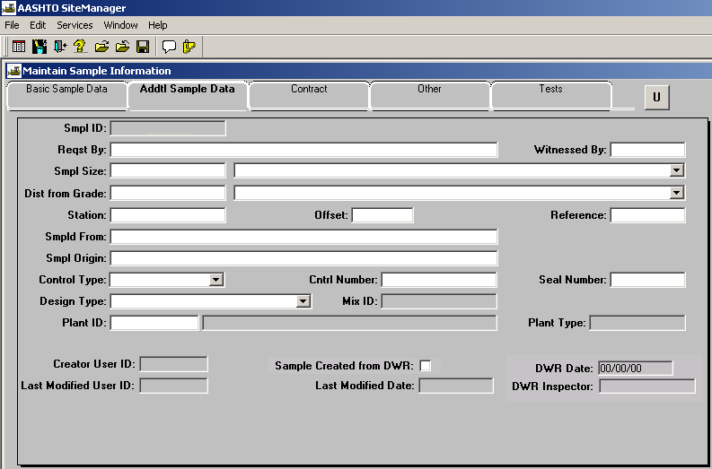
Buy American. (Obsolete – this field has been removed from the system. Depending on the material, this information is communicated by the certification, mill test report, or other means.)
Buy American. (Obsolete – the field adjacent to the Buy American checkbox has been removed from the system.)
Requested By. The person or entity who requested the sample, if applicable, is listed. It may be left blank if it is a routine sample, or no specific request has been made.
Witnessed By. The person who witnessed the sampling process when not a routine sample and witnessing is required. Witnessing is typically required when resampling due to a dispute over the original sample’s characteristics.
Sample Size. The size of the sample submitted to the Central Laboratory so Laboratory Receiving can confirm full shipment. For samples processed in the district, this field may remain blank. Appropriate Sample Size Units shall be selected from list or, if the required unit is not included in the list, the unit may be typed in the Sample Size field with the Sample Size value.
Dist from Grade. The distance from the finished grade for samples taken from subgrade. Appropriate “Dist from Grade” units shall selected. Use English units unless the contract is known to be metric.
Station. The station number location where the sample was taken, when applicable.
Offset. The distance and direction from the reference line of where the sample was taken, when applicable.
Reference. The line from which the offset is measured.
Sampled From. The specific point at which the sample was taken (e.g. belt, stockpile, roadway, drum, bundle, stock, etc.).
Sample Origin. The general location from which the sample was taken (e.g. quarry ,plant, project). In some instances it is necessary to include the specific quarry, or plant, or other information. If the Basic tab does not capture the information, include it here. For example, aggregate taken from a ready mix plant would have come from a quarry. On the Basic tab the quarry would be listed. In this field, the specific ready mix plant would be indicated. (Note: the instructions for Smpld From and Smpl Origin were reversed on 8/1/2008 due to the nature of the information to capture and the relative field size. They were reversed back to original configuration on 3/19/2009 after field size for sample from was increased to match Sample Origin. This was done to reduce user’s confusion.)
Control Type. The identification assigned by the Producer/Supplier (e.g. heat number, batch number, lot number), when applicable.
Control Number. The number associated with the Control Type which the Producer/Supplier or Manufacturer has assigned to the material represented by this sample. If no number has been assigned and the material can be identified in lots or batches by personnel performing the sampling, the Control Number may be assigned by the sampler. When multiple numbers apply to the sample, typically for 2-part and 3-part paints or epoxies, the numbers will be separated by commas and will have an identifier added when appropriate, for example: “A:5B32WAA, B:6C43XBB” (Note the identifiers, “A” and “B”). If there is not room for all the characters assigned, the second or third series of numbers can be placed in the Seal Number field, which is adjacent to the Control Number field. If the number provided by the Producer/Supplier contains special characters such as “-“, “/”. “|”, “\”, convert all such characters to a dash (“-”) as you enter the value. Example “A:7C/44G\16” would be entered as “A:7C-44G-16”. (Note: Substituting a dash for all special characters facilitates any data tool query searches that are performed.)
Seal Number. If the material represented by the Control Type and Number has been sealed to prevent modification, make note here. This function is rarely used. Seals may be found on rail cars, truck, tanks, and other similar transportation or storage devices. This field is also used for additional detail that will not fit into the Control Number field.
Design Type. If the material sampled is controlled by an existing mix design, select from the mix type from the list.
Mix ID. The identification number of the mix design represented by this sample should be typed in or selected.
Plant ID. For aggregates, select the appropriate source, ledge or ledge combination. If the required information is not listed, contact the system administrator. For concrete and asphalt, select the appropriate plant, if listed. Typically asphalt plants and concrete paving plants are listed but ready mix plants are not.
Plant Type. Automatically filled in by system.
Sample Created from DWR. Automatically filled in by system when the sample record was created via the DWR window.

Contract tab.
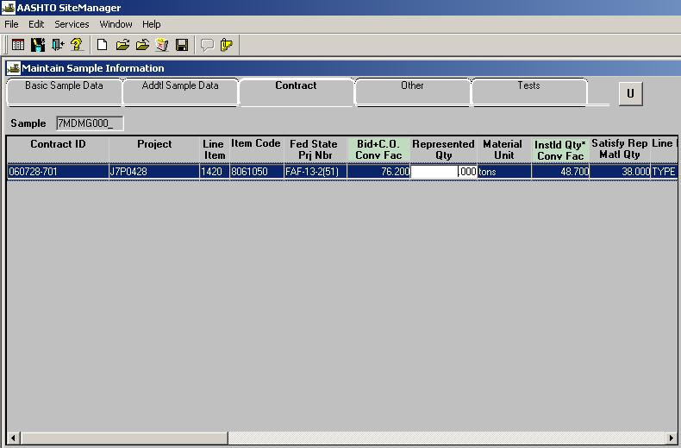
Information is placed on the Contract tab to associate (report) a sample to a particular Contract. The material is associated (reported) to the specific line item of a specific contract and project for which it was inspected. When the line item is unknown and several line items are shown for the contract, all the material may be posted to the first line item. Construction may transfer to other lines within a contract. More than one contract may be selected. More than one line item on each contract may be selected. When the necessary contract is not included in the list it may be ncesassary to have district materials personnel alter the contract sampling and testing requirements. If the project is not being administered using SM, which may include Off-System jobs, the contract may be entered on the Other Tab.
The total quantity of material associated to all line items should not exceed the total represented by the sample without remarks indicating the rationale.
Represented Quanty. This field is the quantity of material to be associated to that line item.
Material reported to another district when the contract is unknown shall be posted to that district's inventory contract (Format: D# - Inventory, where the district number is substituted for the # sign). District materials in the receiving district should then be notified via Lotus Notes (D#MAContacts). Any district may report material to their own "Inventory". Only the district that "owns" the inventory may transfer it to another contract.

Other tab.
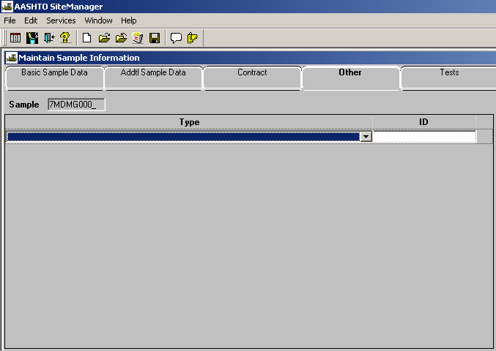
Select the type of work for which the material is designated, when material is to be used for a known purpose other than a Construction project. (i.e., Purchase Order, Research Project HPR). Any projects not being administered using SiteManager or otherwise not listed on the Contract Tab, including Off-System projects may be included here by selecting the appropriate type of work. Other information important to the sample record may also be entered on this Tab.
Type. The type of work should be chosen from the pull-down menu under the Other Tab. Select one or more of the Types shown, as appropriate for the material. A particular Type may be selected multiples times, if necessary.
ID. ID should be the identifying number, letters, or information associated with the Type and providing information that does not have an designated field on another tab.
The Type and ID combinations shall be provided as necessary to record all information necessary for the material associated with this sample. Table of typical entries:
OTHER TYPE OTHER ID
Change Order Items 040123-503
Consultant Request J6P0672F
District Permit 5-04-0671
Federal aid Acceptance Sample and Test J6P1471
Independent Assurance Test J6U0132
Initial Approval Sample ID # 05XXX010
Mixing Facility (AC, PCC) 3027000020 Desloge
Non SiteManager Project J0V0321B
PAL Material User 3050500434
Preliminary Survey J1P0760B
Project Test 960618-X04
Purchase Order PGQ6050X200000166
Rejected Material J5P0484 – 2 pipes rejected at plant Research & Development 910 SPR 1999 96 Y
SiteManager Project (No sampling req.) 03JRB008
Source Approval Sample ID# 05XXX010

TestS TAB.
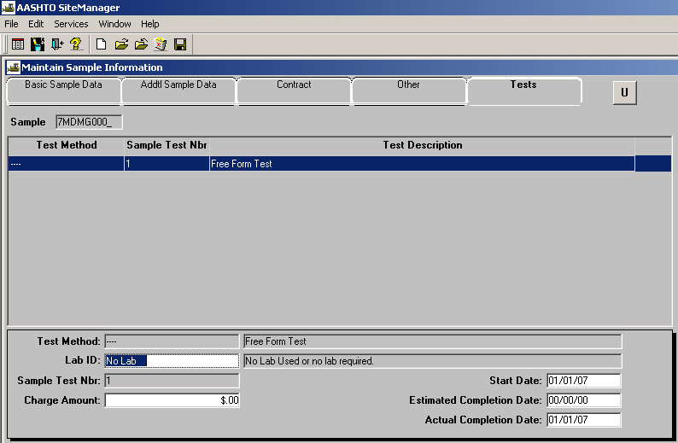
This section is completed to attach test templates to the sample. Test templates allow the entry of test results and other data that is associated with the sample record.
Test Method. The Test Method is chosen by district personnel for each test to be performed on the sample by the district. Tests intended for use in the district include T27, and all Test Methods that begin with "SA". The district is not to use any Test Method that begins with "x", "y", or "z". The district will use Test Methods beginning with "C" or "P" only when informed to do so by Headquarters Construction and Materials. Test Method is chosen by the Central Laboratory for each test to be performed by the Central Laboratory. Multiple tests may be selected. Tests may be performed, and test results recorded, on a sample by both the district and the Central Laboratory. When the district requires testing to be performed by the Central Laboratory, other than that normal to the sampled material, the Central Laboratory is to be notified on the sample tag of the special instructions.
Lab ID. The Laboratory where the test was performed. If there were not laboratory tests, or the record is for the purpose of collecting data without testing, the select No Lab.
Sample Test Number. Typically, this is a sequential number starting with one (1) for each test attached to the sample. The second instance of a specific test associated with the sample would be (2), and so on. This allows the same test to be run on a sample multiple times. If, for example, four different tests are run on the sample, each of those four tests could have a Sample Test Number of one (1). While sequentially numbering tests is generally the best option, the user may select some alternate means of uniquely identifying the tests for a given test method and sample. For example, the user may wish to number tests sequentially over a series of days, even though different sample records are required and created. Any value the field will select is acceptable as a sample test number, including letters. Characters other than letters and numbers may create problems and are discouraged.
Start Date. Start Date is the date the test was started or the data was entered into the test template. The date the test is attached to the sample record is automatically entered but the user may change it. This date must be before the Actual Completion Date. It should be changed prior to entering the Actual Completion Date if the Actual Completion Date is before the Start Date as automatically entered.
Charge Amount. This is not used.
Estimated Completion Date. This is not used.
Actual Completion Date. The date the test was completed or required information was entered. When a test is interrupted due to failure of the sample in the early stages of that test, the Actual Completion Date shall be filled. In the event of a failure of a companion test or change in the sample's circumstances, any tests for which no testing was performed shall be deleted.

GENERAL COMMENTS
Test results for each test are entered, completing all applicable information.
Reviewer ID is included on some templates and may be completed by the reviewer, if applicable.
Tester’s ID is automatically recorded for each person who opens the test and performs and edit of the data or saves.
Remarks. Remarks placed in the remarks field should include the date and the userid of the individual entering the remarks
Authorization. All samples should be authorized when the information is complete, or is as complete as possible. When material represented by a sample is associated to a line item for a Contract, that sample shall be Authorized* to complete the association. This authorization is necessary to allow the payment of the material on the estimate. Samples processed solely within the district shall be authorized by district personnel designated by the districts to do so. Samples submitted to the Central Laboratory shall be authorized by Central Laboratory personnel. *"Authorized" is the term used in SiteManager to indicate that all transactions with regard to the sample are finished. Normally a sample will be authorized once all testing is completed and recorded with the sample data. A sample may also be authorized once it has been determined to be an invalid sample or to contain incorrect sample data. When all data has been entered for the sample or it is known that no additional data will be entered, the sample shall be authorized.
When a sample has been authorized, no modifications may be made to it unless the user has the authority to Unauthorize the sample with the “U” button. If an authorized sample is found to contain erroneous data, that sample may be revised using the Unauthorize process, and remarks entered explaining the reason for the revision, or the sample may be revised using the Revise function under the Services menu.
If it becomes necessary to void a sample, it should be marked as Void and Authorized. Disposition Remarks should be made explaining the reason for marking it void. All samples which cannot otherwise be completed shall be voided as soon as it is determined that the sample, or sample data, is invalid.
After a sample is assigned and authorized to a contract, no more material may be assigned directly from that sample unless the user has the authority to Unauthorize the sample record. If a sample represents more quantity than was assigned, the remainder may be assigned to the same or another line item. This shall be accomplished by using a new Sample Identification Number. The sample data from the sample containing the extra quantity shall be copied to the new Sample Identification Number and the association made from it.
The sampler is responsible for checking on the status of the sampler's own samples. Once the sampler notes that a sample submitted to the Laboratory has been Authorized, it is the sampler's responsibility to distribute paper copies as necessary to satisfy the needs of those associated with further processing the sample. The use of paper for reporting purposes is at the will of the district. Headquarters Construction and Materials will not issue a paper report except by request and with unusual circumstances. If it is necessary to have a hard copy, the sampler should attach the Free Form Test (----) to the sample. Using the form, necessary information can be included such as the quantity plus a distribution list. The represented quantity from the Basic Sample Data Tab is automatically shown at the top of the report and is not necessarily the required quantity for the intent of the report. A hard copy could be printed from this, for example, the "receiving district".
Sample ID Sheet. A page in this article is provided as a blank sample ID sheet intended for manual collection of sample data on paper. The form is sequenced to allow direct transfer of data from the paper to SM. The district shall be responsible for the input of all sample data related to samples from the district. This page is not to be used for the primary transmission of sample data to the Central Laboratory.
Portland Cement Concrete Cylinder records. The record must include the following information, which may be included in the Remarks:
Number of Cylinders if not explicitly listed in a test template
Cement Factor used to select appropriate pads for test machine
Aggregate Sources required when cannot be determined from Mix ID information
Cement Type & Source required when cannot be determined from Mix ID information
Fly Ash Type & Source required when cannot be determined from Mix ID information
Date of Pour assumed to be sample date unless remarked otherwise
Location of Pour if not entered elsewhere in the record

When submitting a set of cylinders to the Central Lab, use one ID Number for each set of two cylinders, except when multiple sets are made the same day, as the same pour, with the same mix design, from the same plant. In that instance, multiple sets can be included under a single sample ID. Include, in remarks, the reason for multiple cylinder sets, for example; “Quantity poured today warrants 3 sets of cylinders”. Assign each cylinder with its own specimen number. This is one of the few instances where the district inspector enters data on a Test form that the Central Lab completes.
The Tests tab shall have the test T22 attached. On the Description tab, enter the air, slump, concrete temperature when available, and the cement factor for the mix.
The Specimens tab shall have each specimen number entered. Specimen numbers should start with number 1 for the first cylinder made on the job and continue consecutively though the project for each individual mix design. When changing mixes, start a new numbering group. SiteManager does not accept letters in the specimen number field. For companion cylinders, the Construction set and the Materials set may have the same specimen numbers because the cylinders are also identified by the Sample ID number, which will be different.
The Central Lab will enter actual test data after breaking the samples. The Central Lab will also authorize the sample, which locks the record, after the testing is complete.
Cylinders to be broken in the district are entered the same way however, multiple cylinders made the same day, as the same pour, with the same mix design, and broken over an extended period may be entered with a single Sample ID number. As each specimen is broken, the record is updated to indicate the compressive strength obtained.
District Engineer's Certification. A QRG is provided with instructions on the DEC.
Substituting One Material for Another on a report to a contract. A sample record is created which indicates the material the user wishes to report. The sample is linked to an existing accepted sample of material which could be substituted according to specifications and the inspector's knowledge of the material. In remarks, the inspector enters the rational for the substitution.
Example: 1007T1ABLS Type 1 Limestone for Aggregate Base is going to be substituted for 1007T5ABLS Type 5 Limestone for Aggregate Base. The new sample of Type 1 base will be linked to an existing sample of Type 5 base. The remarks will state something similar to "Material originally inspected as Type 5 base but is known to meet the required specifications for Type 1 base."
QC/QA data. Data obtained by the Contractor's or Producer/Supplier's agent may be entered into SM but source of the data should be clearly indicated in the remarks and by any other means that seem appropriate based on the information and where it fits in the sample record. Test results obtained for MoDOT and observed by a MoDOT inspector, such as testing performed at a private testing lab, can also be entered into SM.

F.A.S.T. FAST aggregate inspection can be done by using the appropriate Materials Test Template to record and enter the required information. The FAST templates all have template descriptions that start "FAST - ". Sample status has two options to use, Compare Favorably/Compliant (FAST/IAS) or Not Compare Favore/Not Comply (FAST/IAS). Selecting one of these will automatically put the correct comment at the bottom of the form. The sample type would be selected as Proj F.A.S.T. After the sample record is complete, authorize it, then go to the Disposition remarks and put in the distribution.
I.A.S. IAS aggregate inspection can be done by using the test T27 to capture the gradation results. The sample type would be selected as Proj I.A.S. IAS comparison reporting is done by attaching the appropriate Materials Test Template to the sample record and entering the required information. The IAS templates all have template descriptions that start "IAS - ". When the record is complete, authorize it and type the distribution in the disposition remarks.
Sample Status Rejected/Fail.
When the material is damaged or incorrectly manufactured at a plant, a complete sample record shall be made with the status Rejected/Fail. The material shall be reported to the contract tab and reasons for rejection shall be added to either the Free Form Test or the Remarks.
If material arrives on a jobsite and is damaged from mishandling or abuse, and a record was previously made for either PAL, precasting/prestressing work, etc., the original record should be marked Rejected/Fail. If material on the jobsite is damaged or unsuitable and no sample record exists, a complete sample record shall be created and the Status marked Rejected/Fail. The material shall be reported to the correct line on the contract tab and reasons for rejections shall be added to either the Free Form or the Remarks.

Missouri Department of Transportation
Construction and Materials
1617 Missouri Blvd., Jefferson City, MO 65109
BASIC TAB PENDING PENDING-RUSH
Sample ID __________________ Sample Unit _______________ Status: (select one) PENDING-RESAMPLE
Link to: __________________ (another sample) Sample Date: __________________
Sample Type: (select one) Acceptance Method (select one)
Compaction Standard IAS Audit Production Accepted on PAL
District General Information Testing Proj Approval Approved Producer QC/QA District Permit Material Approval Proj Check Sample Certification Review
District Project Material Report Proj Gen Investigation Certification & Testing
District Purchase Order New Product Purchase Order Appr Label Analysis
Gen Appr Initial Off System Purchase Order Bid Prequalified Sample
Gen Appr Source Prel Engr BrDkCondSurvey Purchase Order Ck Sample Prequalified or Brand Name
Gen Investigation Prel Engr Pavement Evaluation QA Comp check QC- proj specific Prior Approval or Acceptance Gen Prod Absorption Prel Engr Soil Survey-Comp QA Samp or Fac Review - not PAL Sample & Test
Gen.Prod.Unit Weight Prel Engr Soil Survey-Fert QC Matl Acceptance - proj specific Testing
Gen Res Investigation Prel Engr Soil Survey-Part Quarterly Split Samples Visual Inspection
Trial Mix
Sampled By: __________________________________________(User ID)

Material: __________________________________________ (Material Code)

Prod/Supplier: ________________________________________(Facility Number)

Manufacturer: _______________________________(if different P/S) Town: ______________________________

Geographic Area: ________________________________ (District) Product Name: __________________(Brand)

Intended Use: ______________________________________ Represented Quantity: __________________________
ADDTL TAB
Requested By: _____________________________________ Witnessed by:________________________________

Sample Size: _______________(Quantity) ___________(Units) Distance from Grade: ___________________

Station: ________________ Offset: _________________ Reference: ____________________________

Sampled From: ____________________________________

Sample Origin: __________________________________`__

Control Type: ______________(Heat,Batch,Lot) Control Number: _______ Seal Number ________

Design Type/Mix I.D.: ______________________________________________________

Plant ID: ______________________________________________________

CONTRACT
Contract ID _____________ Project ______________________ Line Item _________ Quantity ____________

Contract ID _____________ Project ________________________ Line Item __________ Quantity ___________

Contract ID _____________ Project ________________________ Line Item _________ Quantity ________OTHER Type:

_____________________(P.O.,HPR etc.) ID: ________________________________________
Remarks:

QUICK INSTRUCTIONS TO COMPLETE SAMPLE SHEET:

Sample ID – 9 characters used to make the sample unique. Special rules apply.
See Materials Manual 3510.3.1.1
Sample Unit – Unit of Measure normally applied to determine quantity of material represented by the sample
Link to – Sample ID number of a sample that is directly related to this sample, if
one exists
Sample date – The date the sample was obtained.
Sample Type – Select one. See Material Manual AS-3510.3.9
Acceptance Method – Select one. See Material Manual AS-3510.3.10
Sampled by – User ID of individual who obtained the sample.
Material – Material code that best represents the sample.
Prod/Supplier – The facility number of the producer /supplier of the material.
Exception: the producer of asphalt binder shall be the refinery or the terminal.
Manufacturer – The facility number of the manufacturer when different from the prod/supplier.
Town – Location of manufacturer when manufacturer is filled in.
Geographic Area – Sampler's assigned district. General Headquarters = 11.
Product Name – Brand name of the material when applicable.
Intended Use – Intended use of material.
Represented Qty – Quantity of the material represented by the sample.
Requested by – Person who requested the sample when not a routine sample.
Witnessed by – Person who witnessed the sampling process when not a routine sample.
Sample Size – Amount of material submitted to Lab. Used to confirm that a complete shipment was received.
Distance from grade – Distance above or below final grade when sample was taken.
Station – Station where sample was taken.
Offset – Distance and direction from reference line to place where sample was taken.
Reference – The line from which offset is measured.
Sampled from – The specific point where the sample was taken (stockpile).
Sample origin – The general location where the sample was taken (quarry).
Control Type – Term used by producer to track production (lot).
Control number – Value designated by producer to track production.
Seal number – Number on seal used to lock material container. Rarely used. May contain
overflow from Control Number
Design Type – Type of mix design (Superpave)
External Ref – Used to indicate that an additional document needs to be attached to the sample record.
Contract Data – May be included when known.
Other Data – Non-contract data such as purchase order number.
Remarks – Include any other comments.

Bold - required fields
Examples in ( )
Sample ID#__________________________________________. Sample ID#__________________________________________.

Product w/grade&size__________________________________. Product w/grade&size__________________________________.

Source/Manufacturer___________________________________. Source/Manufacturer___________________________________

Special Instructions____________________________________. Special Instructions____________________________________.

____________________________________________________. ____________________________________________________

____________________________________________________. ____________________________________________________

____________________________________________________. ____________________________________________________.

Sample ID#__________________________________________. Sample ID#__________________________________________.

Product w/grade&size__________________________________. Product w/grade&size__________________________________.

Source/Manufacturer___________________________________. Source/Manufacturer___________________________________.

Special Instructions____________________________________. Special Instructions____________________________________.

____________________________________________________. ____________________________________________________.

____________________________________________________. ____________________________________________________.

____________________________________________________. ____________________________________________________.

from DISTRICT____________ from DISTRICT____________
_________________________ ________________________
_________________________ ________________________

Missouri Dept. of Transportation Missouri Dept. of Transportation
Central Laboratory Central Laboratory
1617 Missouri Blvd. 1617 Missouri Blvd.
Jefferson City, MO 65109 Jefferson City, MO 65109
from DISTRICT____________ from DISTRICT____________
________________________ _________________________
________________________ _________________________

Missouri Dept. of Transportation Missouri Dept. of Transportation
Central Laboratory Central Laboratory
1617 Missouri Blvd. 1617 Missouri Blvd.
Jefferson City, MO 65109 Jefferson City, MO 65109

