Quick Reference Guide – Contract Finalization
Log on to the system as Construction Resident Engineer. Once it has been verified that all DWR's are correct and have been authorized, navigate to Contractor Payments – Estimate – Generate Estimate.
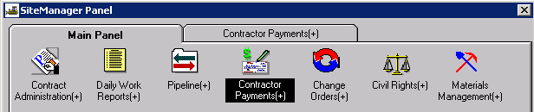
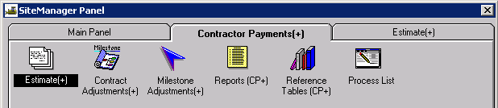
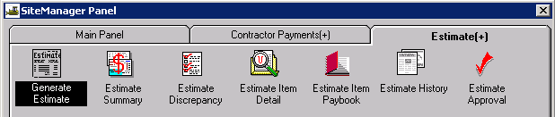
Select the appropriate Contract ID.
Verify the Final radio button is selected and the End Date is correct.
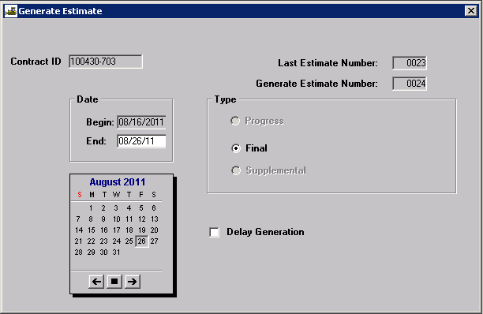
Click the Generate Estimate icon .
Select OK on the following SiteManager messages.
When the estimate has finished running, the following message will appear (unless the user is accessing the system from the Remote Desktop Connection). Select OK.
Print the Cognos 8 “Estimate Summary for Contract, by Est Nbr” report. Verify that all quantities are correct, no discrepancies exist, stockpiled materials are cleared out, and any liquidated damages or incentive/disincentive amounts have been correctly assessed. Verify that there are no pending change orders awaiting approval. These items must be addressed prior to approving the final estimate.
The system will not allow any discrepancies to exist on a final estimate. Therefore, all discrepancies must be resolved before approving a final estimate.
When the final estimate has been approved at the Resident Engineer level, the Final Plans Reviewer should be notified that a final estimate has been generated. The final estimate is then sent to the district with the final plans package.

