Quick Reference Guide -- Subcontracts
This article is intended to guide the user in the creation of a subcontract in SiteManager.
Log on to SiteManager and navigate to Contract Administration – Contractor Management – Subcontracts.
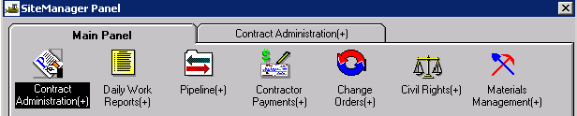
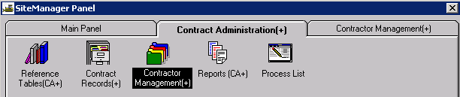
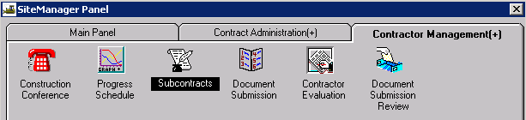

Description Tab
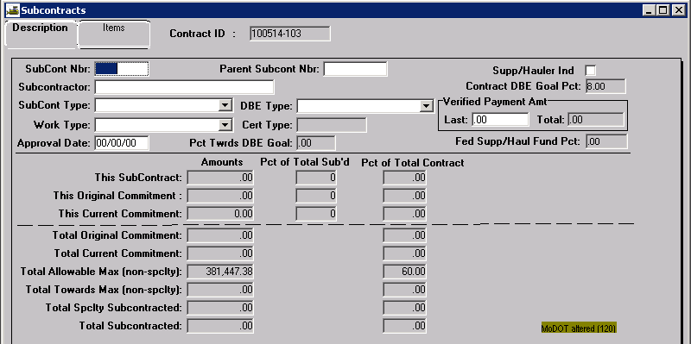
Contract ID: Select Services – Choose Keys to select contract.
SubCont Nbr: Enter a two-digit subcontract number, such as 01, 02, etc.
Parent SubCont Nbr: Do not enter anything in this field. MoDOT does not use parent subcontractors.
Supp/Hauler Ind: Do not check this box. MoDOT does not subcontract with suppliers or haulers.
Subcontractor: Perform a search and select the appropriate subcontractor (vendor) from the list. Some subcontractors may be listed more than once. The subcontractor’s name may not appear on the list exactly as it does on the Request to Subcontract Work (Form C-220) received from the prime. Verify the subcontractor’s Vendor Id on the Form C-220 with the Search Window. Any vendor listed as “Subcontractor,” “Prime,” or “Expired Prime” may be selected.
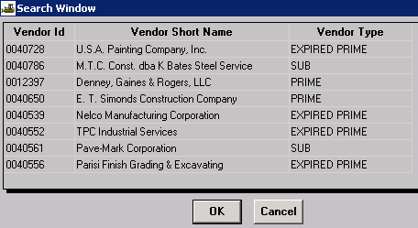
Note: If the subcontractor does not appear on the list, send an email to the Construction Contract Administrator at the Division Construction & Materials office to have the subcontractor added.
SubCont Type: Select the type that most closely fits.
DBE Type: Select either “DBE” or “NO” from the drop down.
Work Type: Select a work type from the drop down that most closely matches the work the subcontractor will be doing. Because the work types are not associated with each contractor, SiteManager will produce the following message:
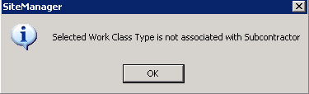
Select OK.
Verified Payment Amt: MoDOT does not use these fields.
Approval Date: Do not enter anything in this field. An approval date will be entered when the subcontract is approved at the District level.

Adding Insurance Information
Open the MoDOT Contractors Database in Lotus Notes.
Locate and open the subcontractor for your contract. Highlight and copy the insurance information.
Insurance Provider: Hub International
Address: 6800 College Blvd., Ste. 700
City: Overland Park State: KS Zip: 66211
Insurance Status: Approved
Insurance Expiration Date: 06/01/2011
General Liability: 06/01/2011 Auto Liability: 06/01/2011
Worker's Comp: 01/01/2012 Excess Liability: 06/01/2011
Transient Certificate: Not Required

Return to the subcontract in SiteManager and double click the remarks bubble to open the General Remarks area.
Enter your userid and the current date at the beginning of the Remarks area. Press enter and paste the insurance information in the Remarks area (CTRL-P or right click and Paste).
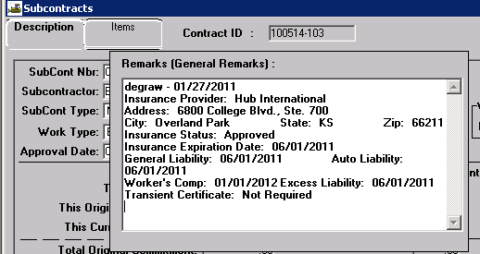

Click outside of the remarks area to close.
Click the Save icon to save the remarks and the information entered on the Description tab.

Items Tab
Click the New icon to open the Items detail at the bottom of the window.
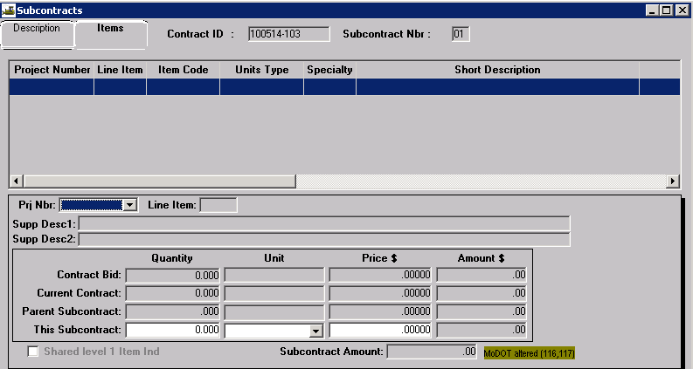
Prj Nbr: Select the appropriate project number from the drop down.
Line Item: Perform a search and select the appropriate line item.
Note: The tab order for this window has been changed. Tabbing will take the user from “Line Item” to “This Subcontract, Unit.” This is necessary so the system will not zero “This Subcontract, Quantity” when the unit is changed to “partial.”
This Subcontract, Unit: The contract unit will be displayed for the line item. Always select the corresponding Partial unit. For example, if the contract item unit is Linear Foot, the user should select Linear Foot (Partial) from the drop down.
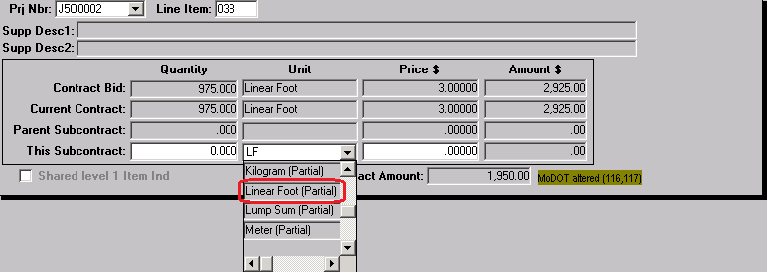
This Subcontract, Quantity: Enter the quantity of the subcontracted item.
This Subcontract, Price: Enter the amount shown on the Request to Subcontract Work (Form C-220) for the subcontract.
This Subcontract, Amount: This field is automatically calculated by the system.
Save the information. Select the New icon and repeat the above steps to add additional items to the subcontract.
Return to the Description tab and select the New icon to enter additional subcontracts.

Modifying Existing Subcontracts
Certain situations will require modification of approved subcontracts.
Additional Contract or Contingent Item Work Added to an Approved Subcontract
Revise the previously approved subcontract in SiteManager for the additional items of work. This will allow the inspector to select the subcontractor as doing the additional work on the DWR Work Items tab. The user shall place a Remark indicating the date of the revision and why the subcontract was revised. No revision of the hardcopy is required.
Routine Increase of Contract Quantity on Subcontracted Items
No modification of the subcontract is required.
Change of Subcontractors for Previously Approved Subcontracted Work Items
In this situation, the user shall modify the existing subcontract removing the item(s) of work not being performed. The user shall add a remark indicating the reason for the revision. No revision of the hardcopy is required. A subcontract shall be added with the items of work to be performed by the new subcontractor. Hardcopies of the new subcontract shall be submitted.

