Quick Reference Guide – for ROUTINE
Adobe Digital Signatures (Contractor Instructions)

Version 02/10/2011

These instructions are based on Adobe Acrobat Pro 7.0.5 and may not be applicable to other versions.

0) This guide will be used as many times as necessary, once the user has gone through the “Quick Reference Guide for an INITIAL Adobe Digital Signature”.

1) This process assumes that a person is authorized to sign documents based on the person’s title, or the person has been delegated to sign documents for the authorized person.

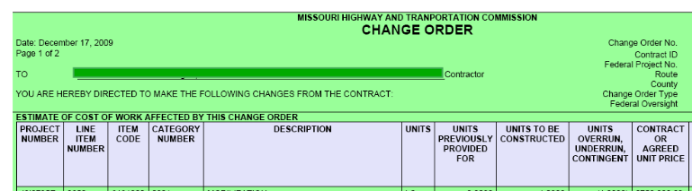
2) Detach the Change Order from the email by Saving from the email system to a hard drive on the computer. Open the PDF document in Adobe Pro. (Part of an example PDF page is shown above. This example is a Change Order, but digital signatures may be applied to any PDF file.)

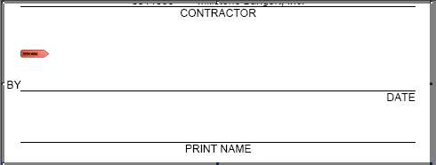
3) Using the Adobe Acrobat Hand Tool  click in the area of the signature symbol.

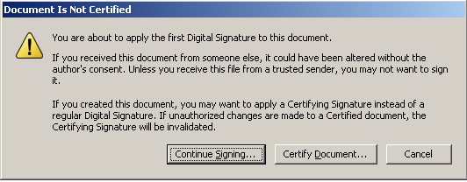
4) Click Continue Signing.

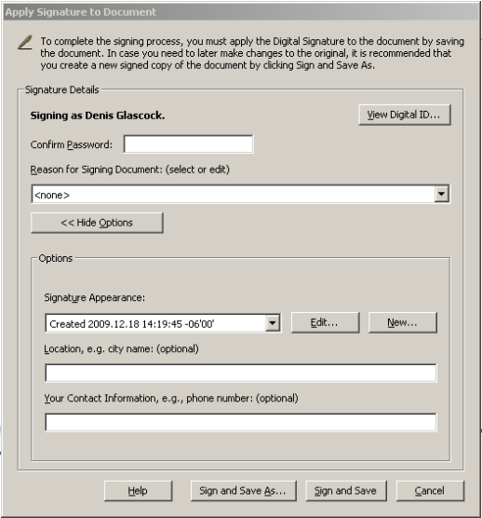
5) Enter the password that you gave the Digital Signature process during the initial set up. If the options are not showing, click Show Options. With Options showing, under Signature Appearance, select the Signature Appearance you created when you scanned an image of your signature, then click Sign and Save.

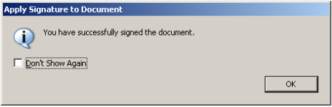
6) This may pop-up. You can mark “Don’t Show Again” if you want.

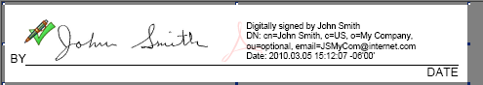
7) The document will look something like this in the area where it was digitally signed.

8) Attach the Change Order to an email and return it to the Resident Engineer.

