Quick Reference Guide -- Change Order Reports
This article is intended to guide the user in the creation of a change order report in ReportNet. Please read this QRG thoroughly before generating your change order report. It is important that the instructions below are followed in order to obtain the correct results.
There are four change order reports located in ReportNet – Official MoDOT Change Order Report, Official MoDOT MILESTONE ADJUSTMENT Change Order Report, Official MoDOT TIME ADJUSTMENT Change Order Report, and Official MoDOT ZERO DOLLAR Change Order Report.
The “Official MoDOT Change Order Report” must be used for changes to Contract Items. Make sure you are associating the change order reasons to specific line items. If you are not, the reasons will not print correctly on the report.
All change order reports should be printed after the change order status has been changed from "Draft" to "Pending." The results of your report are dependent on the fact that all previous change orders, with the exception of Zero-Dollar or Time Extension change orders, MUST be in "Approved" status.
All established Policies should be followed. For instance, Categories must be entered for contingent items; the reasons MUST be associated to line numbers, etc.

Accessing and Printing the Change Order Report
- Start ReportNet on your computer.
- Navigate to the Public Folders. From there, select SiteManager Reporting.
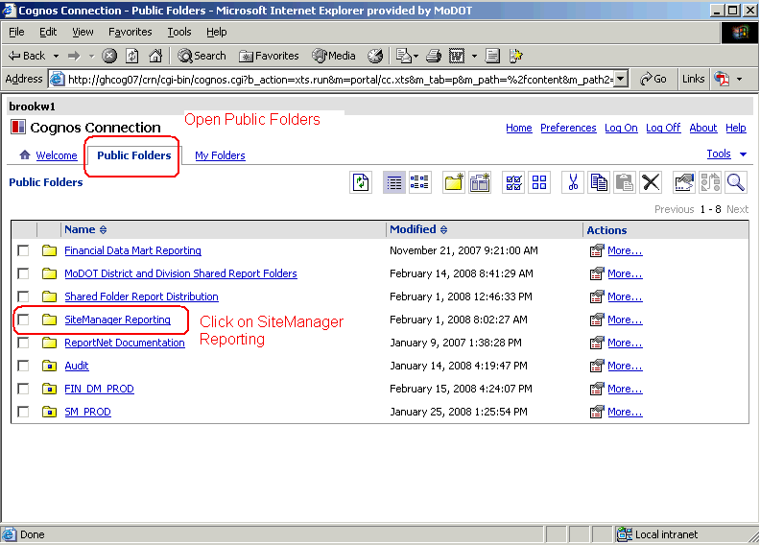
- Open the Headquarters folder. From there, select the Contract - Change Order folder.
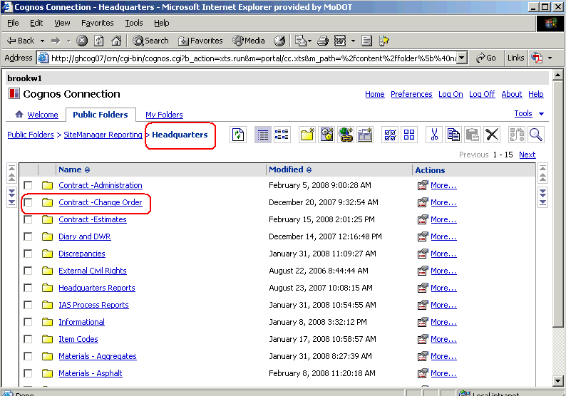
- Select the appropriate change order report.
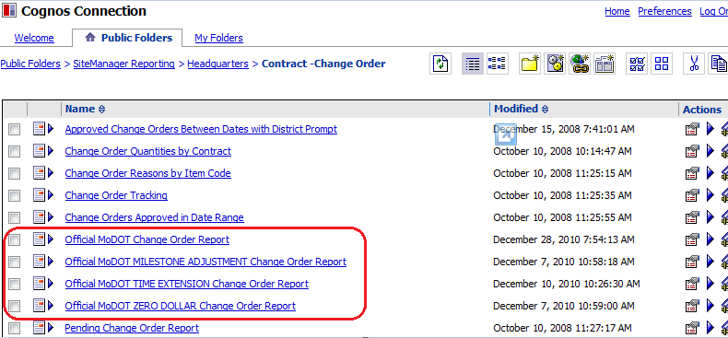
- When the report opens, you will be prompted for specific information. The “Official MoDOT Change Order” prompt boxes are shown in this example. Information required may be different for the other types of change order reports.
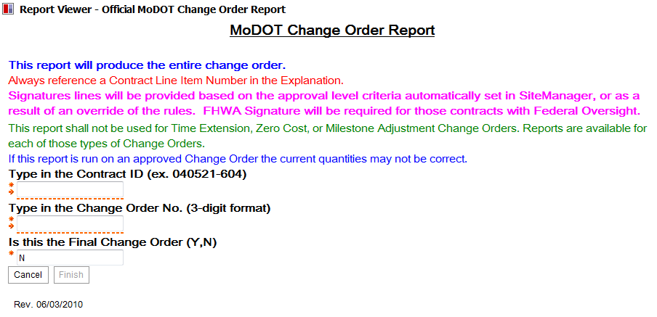
- All prompts are required. Information must be entered exactly as it appears in SiteManager. For example, Change Order 1 must be entered as “001”.
- Select the “Finish” button to generate the report.
- Print the report using the “Print” icon. (Do NOT use “File – Print” as this will not work.)
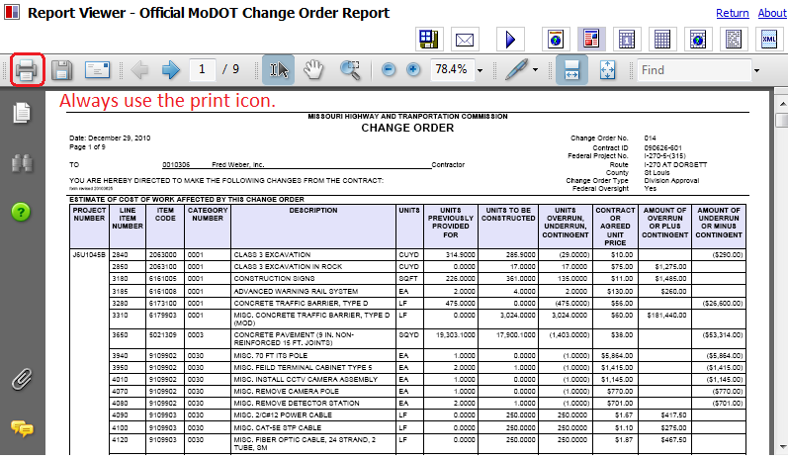

Saving the Change Order Report
SiteManager updates the header information each time a change order is generated. Therefore, you must save the report so the header will correctly reflect the contract information at the time of the report was created.
Policy: Change orders shall be saved in .PDF format to the V: drive in the following path for your district and org code: V:\Contract Information Archive\District # \ ORG # \ Contract ID \Change Orders\Pending. File name should include the change order number placed within the file name so the change orders will sort properly when listed in the folder. See example below:
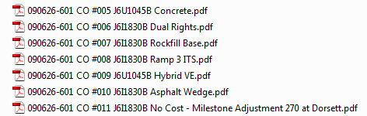

Once the change order has been approved at all levels, it shall be saved with all attachments in a single file to V:\Contract Information Archive\District # \ ORG # \ Contract ID \Change Orders\Completed.

