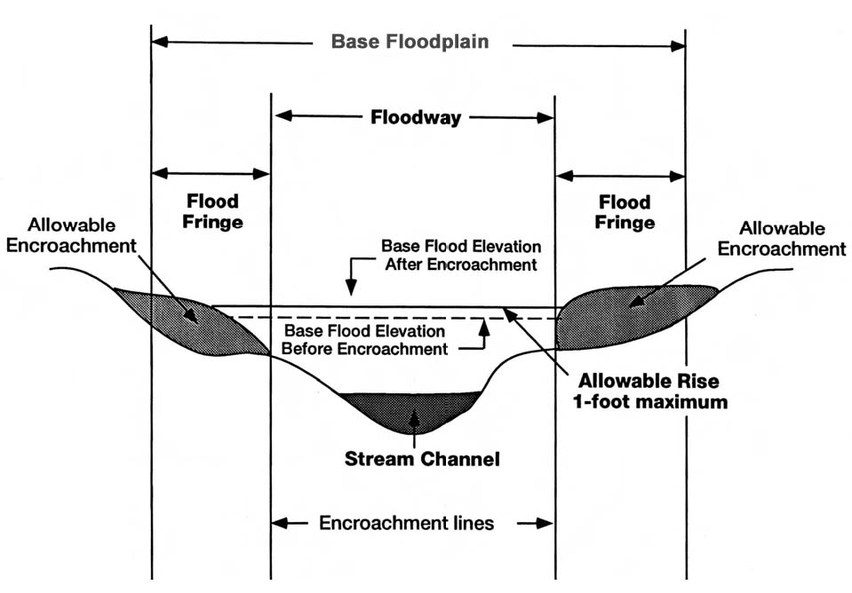
Diagram of Typical Floodplain
Figure 136.6.10

