Quick Reference Guide – Sample Record of Soil Density Inspection
Version 11/19/2010
This article is intended to guide you in the creation of a Soil Density inspection record with in SM. Initially you should be familiar with the General Information on how to create a Sample Record. See the Quick Reference Guide - Sample Record General Information.

SiteManager Sample Record:

Log on to SiteManager and navigate to Materials Managment.Sampling and Testing.Maintain Sample Information.
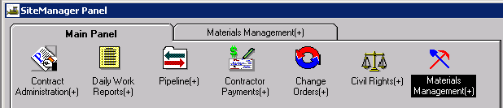

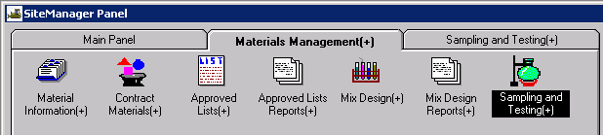

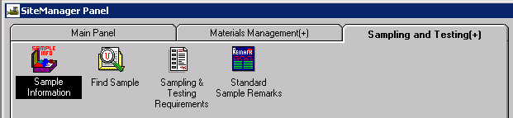

This window has five tabs across the top: Basic Sample Data, Additional Sample Data, Contract, Other, and Tests. When the window opens it should be focused in the first tab, the Basic Sample Data tab: (Tab you are focused in is always in bold letters).

Basic Sample Data tab

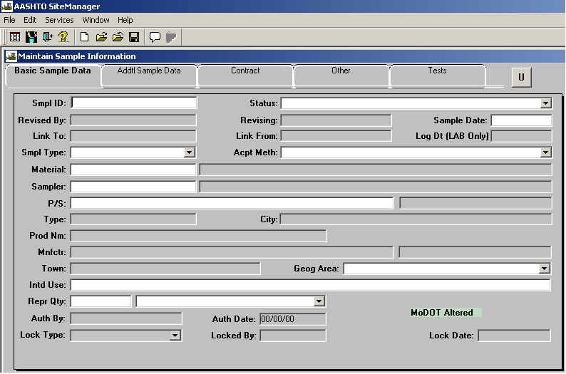

Enter your ID number in the field labeled “Sample ID” (Last two digits of Year, District, User’s assigned initials, 3 digits, with leading zeros ex.”001”). Once the record is saved the Id number cannot be changed or the record deleted.

For the “Status” field, click on the expand arrow to select the appropriate choice (usually “Accepted/Complete).

For the “Sample Date” field enter the date the sample was obtained. Multiple tests performed on a single day can be entered on one record. A separate sample record should be created for each date.

In the “Sample Type” field select “District Project”.

In the “Acceptance Method” field select “Sample and Test”.

In the “Material” field perform a search and select “Compacted Soil for Subgrade or Embankment".

In the “Sampler” field , the person who obtained the sample. Typically, the sampler is the individual entering the sample data.

Select “P/S”. This stands for Producer/Supplier and can only be populated after a material has been selected. Perform a search for the correct Producer/Supplier. Select “MoDOT (Jobsite, roadway or other similar site)” as the Producer/Supplier.

For the “Geographical Area” field select your District.

In the “Intended Use” field type in a short description for the use of the material.

In the “Represented Qty” field and enter the amount represented by this record. This is an estimated amount.

Select the “Remarks” icon from the menu bar if any additional information is needed for this record.
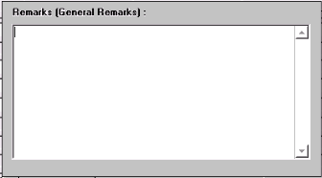

Save the record. The Sample ID number becomes protected and cannot be modified.

Addtl Sample Tab:
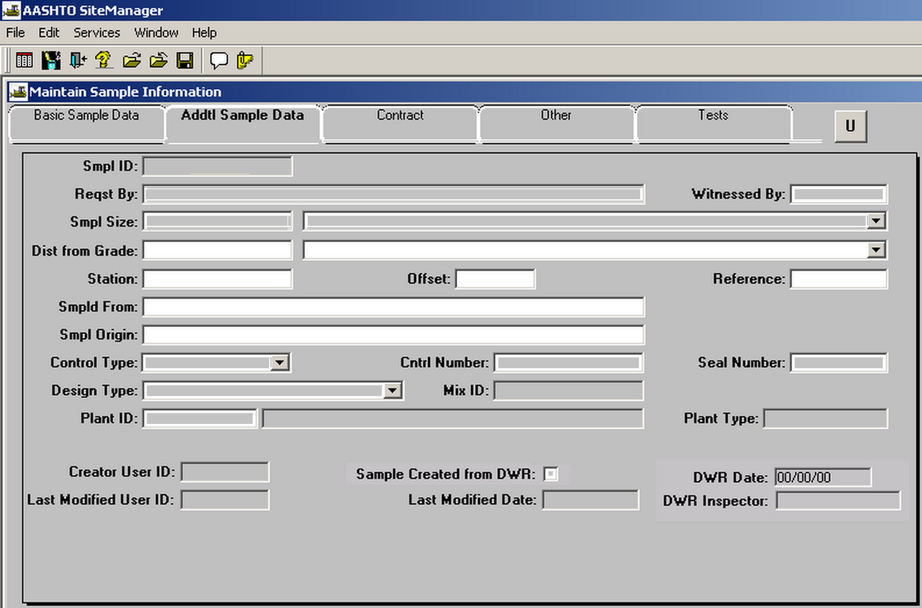
In the “Distance from Grade, Station, Offset and Reference” fields and enter the location that the test was taken. Use only the fields necessary to establish the sampling location.

In the "Sampled From" field and enter “Roadway”.

In the "Sample Origin" field enter “Job site”.

Contract Tab:
Select the “New” icon. Select the contract for which you are creating the sample record.

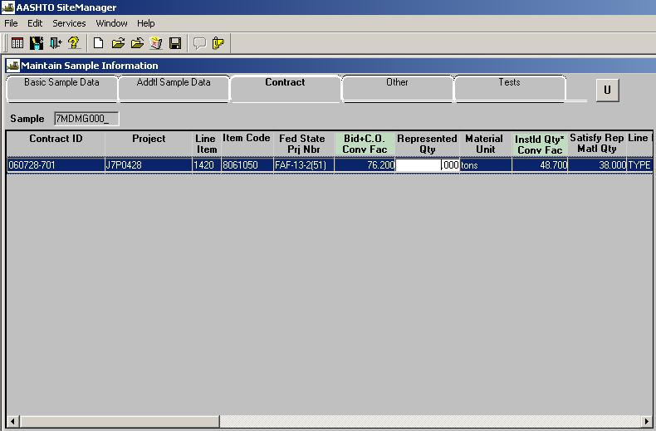

If you cannot find the contract in the list, contact District Materials to have the material code of your sample associated to the correct line item and contract. Once this is done, you will need to reopen the Contract Tab window and look for your contract. Select the correct contract.

After selecting the correct contract, select the line(s) item that corresponds to the density tests you performed.

If other lines are available not related to the testing you have performed, you will receive the message shown below. Select No.

Select the “Represented Qty” field to input the quantity of material to associate to that line item.

Other Tab: Leave blank. This tab is not used for subgrade compaction samples except in special circumstances where the project is not being documented with SiteManager.

Test Tab:
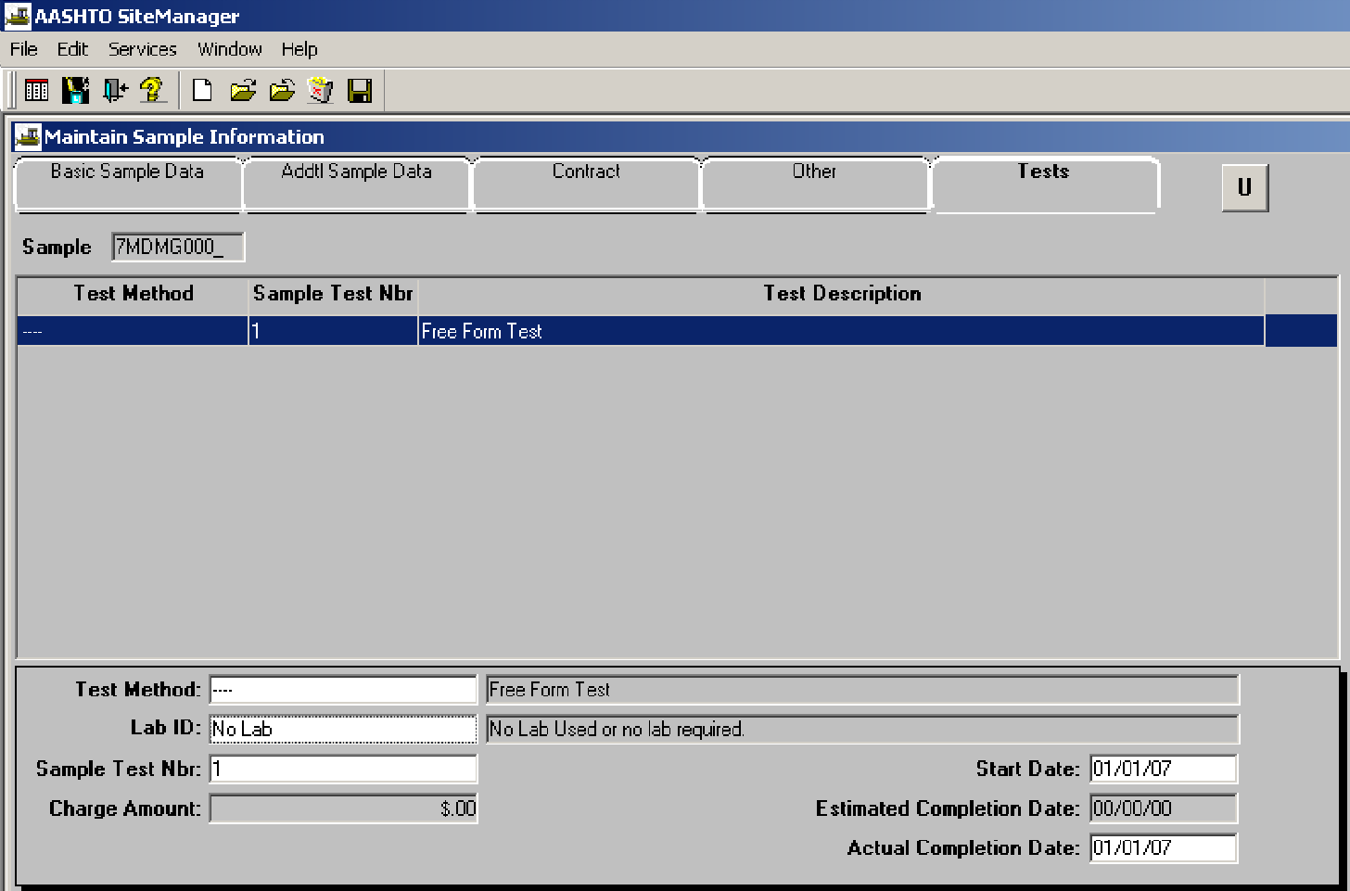

Focus in the bottom panel of the window, in the field “Test Method”. Perform a search and select the correct test (SAA200AA).

In the “Lab ID” field, perform a search and select “No Lab”.

In the “Sample Test Nbr” field and enter the number “1” for the first test result. When adding more than one test result to this record, the sample test number must be increased incrementally for each test.

In the “Start Date” field and enter the date that the test was performed.

Skip the “Estimated Completion Date”.

In the “Actual Completion Date” field and enter the same date that the test was completed, (usually the same date as the “start date”).

From the Services drop down menu, select Enter/View Test Data. This will open the appropriate test template, allowing the Inspector to enter test results. When the Test Template Usage screen appears, enter the correct density information for the three categories of Above 18", Below 18", and Too Rocky to Test.

If more room is needed for comments than is provided, use the Remarks option, or add a “Free Form” test.
Save and close. The record is complete.

