Quick Reference Guide – Disposition Remarks for PAL Materials
Version 12/10/2010

Disposition remarks are required on all PAL delivered materials. The remarks should be entered as soon as possible after delivery of material. Disposition remarks may be reviewed by auditors and supervisors any time the project is active.

Construction personnel at the project site will review any PAL material that arrives, for general condition and apparent compliance with the applicable specifications. Material that appears to be specification compliant and that has a proper PAL tag attached may be released for use by the contractor. The PAL I.D. number and a basic description of the material will be recorded by the construction inspection staff for confirmation of the SiteManager record. The SiteManager sample record will be reviewed to confirm that the material received matches the material indicated by the sample record. The match will be documented in the SiteManager record as a Remark or (Services) Disposition Remark. The remark will include the inspector’s userid, the date, and the comment “material received”. In the event that the material does not reasonably match the sample record description, District Materials and Headquarters Construction and Materials are to be notified by the inspector.

It’s recommended that PAL deliveries be documented in bound field diary, including PAL number, material type, supplier and quantity, along with any remarks concerning the delivery. This information will be then be noted on the SiteManager sample record in the following manner.

Navigate to the Sample Information window
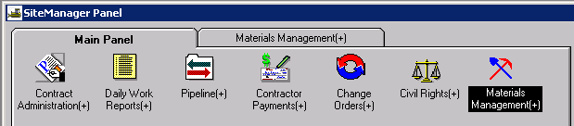

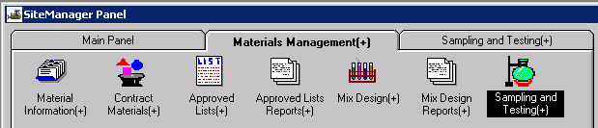

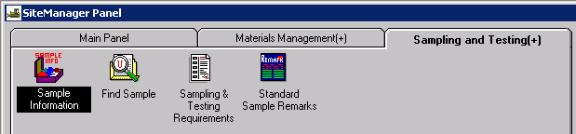

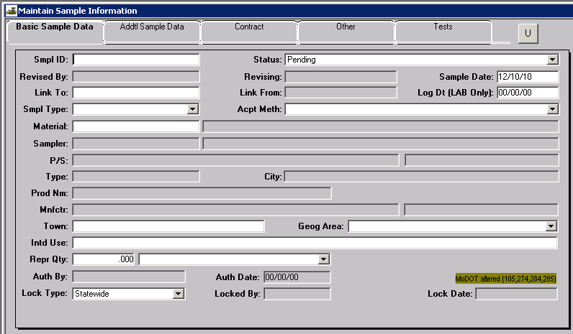
- Open the record with the corresponding PAL number by typing the PAL number in the Smpl ID field. Press Enter or Tab to retrieve the record.
- Compare the record to the field observations. They should match. If not notify HQ Construction and Materials at 573-751-6735 or your District Materials Office.
- To enter Disposition remarks:
  - If the record is authorized (grayed out) Go to Services, Enter Disposition Remarks. A white box will appear for you to type in. To save remarks, click outside the box and then use the save icon.
  - If the record is not authorized, use the remarks balloon available on the first tab. Enter the required information (#4) and notify HQ Construction and Materials the record is still open so they may follow-up with the vendor. The vendor is supposed to notify of shipment, which would result in the record being authorized. To save remarks, click outside the box and then use the save icon.
- Required information:
  - Inspector’s userid
  - Date checked
  - “Material received in good condition” or state otherwise
  - You may enter a quantity if the nature of the material is such that the quantity in the shipment can be accurately determined with relative ease.

Here’s an example of remarks made for PAL – notice the lines in the white balloon. This will indicate a record has remarks on it.

