Quick Reference Guide – Sample Record of Visual Inspection
Version 11/24/2010
This article is intended to guide you in the creation of a Visual inspection record in SM. Initially you should be familiar with the General Information on how to create a Sample Record. See the Quick Reference Guide - Sample Record General Information.

Make certain that a visual inspection is appropriate for this material. See the specification and the EPG entries for the material. If the specification indicates limits that can be judged visually, such as the size of the largest stones and the relative amount of smaller stones, then a visual inspection may be acceptable. There may be instances where the material involves such a small quantity that traditional inspection is unwarranted but a visual inspection may identify at least the most obvious issues with the material. If in doubt regarding the appropriateness of a visual inspection, contact the District Construction and Materials Engineer, or a Construction and Material Liaison.

SiteManager Sample Record:

Log on to SiteManager and navigate to Materials Managment.Sampling and Testing.Maintain Sample Information.
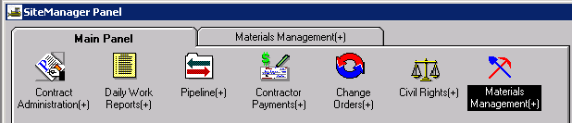

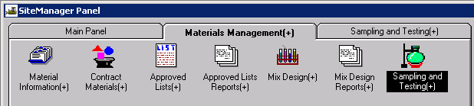

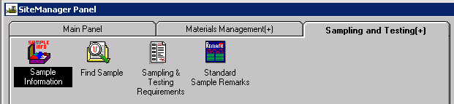

This window has five tabs across the top: Basic Sample Data, Additional Sample Data, Contract, Other, and Tests. When the window opens it should be focused in the first tab, the Basic Sample Data tab: (Tab you are focused in is always in bold letters).

Basic Sample Data tab

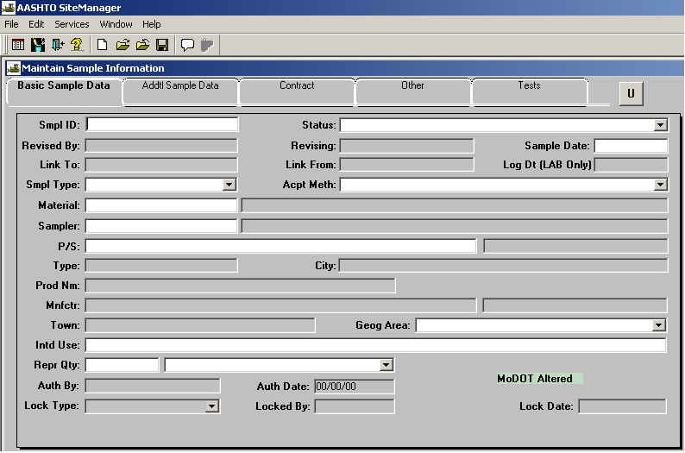

Enter your ID number in the field labeled “Sample ID” (Last two digits of Year, District, User’s assigned initials, 3 digits, with leading zeros ex.”001”). Once the record is saved the Id number cannot be changed or the record deleted.

For the “Status” field, click on the expand arrow to select the appropriate choice (usually “Accepted/Complete).

For the “Sample Date” field enter the date the sample was obtained. Multiple tests performed on a single day can be entered on one record. A separate sample record should be created for each date.

In the “Sample Type” field typically select “District Project” unless some other selection is more accurate.

In the “Acceptance Method” field select “Visual Inspection”.

In the “Material” field perform a search and select the material you are inspecting.

In the “Sampler” field , the person who is performing the visual inspection. Typically, the sampler is the individual entering the sample data.

Select “P/S”. This stands for Producer/Supplier and can only be populated after a material has been selected. Perform a search for the correct Producer/Supplier. Select the appropriate Producer/Supplier For the material being inspected.

For the “Geographical Area” field select your District.

In the “Intended Use” field type in a short description for the use of the material.

In the “Represented Qty” field and enter the amount represented by this record. This is an estimated amount.

Select the “Remarks” icon from the menu bar if any additional information is needed for this record.
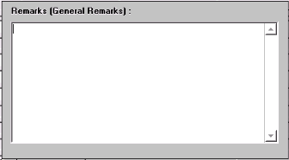

Save the record. The Sample ID number becomes protected and cannot be modified.

Addtl Sample Tab:
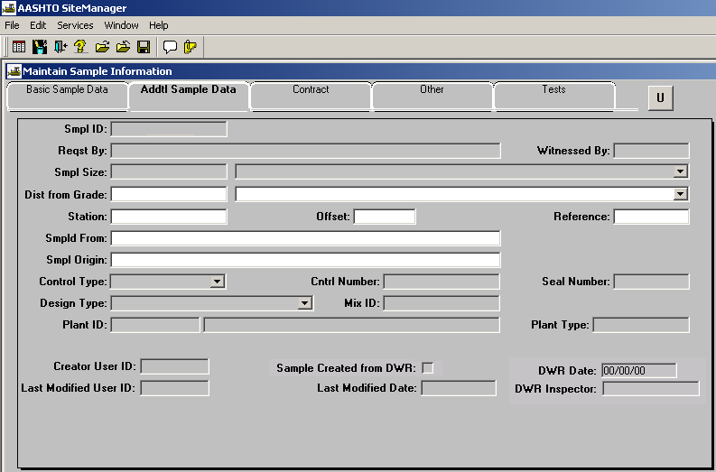
In the “Distance from Grade, Station, Offset and Reference” fields and enter the location where the material being inspected exists. Use only the fields necessary to establish the sampling location. It these designations do not apply to the location of the material, the next two fields may be adequate.

In the "Sampled From" field and enter the specific location the sample was observed, such as “north side of Turkey creek”.

In the "Sample Origin" field enter the general location of the observation, such as “Job site”.

Typically, material that has a Control Number or Mix Id is not accepted on a visual inspection however, if this is true, filling in these fields and the associated fields appropriately.

Contract Tab:
Select the “New” icon. Select the contract for which you are creating the sample record.

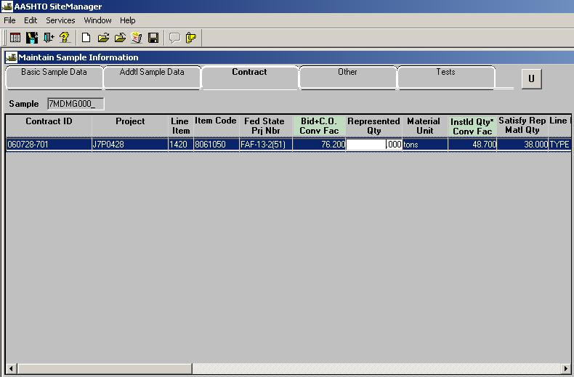

If you cannot find the contract in the list, contact District Materials to have the material code of your sample associated to the correct line item and contract. Once this is done, you will need to reopen the Contract Tab window and look for your contract. Select the correct contract.

After selecting the correct contract, select the line item(s) that correspond(s) to the visual inspection you performed.

If other lines are available not related to the inspection you have performed, you will receive the message shown below. Select No.
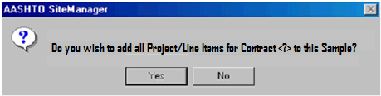

Select the “Represented Qty” field to input the quantity of material to associate to the line item.

Other Tab: Leave blank. This tab is not used for visual inspection samples except in special circumstances where the project is not being documented with SiteManager.

Tests Tab:
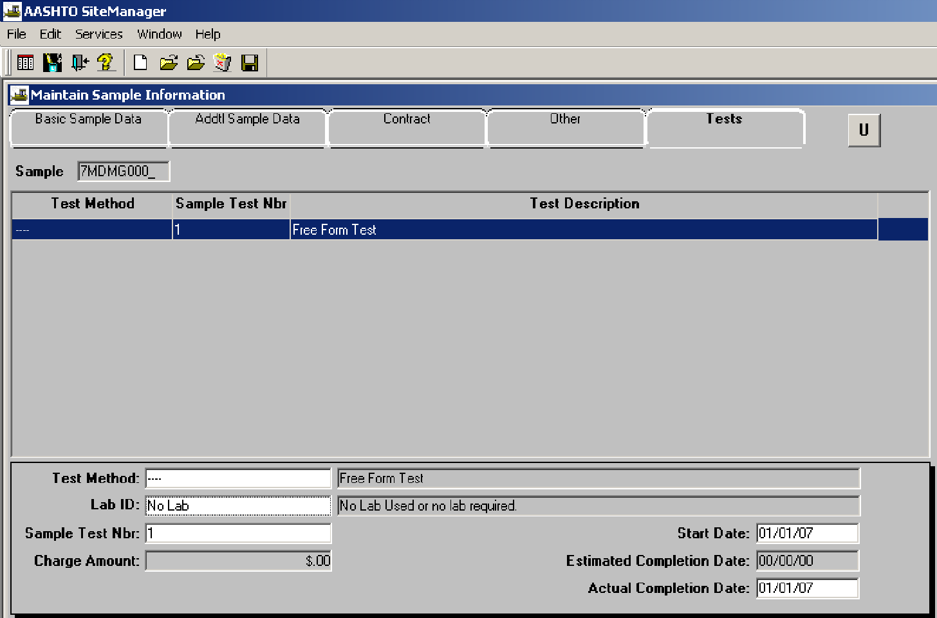

Focus in the bottom panel of the window, in the field “Test Method”. Perform a search and select the correct test (- - - -). (four dashes in a row represents the Free Form Test

In the “Lab ID” field, perform a search and select “No Lab” unless the visual inspection of the material was performed in one of the labs listed.

In the “Sample Test Nbr” field and enter the number “1”. Typically a visual inspection can be entered with one instance of the Free Form Test template, but, if necessary to add more than one “Test” to this record, the sample test number must be increased incrementally for each additional test.

In the “Start Date” field and enter the date that the visual inspection was performed.

Skip the “Estimated Completion Date”.

In the “Actual Completion Date” field and enter the date that the visual inspection was completed, (usually the same date as the “start date”).

From the Services drop down menu, select Enter/View Test Data. This will open the test template, allowing the Inspector to enter the results of the visual inspection. The entry in the Free Form template should describe, in detail, the compliance of the material with the visually determined limits of the specification. Review the specification prior to the visual inspection, then make comments on each point of the specification, indicating why the visual inspection found the material acceptable, or not.
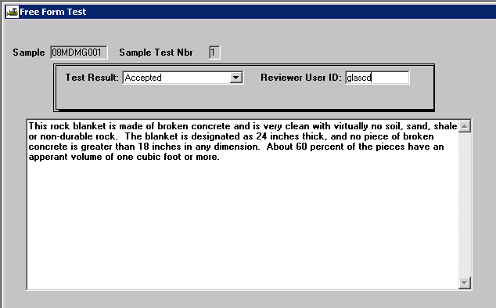

Select a Test Result. In districts where a review of the entry is required, the Reviewer User ID should be selected.
Save and close. The record is complete.

