QRG – Terminal Services/Remote Desktop Connection
Using Terminal Services to access SM can often speed up your work. This article is intended to guide the user on how to log on to Terminal Services through the Remote Desktop Connection:
Step 1: You must first establish a network connection (either through a hard wire or wireless connection). Log on to Terminal Services through the Remote Desktop Connection icon:
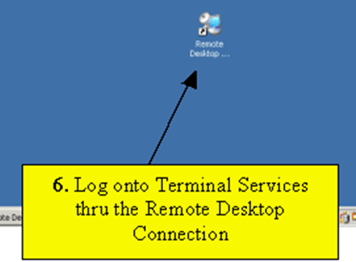

Step 2: Connect to the proper server. Currently, that server is "GHTSSMWP01". Select the Connect Button:
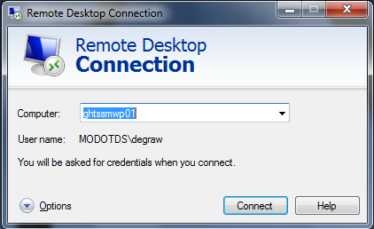

…or

Select the Start button – Remote Desktop Connection – ghtssmwp01 (as shown below):
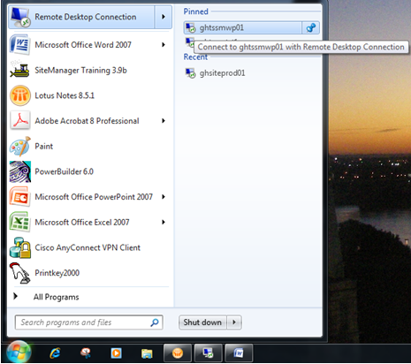

Step 3: Click "OK" on the MoDOT system authorization message:
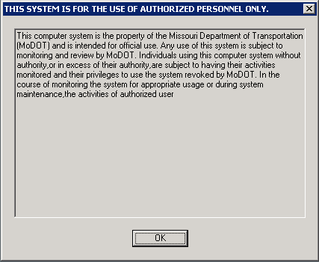

Step 4: Log on to the Remote Desktop Connection using your Network User ID and Password:
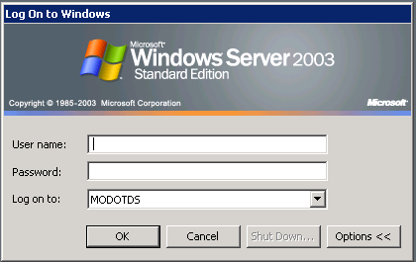

Step 5: Log on to SiteManager as normal.
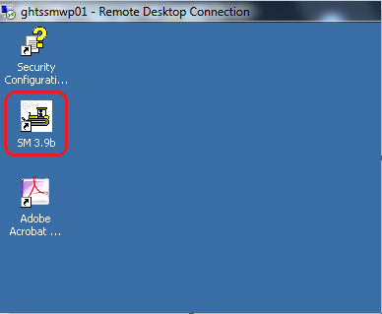

Note: When logging on to SiteManager in Terminal Services, unless you are the first user to log on, you will receive the following DPS Status Monitor message:
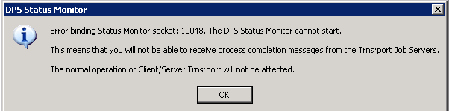
This is not an error; it is simply a message stating you will not receive process completion messages. Click the OK button and continue.

Step 6: To log off of Terminal Services, select the “Start” button, then select “Log Off.”
NEVER select “Shut Down.”
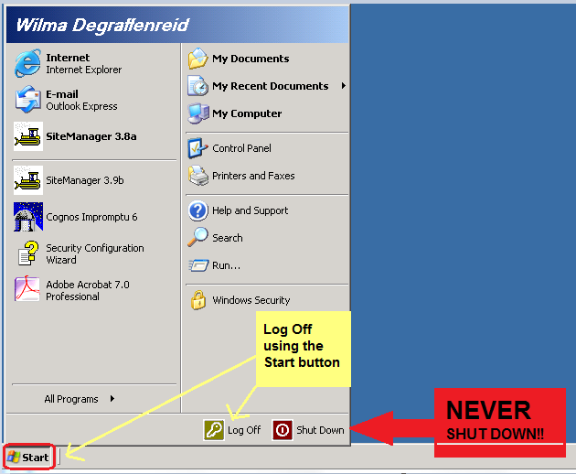

Step 7: You should always receive a Log Off Windows message. Select "Log Off" button to terminate your Remote Desktop connection.
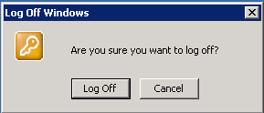

NOTE: Selecting the “X” in the upper right corner of the Remote Desktop does not close the program.
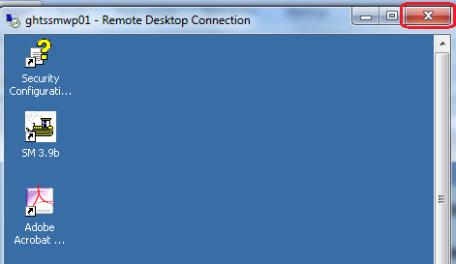

It simply disconnects your session, and if you have not logged off of SiteManager, it will continue to run.
