Quick Reference Guide – Sample Record of DEC Inspection
Version 11/18/2010
DEC stands for District Engineers Certification of signs, signals and lighting. The DEC was traditionally a letter written to file under the district engineer’s signature, indicating that the signs, signals and lighting, and all the components used in their construction were in compliance with applicable specifications.

The DEC is now part of a sample record so it may be used to resolve Contract Sampling and Testing Requirements.

SiteManager Sample Record:

Log on to SiteManager and navigate to Materials Managment.Sampling and Testing.Maintain Sample Information.
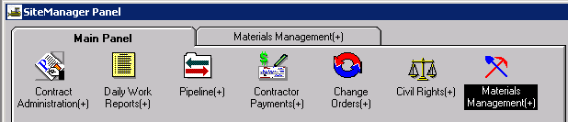

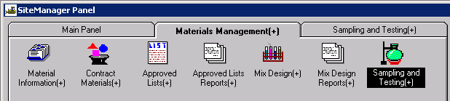

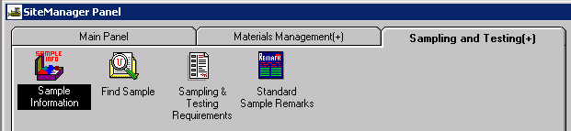

This window has five tabs across the top: Basic Sample Data, Additional Sample Data, Contract, Other, and Tests. When the window opens it should be focused in the first tab, the Basic Sample Data tab: (Tab you are focused in is always in bold letters).

Basic Sample Data tab
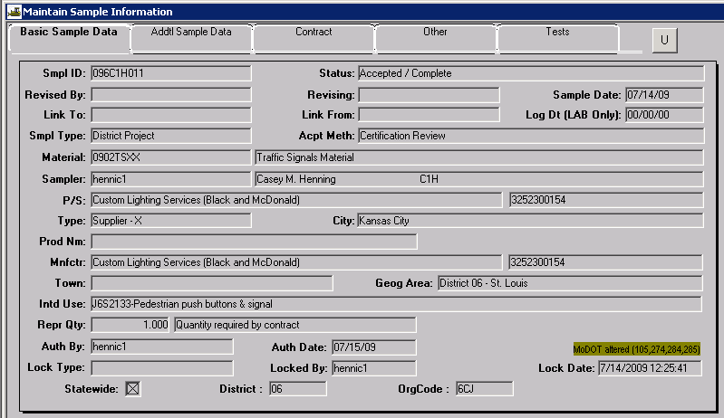
- Smpl ID = sample id number – create this in accordance the QRG Sample Record General Informaiton.
- Status = Accepted / Complete
- Smpl Dt = date of the inspection
- Smpl Type = District Project
- Acpt Meth = Certification review
- Material = material code, needs to match the sampling checklist, use the search lense. Generic codes have been established to let the user cover multiple lines on one report.
- P/S = producer or supplier for this material
- Manufacturer = when all the material is from one manufacturer, show the manufacturer, otherwise leave blank.
- Geog Area = your district
- Intd Use = where the material was used or for what, ex: “signals for 6 intersections”.
- Rprsntd Qty = How many of the units are you reporting. The unit field will be filled in – if it doesn’t match what you believe it should be, contact your District Materials Office. It will default to an English unit but can be changed for Metric jobs.
- Smpld By (Inspector) = who inspected this material. You can type in the userid or search.
- SAVE – Your first tab should look similar to the image above

Additional Sample Data tab
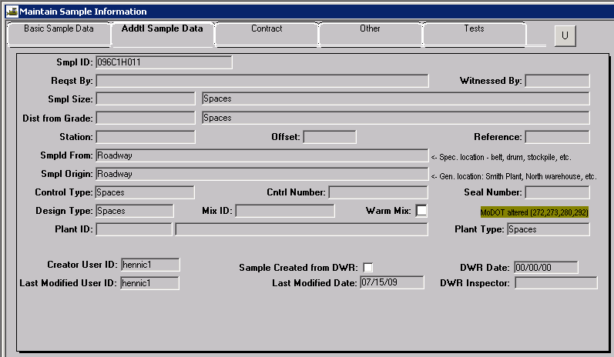
- Smpld From: = jobsite or roadway (wherever the material was first looked at).
- Smpl Origin = jobsite or roadway

Contract Tab

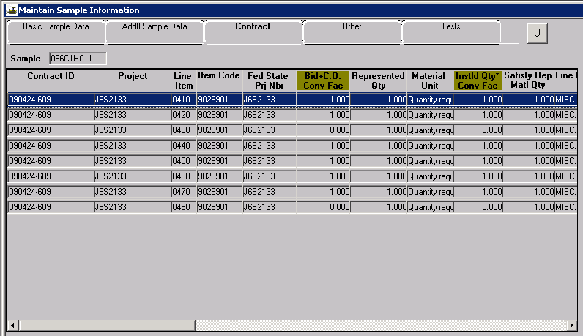
- Hit the new icon to bring up a list of contracts with the material code you chose on the basic tab. Click in the list to highlight your contract or begin typing the first numbers of your contract in the "FIND" box.
- Double click on your contract.
- Choose the first line item
- Answer YES to the next message box asking if you want to add all lines.
- Enter the appropriate quantities on the corresponding line items in the Represented Quantity field.
- SAVE

Other Tab

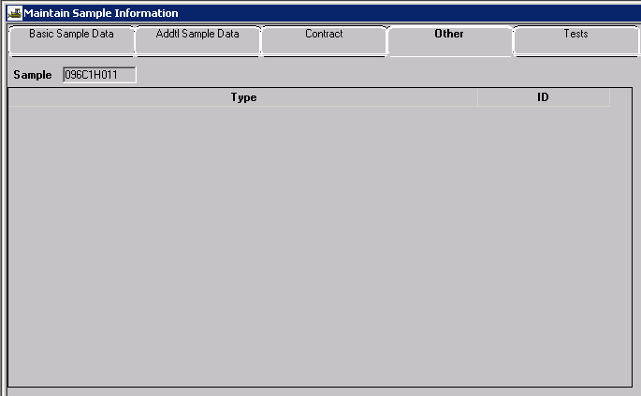

Use this tab only when your contract is not a SM Project, and you may also put the permit number here. All SM project records should be listed on the Contract tab, as discussed above.

Test Tab

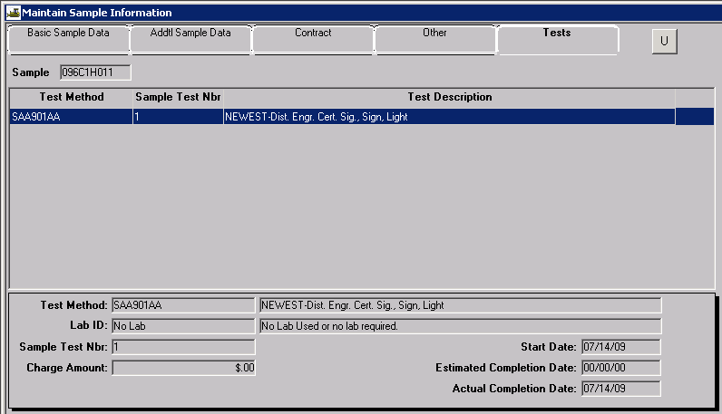

Focus in the bottom portion of the window, in the field " Test Method ". Perform a search and select "Dist. Engr. Cert. Sig., Sign, Light".

Tab to the " Lab ID " field - it can be blank or Select "No Lab".
Tab to the " Sample Test Nbr " field and enter the number "1"
Tab to the " Start Date " field and enter the same date that you entered on the Basic Sample Date tab.
Skip the " Estimated Completion Date "
Tab to the " Actual Completion Date " field and enter the same date as the "start date".
" Save " the record before proceeding.

Enter/View Test Data (Completing the test Information):

Select " Services " from the menu, and then select " Enter/View Test Data ".

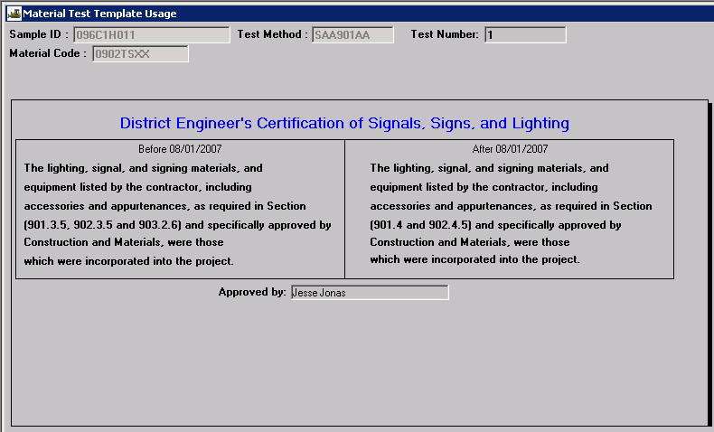

In the "Approved by" box, type in the approving Resident Engineer's name.

SAVE the record and close the window.

Navigate back to the "Basic Sample Data" Tab by clicking on the first tab.

Check all information in your record on all tabs and confirm that it is correct or make corrections.

Authorizing the Sample Record:

The Sample Record must be Authorized, once it is completed and correct. From the Basic Sample Data tab select Services – Authorize.

