Quick Reference Guide
–
For MoDOT USERS To Prepare Document
for CONTRACTOR’s Digital Signature

Version 02/10/2011

These instructions are based on Adobe Acrobat Pro 7.0.5 and may not be applicable to other versions.

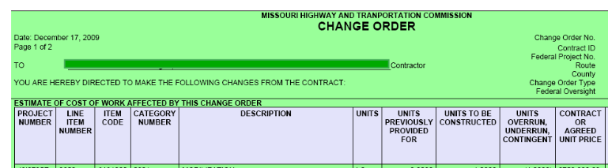
1) Open the PDF document in Adobe Pro. (Part of an example PDF page is shown below. This example is a Change Order, but digital signatures may be applied to any PDF file.)

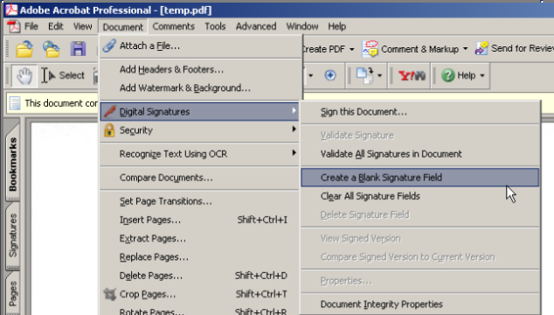
2) Select - Document – Digital Signatures – Create a Blank Signature Field - from the menu.

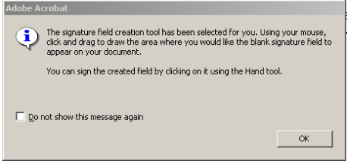
3) This pop-up may be displayed. Click “OK”. If you no longer wish to see this message, check the “Do not show this message again” box.

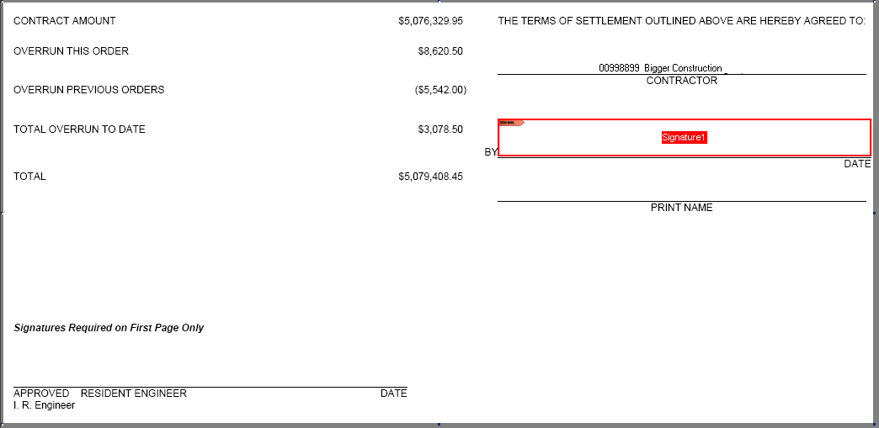
4) Using the tool provided, draw a rectangle where the Contractor should sign the form.
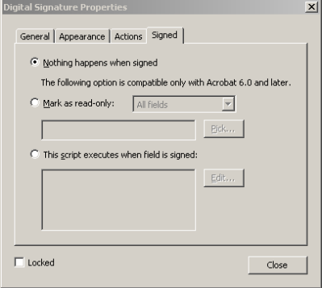
5) This will pop-up will be displayed. Click Close. (Leave all the settings in the window as they are.)

6) Save your changes to the document and close.

7) (For contractors who have signed up for email/digital signature on change orders)
Send an email to the contractor with the Change Order document attached and direct the contractor to digitally sign the Change Order.

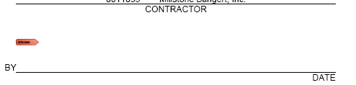
8) The contractor will need to save the Change Order to a hard drive and open it from there. Most email systems will not allow the document to be digitally signed and returned without taking the document out of the email system. In the area where the contractor would normally sign a Change Order the symbol will appear. If the contractor has the hand tool enabled in Adobe, he/she need only click in the signature area, and Adobe will automatically start the digital signature process.

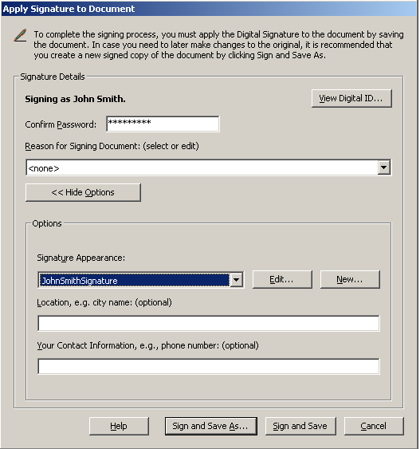

10) The contractor will need to enter the Password he/she designated when the digital signature file was created. A Signature Appearance should be selected, if it is typical, it will have a name like “<PersonsName>Signature”. Then the contractor will click Sign and Save.

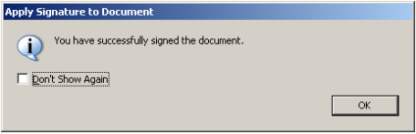
11) This note may pop-up. The contractor can mark “Don’t Show Again” if he/she wants.


11) The document will look something like this in the area where it was digitally signed.

The contractor then needs to attach the document to an email and send it back to the RE.

If the contractor never returns the file, the RE may start over with a saved copy of the Change Order and send it through the process without the contractor signature.

