Quick Reference Guide – for INITIATION of
Adobe Digital Signature (Within MoDOT)

Version 02/10/2011

These instructions are based on Adobe Acrobat Pro 7.0.5 and may not be applicable to other versions.

0) This guide will typically only be used once by a particular person. Subsequent digital signatures may be applied according to the instructions in the Quick Reference Guide “for ROUTINE Adobe Digital Signatures”.

1) This process assumes that a person is authorized to sign documents based on the person’s title, or the person has been delegated to sign documents for the authorized person.

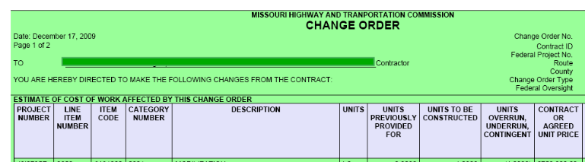
2) Open the PDF document in Adobe Pro. (Part of an example PDF page is shown above. This example is a Change Order, but any PDF can be used for this part of the process. The PDF you created by scanning the signature will work fine.)

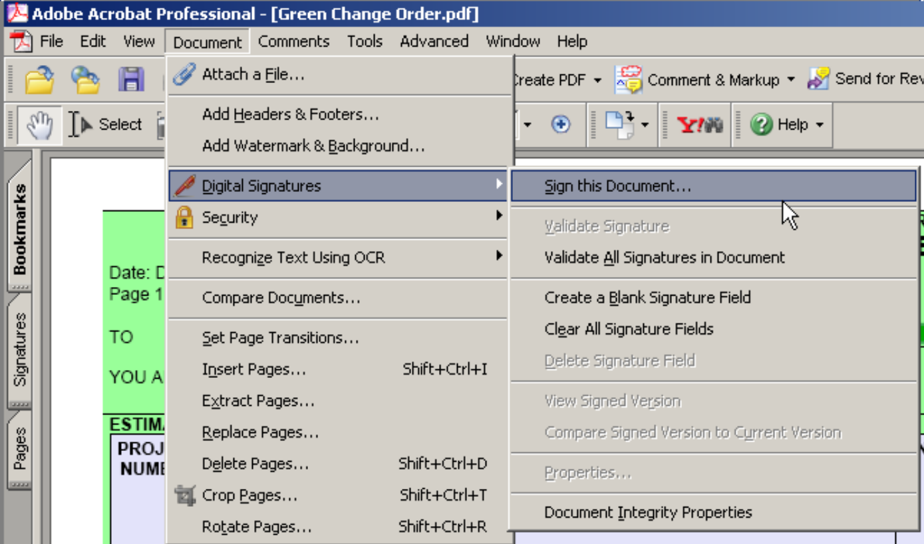

3) Select - Document – Digital Signatures – Sign this Document - from the menu.

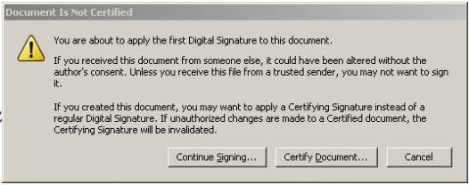
4) This pop-up may be displayed. Click “Continue Signing.”

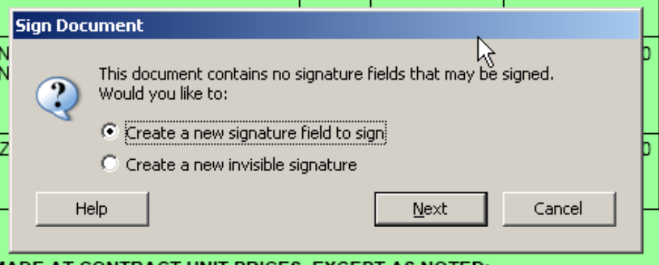
5) This pop-up will be displayed. Click Next.
(Leave the default of “Create a new signature field to sign”.)

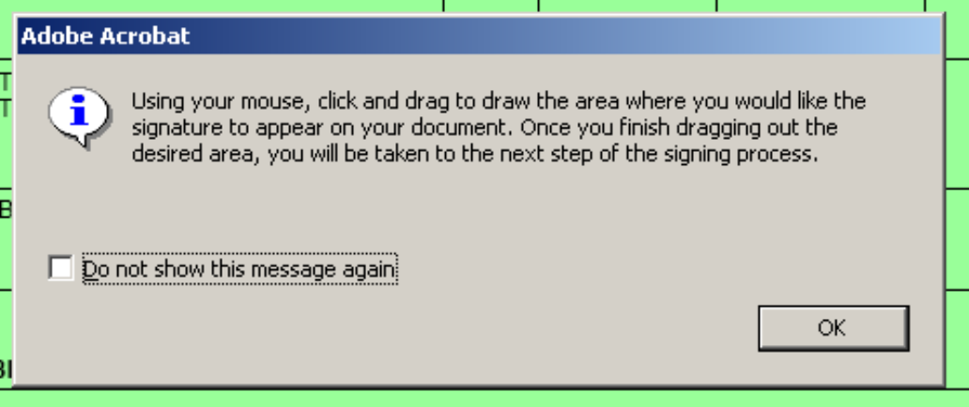
6) This will pop-up to remind you that you will need to designate a location on the page for the digital signature. Once you are familiar with the process you can suppress this notification by checking the box that says, “Do not show this message again.” (NOTE: some documents will come with the signature area already designated; in those instances you will just click in the space provided and “sign”.)

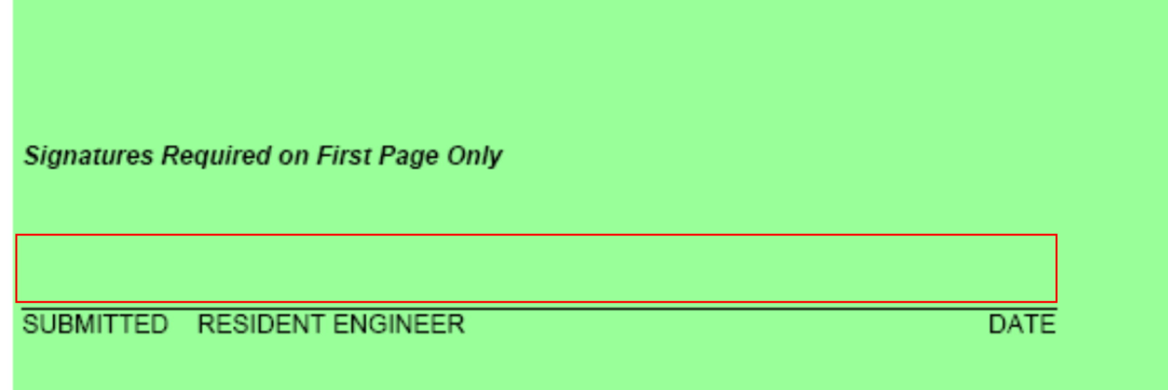
7) Select the area where you want the digital signature to appear. On a Change Order PDF, define the full area of the Change Order signature line that applies to the signature you are attaching. The selection area will appear as a dashed line rectangle. Make the rectangle about the same size as the red outline shown above.

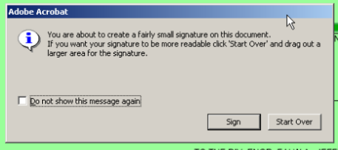
8) You may get this pop-up. If you are satisfied that you selected the correct area, click “Sign”, otherwise click “Start Over” and you will be allowed to repeat step 7 above.
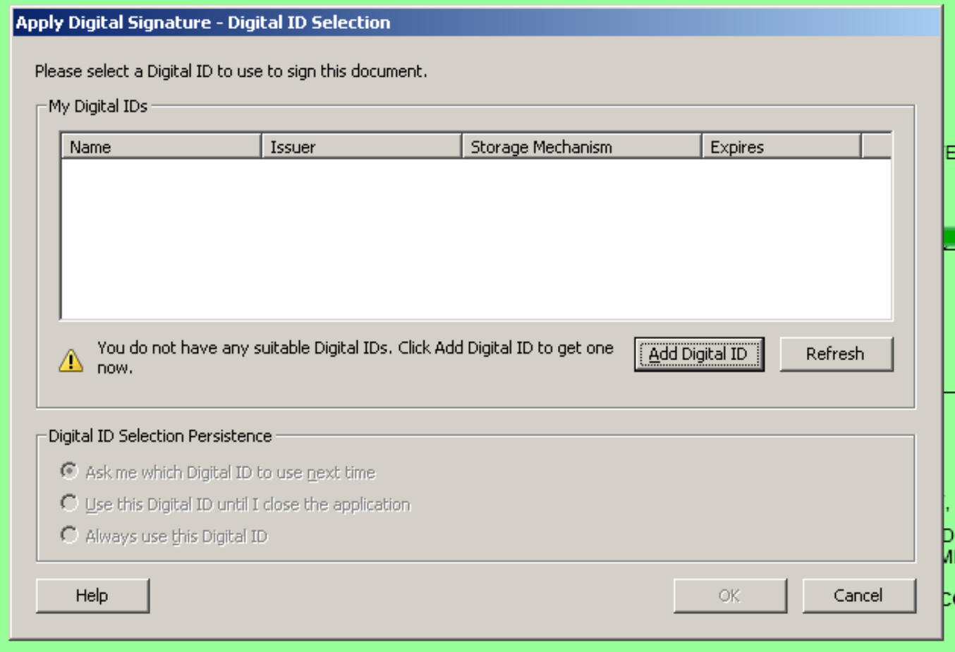
17) When you release the mouse button, this window may pop-up.

If the Digital ID you need is displayed, select it by double clicking the appropriate row.

If the Digital ID you need is NOT displayed, you will need to “Add Digital ID”. See the “Quick Reference Guide to set up Digital ID”

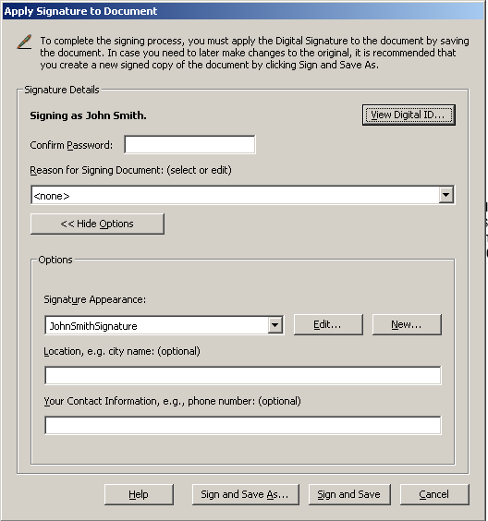
18) Step 17 may not occur, instead, this may pop-up. Enter the password that you established when you created a Digital ID, Select a Signature Appearance that you created when you Captured a Signature Image, then click Sign and Save.

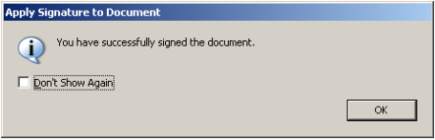
19) This may pop-up. You can mark “Don’t Show Again” if you want.


20) The document will look something like this in the area where it was digitally signed.

