QRG: Change Orders – Mobilization & Contract Bond
This article is intended to guide the user in the creation of a Mobilization and Contract Bond change order.
For any contract for which the contractor chooses to be paid for the Contract Bond, an adjustment to the Mobilization should be made on a change order at the beginning of the job. The original Mobilization amount must be zeroed out and a new Mobilization item number created to reflect the correct calculation of Mobilization. A new line item will also be created in order to pay for the Contract Bond.
Note: When the change order is for Contract Bond ONLY, the contractor's approval may be recorded without submitting the change order to the contractor. The contractor's approval is assumed because the contractor requested the bond payment and submitted the required supporting documentation. (Be sure to send the change order to the contractor for their records.) This applies ONLY when Contract Bond and Mobilization amounts are the ONLY items on the change order. All levels of MoDOT approval may be assumed; however, FHWA approval is still required for projects with FHWA full oversight.
Navigate to Change Orders – Change Order Maintenance – Header.
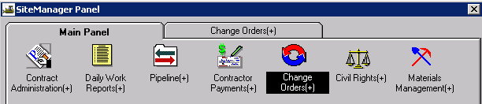
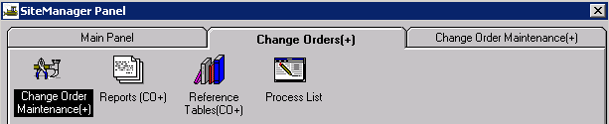
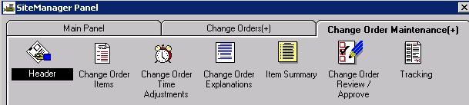

Creating the Change Order Header
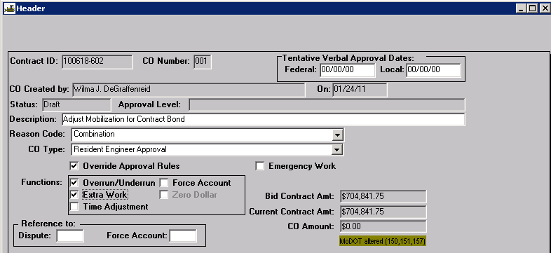
Contract ID: Select Services – Choose Keys to select contract.
CO Number: The system will automatically number the change order.
Tentative Verbal Approval Dates: May be used if it applies.
CO Created By: Automatically entered by system.
On: Date automatically entered by system.
Status: Leave Status as “Draft” until all items and explanations are entered. After all items and explanations have been entered, return to the header and save it as “Pending.” The change order will then be forwarded to the users you select as approval levels.
Approval Level: Automatically entered by system based on change order rules or “Override” selection.
Description: Enter “Adjust Mobilization for Contract Bond.”
Reason Code: Select Combination from the drop down.
CO Type: Select Resident Engineer Approval from the drop down.
Override Approval Rules: Because approval rules will force higher levels of approval than necessary due to the Maximum % of Bid Item Exceeding 999%, select this option.
Emergency Work: Do not check.
Functions: Select both Overrun/Underrun and Extra Work.
Reference To: Dispute and Force Account: These fields are not used.
Save and close the Header window.

Adding Change Order Items
Navigate to the Change Order Items icon.

Change Order Item Tab
Select “New CO Item” from the Services menu and select the “Mobilization” description. Enter “-1” (negative one) for the quantity in the “This Change Order” field. Save.
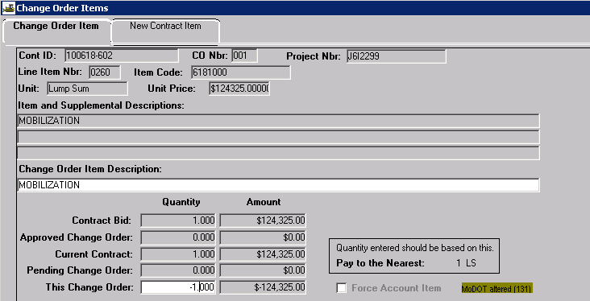

New Contract Item Tab
Select the New icon. Click the New Contract Item tab to add two new line items to the contract.
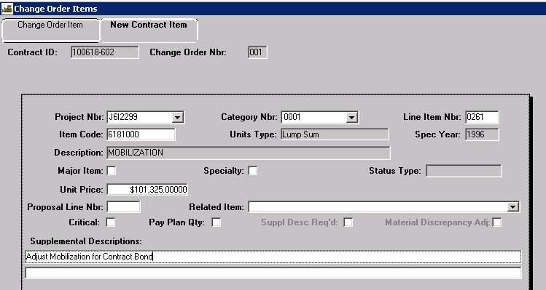
Project Nbr: Select the appropriate project number from the drop down list.
Category Nbr: Select the appropriate category number from the drop down list.
Line Item Nbr: Enter a number incremented by 1 from the original Mobilization line item number. For example, if the original contract Mobilization number is 0260, enter 0261 for the new Mobilization line item number. This will cause it to appear immediately below the original line item number on the estimate.
Item Code: Perform a search and select the Mobilization Item Code (6181000) with a unit of LS and a Spec Year of 1996 (or type the item code in the field).
Unit Price: Enter in the dollar amount of Mobilization calculated as shown below.
(Original Mobilization - Contract Bond/ Railroad Liability Insurance amount)
Example: ($124,325.00 - $23,000.00) = $101,325.00 = New Mobilization Unit Price
Supplemental Descriptions: Enter “Adjust Mobilization for Contract Bond.”
Return to the Change Order Item tab and Save.
Again, select the New icon, then click the New Contract Item tab to add another new line item to the contract.
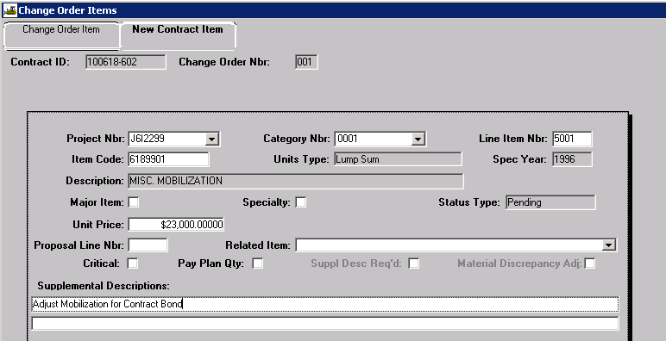
Project Nbr: Select the appropriate project number from the drop down list.
Category Nbr: Select the appropriate category number from the drop down list.
Line Item Nbr: If this is the first contingent item for the contract, enter 5001in the Line Item Nbr field; otherwise, enter the next consecutive number.
Item Code: Perform a search and select the Misc. Mobilization item code 6189901 (or type the item code in the field).
Unit Price: Enter the dollar value of the contract bond.
Supplemental Descriptions: Enter “Adjust Mobilization for Contract Bond.”
Return to the Change Order Item tab and Save.

Adding Change Order Explanations
There are two ways to add change order explanations.
You may navigate to the Change Order Explanations icon,
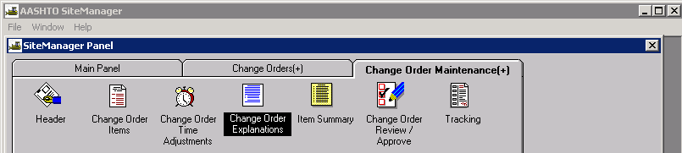
or you may access the Change Order Explanations window from the Services menus of the Change Order Items window.
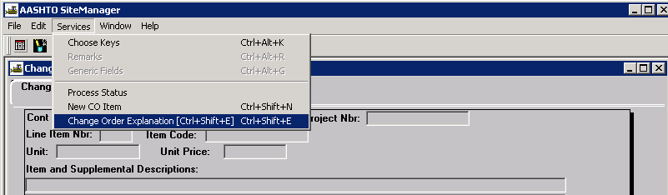
Either option will open the Change Order Explanations window.
Select "Explanations Applied to Specific Items" from the drop down. This will open the Change Order Line Items panel on the right side of the window.
Select the New icon for the Line Items to appear in the Change Order Line Items panel
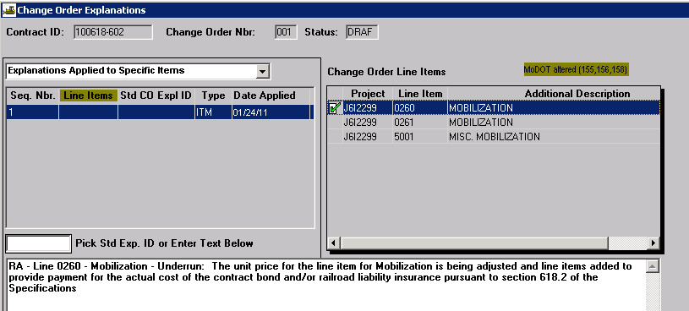
Create an Explanation for each of the 3 Line Items that were added. Be sure to include the required information at the beginning of each explanation: Reason Code - Line Nbr - Description - Overrun, Underrun, or Extra Work: Type reason. For example: RA - Line 0560 - Underrun: The unit price for the line item for Mobilization is being adjusted and line items added to provide payment for the actual cost of the contract bond and/or railroad liability insurance pursuant to section 618.2 of the Missouri Standard Specifications for Highway Construction.
Once the explanation has been typed in the lower window, it should be associated to the appropriate change order line item in the right hand window by double clicking the line number.
Save the explanation and select the New icon to create each explanation.

Changing the Status of a Change Order
Once all items and explanations have been added to the change order, the user must navigate back to the Header.
Verify "Override Approval Rules” has been selected.
Change the status from “Draft” to “Pending” and save.
When the blank Change Order Approval window appears, select the “New” button.
Seq. No. 1: Select "Construction Project Clerk" from the Groups for Approval drop down (this is the group that will approve the change order at the Contractor level), and select the appropriate user from the User ID drop down.
Select the “New” button a second time.
Seq. No. 2: Select "Construction Resident Engineer" from the Groups for Approval drop down and select the appropriate user from the User ID drop down. Select OK.
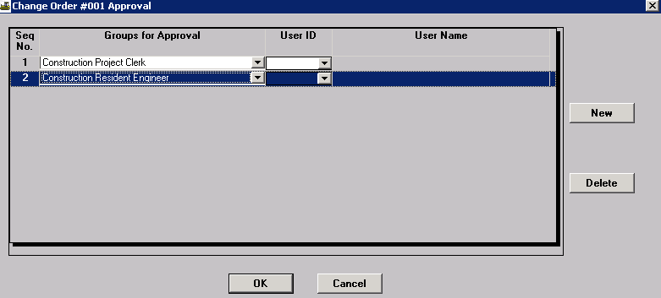

REMINDER: As stated in the third paragraph of this QRG, it will be necessary to add Seq. No. 3 and select "FHWA" from the Groups for Approval drop down if the contract has Federal oversight.

Printing the Change Order
To print the Change Order report, refer to Change Order Reports Quick Reference Guide.

Saving the Change Order
All change orders must be saved in .PDF format to the V: drive in the following path for your district and org code: V:\Contract Information Archive\District # \ ORG # \ Contract ID \Change Orders\Pending. (See Note below.) File name should include the change order number placed within the file name so the change orders will sort properly when listed in the folder. See example below:
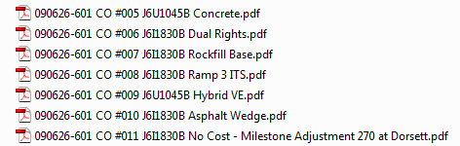

Once the change order has been approved at all levels, it shall be saved with all attachments in a single file to V:\Contract Information Archive\District # \ ORG # \ Contract ID \Change Orders\Completed.
Note: When distributing a change order electronically for signature, it should be stored with all attachments in a single file in the “Completed” change order folder and linked from there. Once the last digital signature is applied, the process is complete. No further action is necessary on the part of the project office, that is, there is no movement of the document from one folder to another.

