JOB SPECIAL PROVISIONS TABLE OF CONTENTS
(Job Special Provisions shall prevail over General Provisions whenever in conflict therewith.)

- General
- Contract Liquidated Damages
- Work Zone Traffic Management Plan
- Supplemental Revisions
- Project Contact for Contractor/Bidder Questions
- Emergency Provisions and Incident Management
- Pilot Car
- Additional Flaggers
- Safety Plan
- Safety Requirements

“THIS MEDIA SHOULD NOT BE CONSIDERED A CERTIFIED DOCUMENT.” | MISSOURI HIGHWAYS AND  TRANSPORTATION COMMISSION  105 W. CAPITOL AVE.  JEFFERSON CITY, MO 65102  Phone 1-888-275-6636
“THIS MEDIA SHOULD NOT BE CONSIDERED A CERTIFIED DOCUMENT.” | If a seal is present on this sheet, JSP’s have been electronically sealed and dated.
“THIS MEDIA SHOULD NOT BE CONSIDERED A CERTIFIED DOCUMENT.” | JOB NUMBER:  COUNTY, MO  DATE PREPARED:
“THIS MEDIA SHOULD NOT BE CONSIDERED A CERTIFIED DOCUMENT.” | ADDENDUM:
Only the following items of the Job Special Provisions (Roadway) are authenticated by this seal:

JOB

SPECIAL PROVISION

A. GENERAL

(To be inserted by Central Office)

B. CONTRACT LIQUIDATED DAMAGES JSP-13-01A

1.0 Description. Liquidated Damages for failure or delay in completing the work on time for this contract shall be in accordance with Sec 108.8. The liquidated damages include separate amounts for road user costs and contract administrative costs incurred by the Commission.

2.0 Period of Performance. Prosecution of work is expected to begin on the date specified below in accordance with Sec 108.2. Regardless of when the work is begun on this contract, all work shall be completed on or before the date specified below. Completion by this date shall be in accordance with the requirements of Sec 108.7.1.

Notice to Proceed: Month XX, 20XX.
Completion Date: Month XX, 20XX.

2.1 Calendar Days. The count of calendar days will begin on the date the contractor starts any construction operations on the project.

Job Number Calendar Days
JXXXXX XX
JXXXXX XX
JXXXXX XX
JXXXXX XX

***(include the underlined language in paragraphs 2.1, 3.0 and 4.0 if both calendar days and a completion date are specified for the project(s))******

3.0 Liquidated Damages for Contract Administrative Costs. Should the contractor fail to complete the work on or before the completion date specified in Section 2.0, or within the number of calendar days specified in Section 2.1, whichever occurs first, the contractor will be charged contract administrative liquidated damages in the amount of $$$ per calendar day for each full calendar day that the work is not fully completed. For projects in combination, these damages will be charged in full for failure to complete one or more projects within the above specified completion date or calendar days.

4.0 Liquidated Damages for Road User Costs. Should the contractor fail to complete the work on or before the completion date specified in Section 2.0, or within the number of calendar days specified in Section 2.1, whichever occurs first, the contractor will be charged road user costs in accordance with Sec 108.8 in the amount specified in Section 4.1. These damages are in addition to the contract administrative damages and any other damages as specified elsewhere in this contract.

4.1 Daily Road User Costs.

Job Number Daily Road User Cost
JXXXXX $ XX
JXXXXX $ XX
JXXXXX $ XX
JXXXXX $ XX

C. WORK ZONE TRAFFIC MANAGEMENT PLAN

1.0 Description. Work zone traffic management shall be in accordance with applicable portions of Division 100 and Division 600 of the Standard Specifications, and specifically as follows.

2.0 Traffic Management Schedule.

2.1 Traffic management schedules shall be submitted to the engineer for review prior to the start of work and prior to any revisions to the traffic management schedule. The traffic management schedule shall include the proposed traffic control measures, hours traffic control will be in place, and work hours.

2.2 Temporary full width road closures up to a maximum of 20 minutes will be allowed on routes with traffic volumes less than 400 ADT. Routes with 400 ADT or more may be considered for temporary closure up to a maximum of 20 minutes if adequate alternate routes are available and approved by the engineer.

2.3 The contractor shall notify the engineer prior to lane closures or shifting traffic onto detours.

2.4 The engineer shall be notified as soon as practical of any postponement due to weather, material or other circumstances.

2.5 In order to ensure minimal traffic interference, the contractor shall schedule lane closures for the absolute minimum amount of time required to complete the work. Lanes shall not be closed until material is available for continuous construction and the contractor is prepared to diligently pursue the work until the closed lane is opened to traffic.

2.6 Traffic Delay. The contractor shall be responsible for maintaining the existing traffic flow through the job site during construction. If disruption of the traffic flow occurs and traffic is backed up in queues of 15 minute delays or longer, then the contractor shall review the construction operations which contributed directly to disruption of the traffic flow and make adjustments to the operations to prevent the queues from occurring again.

3.0 Work Hour Restrictions.

3.1 There are three major summer holiday periods: Memorial Day, Independence Day, and Labor Day. All lanes shall be scheduled to be open to traffic during these holiday periods, from 12:00 noon on the last working day preceding the holiday until 9:00 a.m. on the first working day subsequent to the holiday.

3.2 The contractor shall not perform any construction operation on the active lanes during restricted periods, holiday periods or other special events specified in the contract documents.

3.2 The contractor shall not perform any work between the hours of ½ hour before sunset until ½ hour after sunrise. No night time work will be allowed without submission of an adequate traffic control plan to cover nighttime operations and prior approval by the engineer

4.0 Basis of Payment. No direct payment will be made to the contractor to recover the cost of equipment, labor, materials or time required to fulfill the above provisions, unless specified elsewhere in the contract document.

D. SUPPLEMENTAL REVISIONS

(To be inserted by CO)

E. PROJECT CONTACT FOR CONTRACTOR/BIDDER QUESTIONS JSP-96-05

All questions concerning this project during the bidding process shall be forwarded to the project contact listed below.

________________________, Project Contact
________________________ District
__________________
_________________

Telephone Number __-__-__
e-mail xxxxx@modot.mo.gov
All questions concerning the bid document preparation can be directed to the Central Office – Design at (573) 751-2876.

F. EMERGENCY PROVISIONS AND INCIDENT MANAGEMENT JSP-90-11

1.0 The contractor shall have communication equipment on the construction site or immediate access to other communication systems to request assistance from the police or other emergency agencies for incident management. In case of traffic accidents or the need for police to direct or restore traffic flow through the job site, the contractor shall notify police or other emergency agencies immediately as needed. The area engineer's office shall also be notified when the contractor requests emergency assistance.

2.0 In addition to the 911 emergency telephone number for ambulance, fire or police services, the following agencies may also be notified for accident or emergency situation within the project limits.

Missouri Highway Patrol (XXX-XXX-XXXX)
City of _____________ | City of _____________ | City of _____________
(Fire: XXX-XXX-XXXX | (Fire: XXX-XXX-XXXX | (Fire: XXX-XXX-XXXX
Police: XXX-XXX-XXXX) | Police: XXX-XXX-XXXX) | Police: XXX-XXX-XXXX)
<Add or delete Cities and/or other municipalities as needed>

2.1 This list is not all inclusive. Notification of the need for wrecker or tow truck services will remain the responsibility of the appropriate police agency.

2.2 The contractor shall notify enforcement and emergency agencies before the start of construction to request their cooperation and to provide coordination of services when emergencies arise during the construction at the project site. When the contractor completes this notification with enforcement and emergency agencies, a report shall be furnished to the engineer on the status of incident management.

3.0 No direct pay will be made to the contractor to recover the cost of the communication equipment, labor, materials or time required to fulfill the above provisions.

G. PILOT CAR

1.0 The contractor shall provide a pilot car during construction, as directed by the engineer. Signs for cross roads including state routes, county roads and city streets, and the pilot car shall be provided as shown on the plans and as directed by the engineer.

2.0 Basis of Payment. There will be no direct pay for all labor and equipment necessary to provide the pilot car.

H. ADDITIONAL FLAGGERS (if applicable)

1.0 Additional flagger(s) and appropriate construction signs shall be provided at each of the specified locations when work zone extends through the following intersections and/or approaches:

- XXXXX
- XXXXX
- XXXXX

2.0 Basis of Payment. There will be no direct pay for all labor and equipment necessary to provide additional flaggers. All cost shall be considered completely covered under the pay items provided in the contract.

I. SAFETY PLAN
1.0 Description. This contractor shall submit to the engineer a project Safety Plan (SP) for all work performed by the contractor and all subcontractors. The purpose of the SP is to encourage and enable all work to be performed in the safest possible manner and that all parties involved are aware of their individual responsibility for safety on the jobsite.

1.1 The SP shall be completed by the contractor and provided to the engineer prior to the beginning of any construction activity or phase on the project.

1.2 The contractor shall designate a person to serve as Project Safety Manager (PSM). The PSM shall be responsible for implementing and overseeing the SP. The PSM is not required to be present on the project at all times, but must be available to address safety issues and needs.

1.3 The PSM shall make revisions to the SP as necessary. Any new project activities or phases shall be included in the SP prior to work beginning on that activity or phase.

1.4 An example Safety Plan is available at: www.modot.org/safetyplan

2.0 Emergency Preparedness. The SP shall outline and detail for all workers, the specific procedures and actions necessary to respond to a jobsite emergency and the measures taken to communicate these requirements to all workers.

2.1 The SP shall include a list of local emergency contacts including phone numbers. A copy of the emergency contact list shall be accessible to workers.

2.2 In the case where there is no cellular or land line phone service at the jobsite, the SP shall identify how to reach the nearest available phone service.

3.0 Project Safety Analysis. The SP should contain a basic Project Safety Analysis (PSA) that outlines the actions necessary to complete each activity or phase of the project. The SP shall include a general description of the primary activities or steps required to safely complete the project.

3.1 Each activity should also include a general description of the work involved along with the known risks associated with the activity. In addition the PSA should outline the controls for those risks, including any Personal Protection Equipment (PPE) requirements for that activity or phase, and whether or not the activity or phase requires a specific safety meeting prior to beginning the activity or phase.

3.2 Submittal of the PSA for all activities or phases is not required with the initial submittal of the SP; however, the PSA for each activity or phase shall be completed prior to the beginning of that activity or phase.

4.0 Safety Meetings. The SP shall include the types of safety meetings that will be required of and conducted by the contractor.

5.0 Safety Training. The SP shall identify the required safety training provided to the contractor’s personnel. The contractor shall require that the appropriate safety training for the contractor’s personnel is completed prior to the beginning of work on each activity or phase.

5.1 The SP shall identify the recommended safety training needs and PPE for MoDOT employees who will be exposed to the work activities. MoDOT will provide safety training and PPE to MoDOT employees based on MoDOT safety policies.

6.0 Payment. There will be no direct payment for compliance with this Safety Plan provision.

J. SAFETY REQUIREMENTS

Delete Sec 616.3.1 and substitute the following:

616.3.1 All workers within highway right of way shall wear approved ANSI/ISEA 107 Performance Class 2 or 3 safety apparel and more specifically as follows:

616.3.1.1 Daytime Flagger. During daytime activities, flaggers shall wear a high visibility hard hat, safety glasses, a Performance Class 3 top OR a Performance Class 2 top, and safety footwear. Hard hats other than high visibility orange or green shall be covered with a high visibility covering.

616.3.1.2 Daytime Worker. During daytime activities, workers shall wear a hard hat, safety glasses, a Performance Class 3 top OR a Performance Class 2 top, and safety footwear.

616.3.1.3 Nighttime Flagger. During nighttime activities, flaggers shall wear a high visibility/reflective hard hat, safety glasses, a Performance Class 3 top AND Class E bottoms, OR Performance Class 2 top AND Class E bottoms, and safety footwear. Hard hats shall be reflective or covered with a high visibility covering.

616.3.1.4 Nighttime Worker. During nighttime activities, workers shall wear a hard hat, safety glasses, a Performance Class 3 top OR Performance Class 2 top AND Class E bottoms, and safety footwear.

Note: A graphic representation of the various PPE as described above can be found in the “Additional Information” portion of these provisions. A color representation can be found on the MoDOT website at: http://tinyurl.com/Safe-Apparel.

GRAPHIC REPRESENTATION OF PERSONAL PROTECTIVE EQUIPMENT

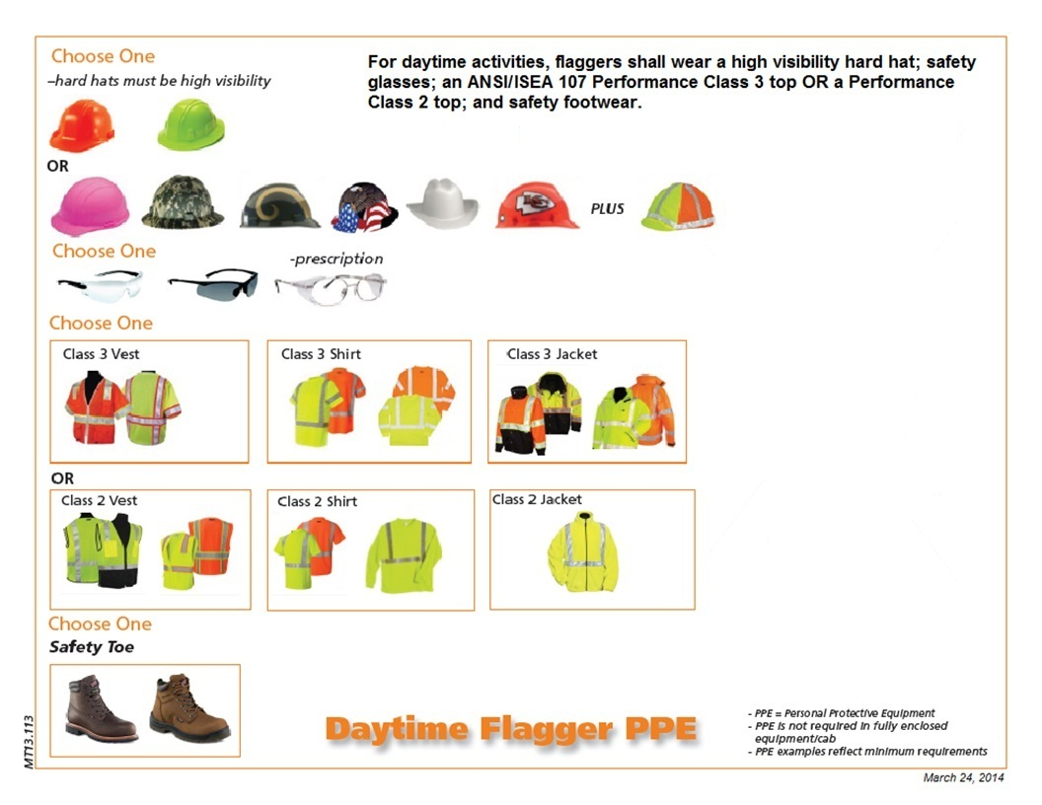
616.3.1.1

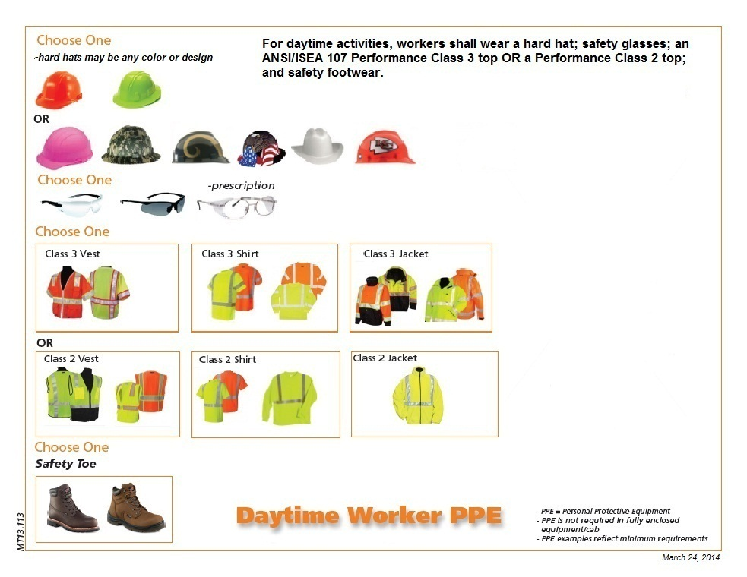
616.3.1.2

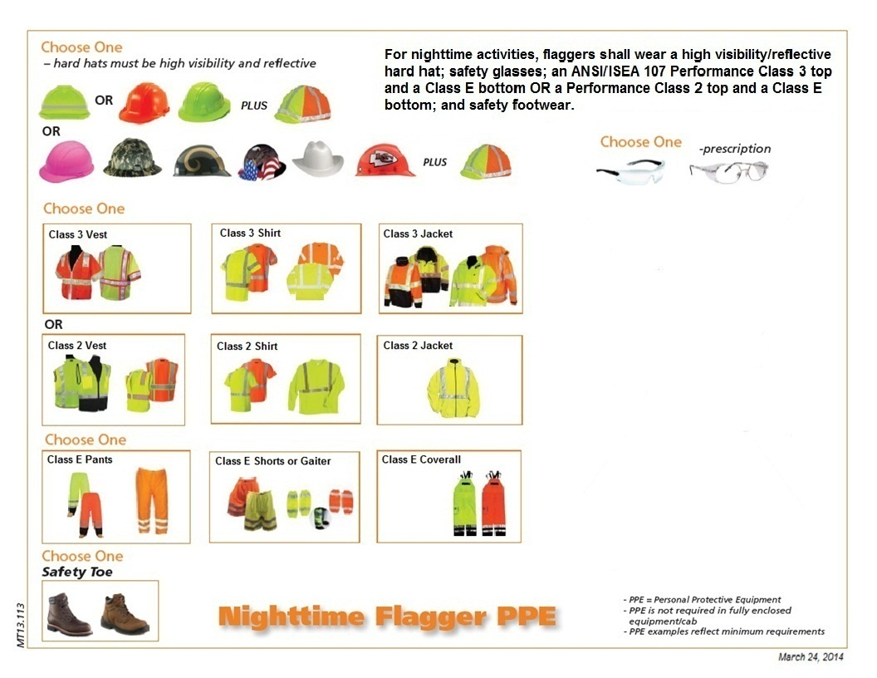
616.3.1.3

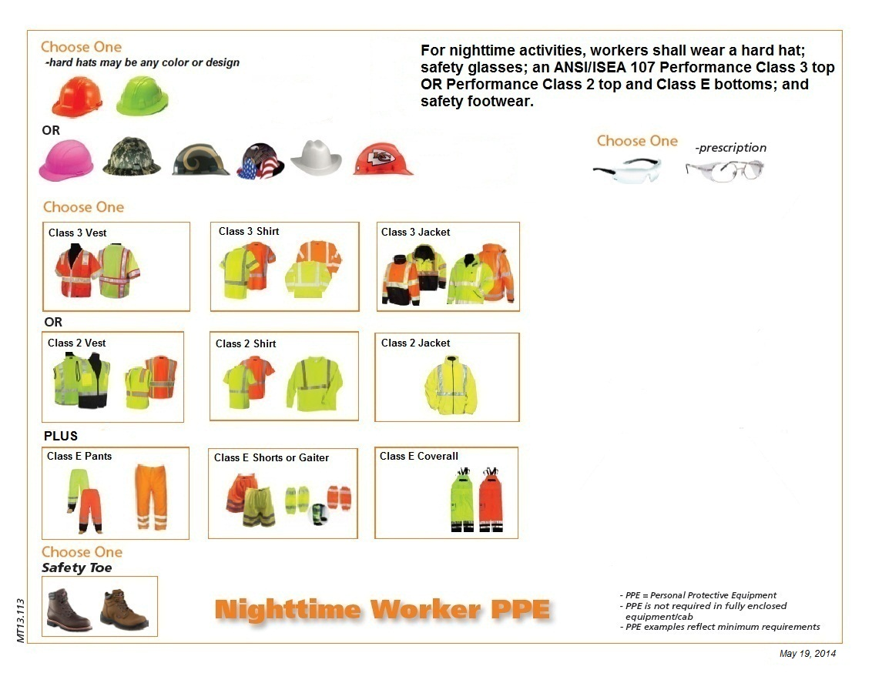
616.3.1.4

