QRG – Concrete Cylinder Sample Sent to Central Lab
A special sample record is required for concrete cylinders submitted to the central lab for 28 day testing. By creating a separate sample record, the field record on the concrete can be completed and authorized while this companion record remains open for editing by the Central Lab when the sample is tested.
Navigate to Materials Management - Sampling and Testing - Sample Information.
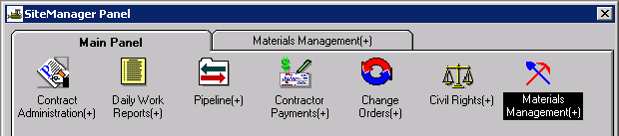

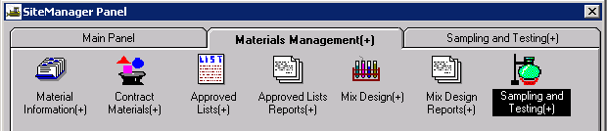

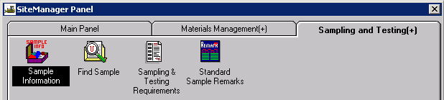

Basic Sample Data Tab:
- Smpl ID = sample id number – it will be unique since this sample is going to the lab. See AS 3510 Automated section for SiteManager Records-Materials Manual
- Status = pending (this goes for all samples going to the lab)
- Smpl Dt = date the sample was taken
- Smpl Type = District Project
- Acpt Meth = Sample and Test
- Material = material code, usually starts with 0501 then search from the list.
- P/S = producer or supplier for this mix – typically a ready mix or paving plant.
- Geog Area = your district
- Intd Use = where the concrete was used ex: bridge number, bent #’s, stations
- Rprsntd Qty = how many cubic yards the cylinders represent. If your pour requires more than 1 set of cylinders, go to the remarks balloon and note this.
- Smpld By (Inspector) = who is submitting this sample? You can type in the userid or search.
- SAVE – Your first tab should look similar to the following example. (The highlighted areas are required.)

Addtl. Sample Data Tab – 5 fields required. See sample below.
1. Smpl Size = 2 (usually) or, however many cylinders you’re sending.
2. Smpld From = pump truck, first truck on jobsite or ready mix truck
3. Smpl Origin = project or jobsite
4. Design Type = PCC
5. Mix ID = the mix number - can be typed in (it must match exactly) or choose from the search window.
6. Save. The Addtl Sample Data Tab should have information similar to this:

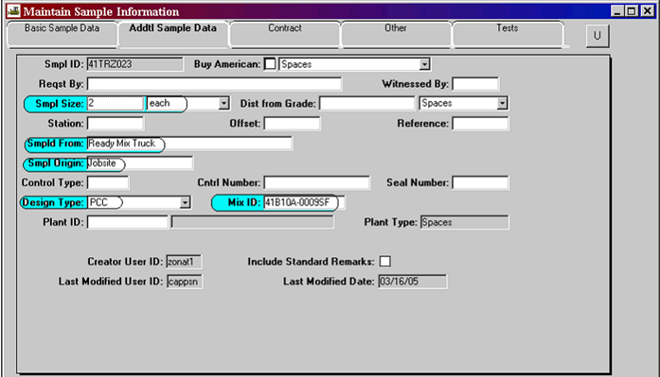

You can click on the white balloon and type in any additional remarks relating to this sample. After typing in the balloon, click someplace in the sample record to save remarks. Then use the save icon again, just to be sure.
Any of the other blocks on this screen can be used – the ones above are required. For example: Plant ID: This will only apply if you have multiple plants with the same name. Usually not used and it will be blank.

Contract Tab
1. Click the new icon and choose the contract from the list.
2. Then choose the line number these cylinders represent.
3. Answer NO to the next message box asking if you’d like to add all lines.
4. The contract and line number should show on this tab. Do not enter a quantity, the plant inspection report will cover the quantity accepted.
5. SAVE
The contract tab will be similar to this: Notice the Represented Qty = 0.
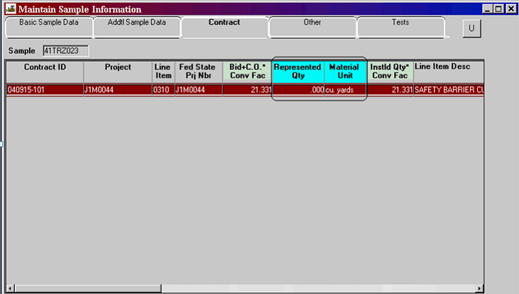

The Other Tab
Use only if this is a non-SiteManager project or a change order is not approved yet. Contact District Materials for instructions.

Tests Tab
Click in the lower portion of this window to add the T22 test method.

1. Test Method = T22 (type in or search) It is case sensitive.
2. Lab ID can be blank – Central lab can fill this in.
3. Start Date = the date the cylinders were made
4. Sample test nbr = 1
5. Estimated Completion Date = date the cylinders should be broke at the Central Lab.
6. SAVE. The first portion of the window will look similar to this:
7. Choose Services from the menu at the top of your screen.
8. Select Enter/View test data
9. This screen has two tabs of its own. The first is Descriptions.
10. Record the Slump – type in the results, choose the proper units and the effective date (specification year if available) from the drop down list. The effective date may be blank.
11. Enter the result from the air test (if it applies) and the effective date if available.
12. Concrete Temperature = enter result if known
13. Water Cement Ratio = Enter cement factor (sacks per cubic yard) or mass (pounds per cubic yard) from the job mix. (Note that these values are not the true water cement ratio, but is information used by the Lab to process the cylinders.
14. SAVE. You should have entered information like this:

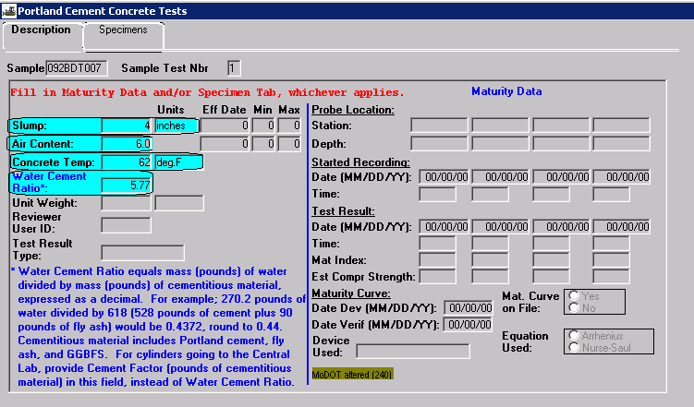
15. Choose the second tab marked Specimens.
16. Enter the cylinder numbers for your cylinders. Hit the new icon to add additional cylinders.
17. SAVE. The Specimens information will look like this:

Note: Shipping Label on the cylinder box – Must be filled out completely. Any additional information you wish to add can be put on the remarks in the SiteManager record. More information is better than not enough!

