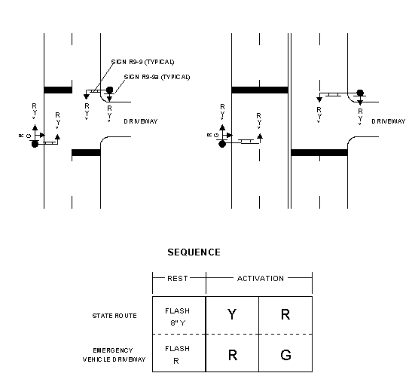

Notes: Timing to be determined by MoDOT personnel.
Center overhead indication over through lane(s).
See Standard Specifications and Standard Plans for design details.

TYPICAL EMERGENCY VEHICLE SIGNAL LAYOUTS

