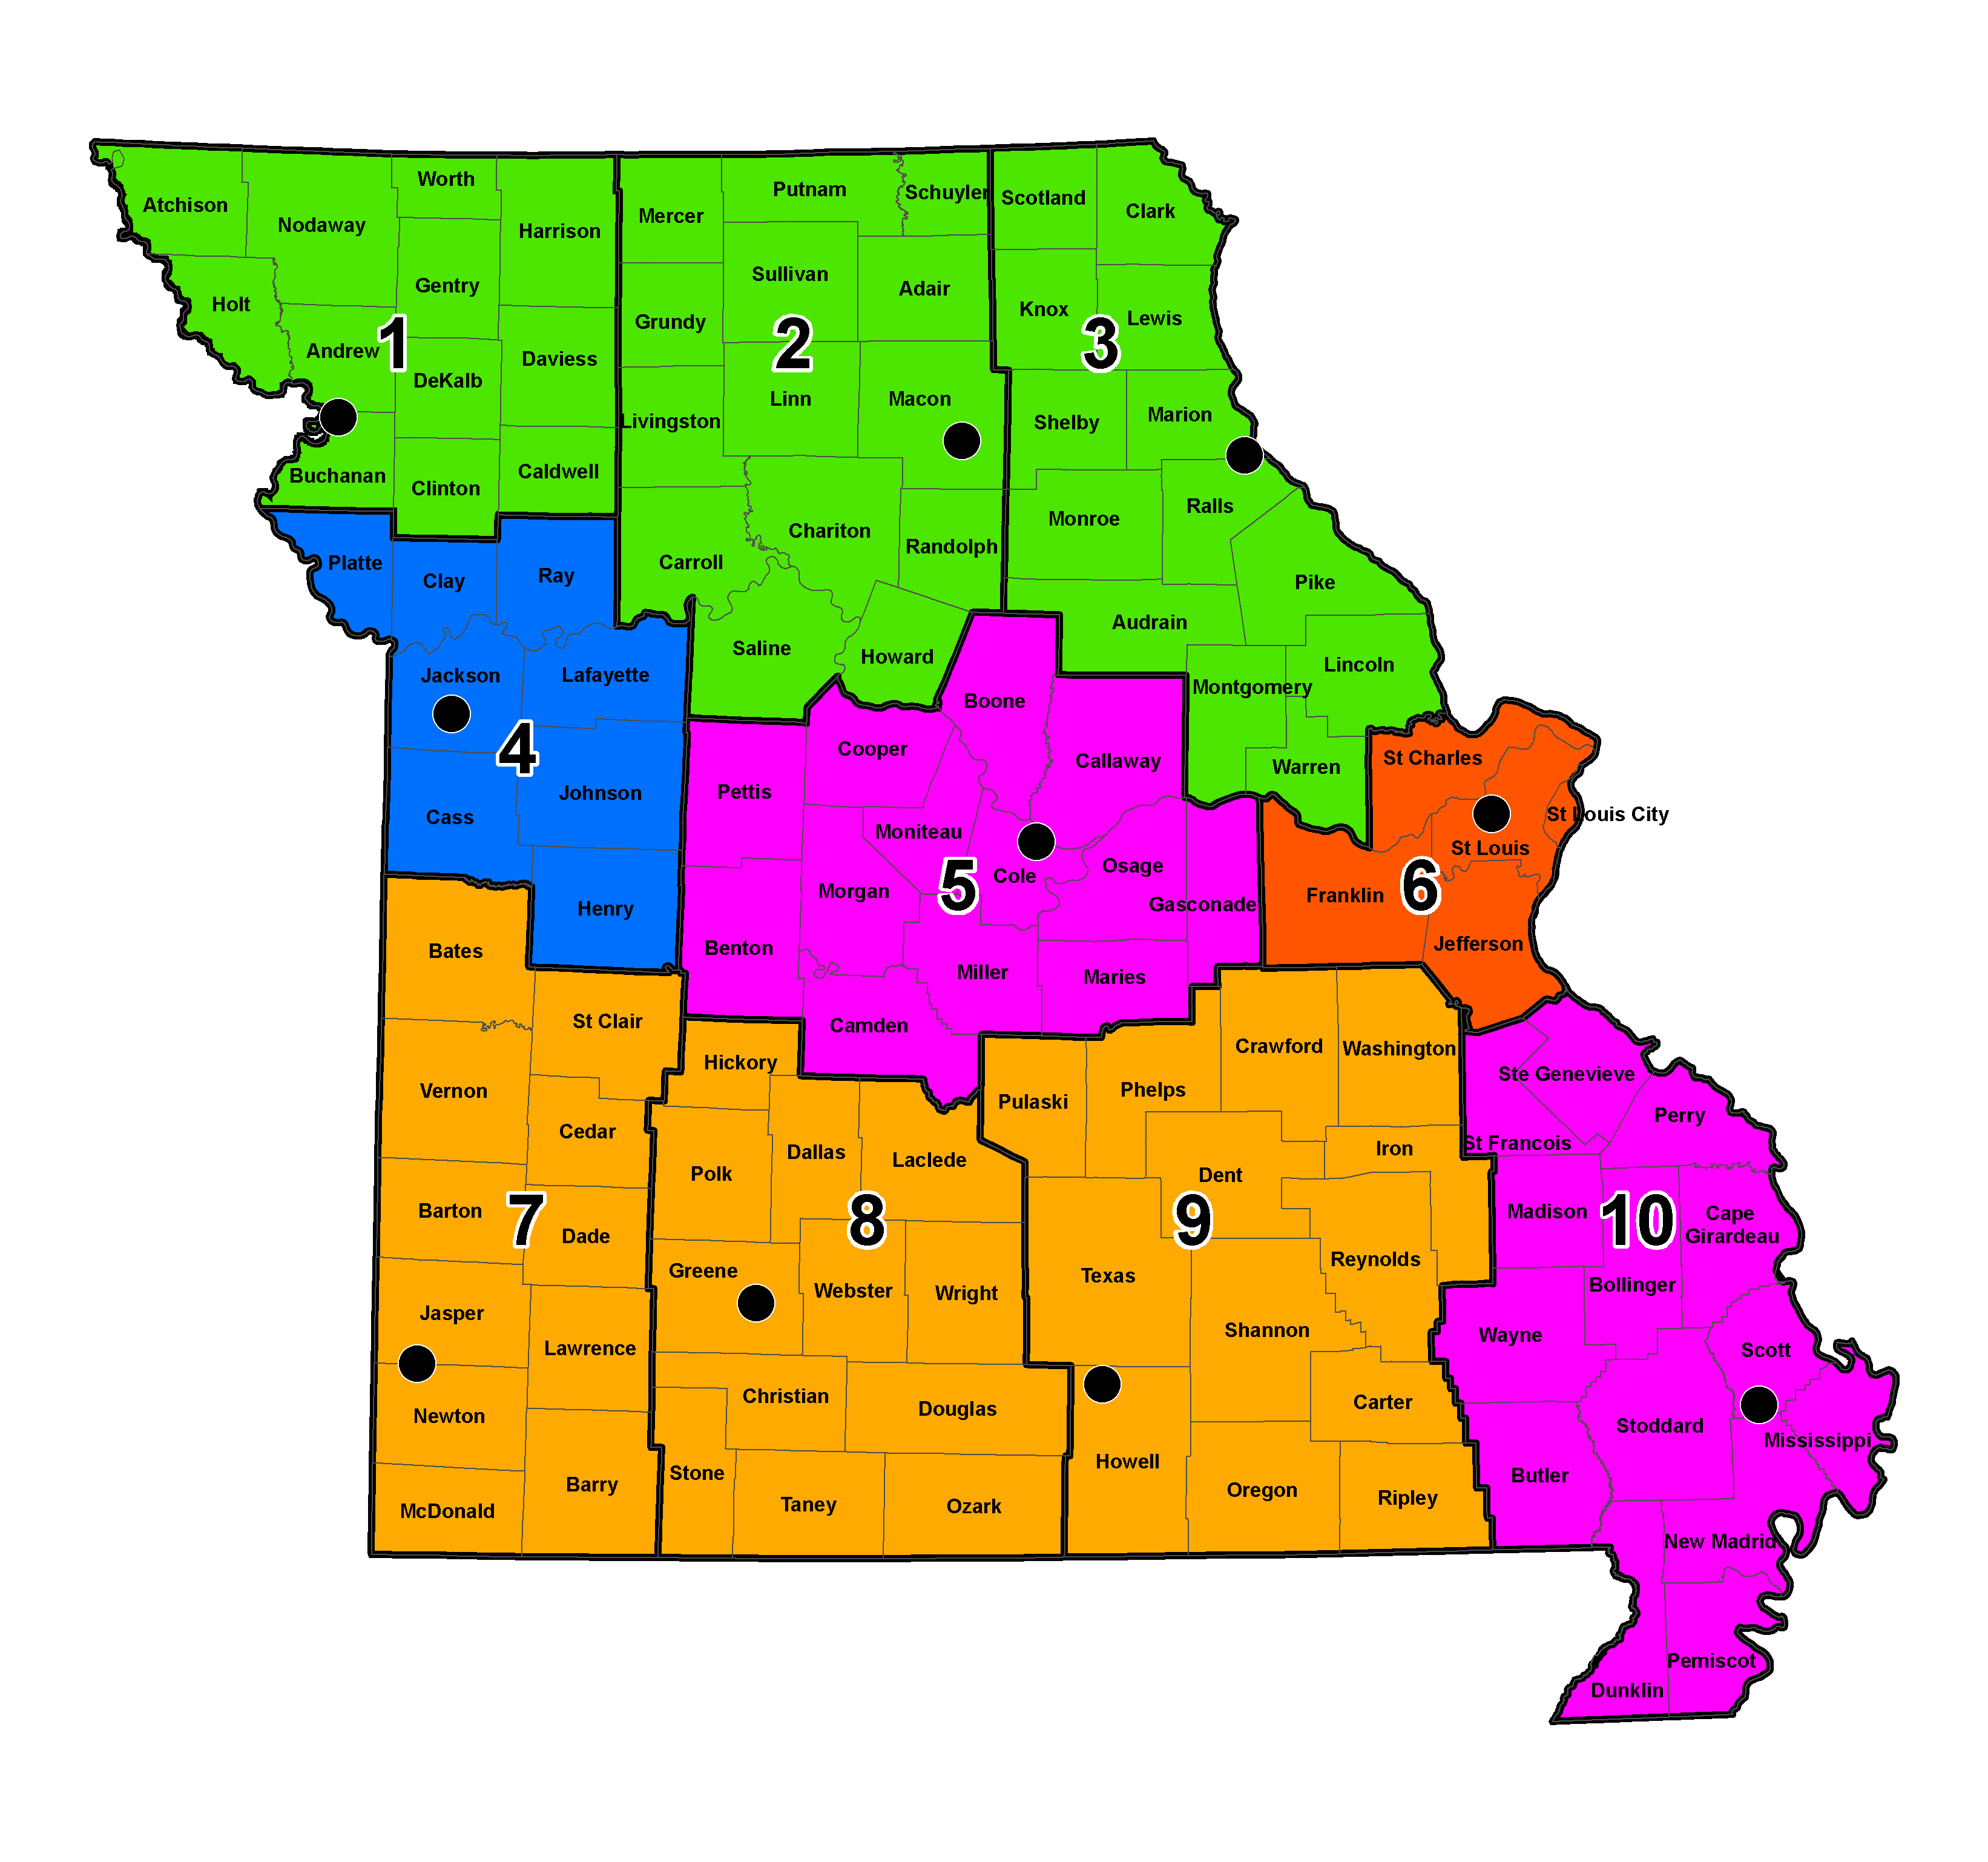
Last updated 7/29/2026

Historic Preservation Staff

Robert L. Reeder
Historic Preservation Manager
573-751-0473

Michael C. Meinkoth
Assistant Historic Preservation Manager
573-526-3593

Mailing Address:
601 W. Main St.
3rd Floor
Jefferson City, MO 65102

FAX: 573-526-1300

Email:
firstname.lastname@modot.mo.gov

District
Title Contact Phone Assignment

Senior Historic Aaron Anglen 573-526-3594
Preservation Specialist Lawrence Ayres 573-526-7836 3,5,7,8,9 & 10
(Archaeologist) James Harcourt 573-526-3562 1,2,4 & 6
Michael Meyer 573-526-3560
Russell Weisman 573-526-3590

Senior Historic Karen Daniels 573-526-7346 3, 4, 6,8,9 & 10
Preservation Specialist Toni Prawl 573-526-3598 1,2,5 & 7
(Architectural Historian)

Senior Historic Randall Dawdy 573-526-3591

Preservation Specialist
(Historic Bridge Coordinator)

Senior Cartographer Sue Olson 573-526-3559 1,2,3,5 & 6
Pamella Schmutzler 573-526-3561 4,7,8,9 & 10

Senior Historic David Austin 573-526-3595 3,6,8,9 & 10
Preservation Specialist Thomas Gubbels 573-522-5554 1,2,4,5 & 7
(Historian)
John (Jack) Eastman 573-526-7905
Larry Grantham 573-522-55571
Intermediate Historic Jane Lee 573-522-9695
Preservation Specialist Brianne Olson 573-526-7908
(Archaeology Assistant) Terrell Martin 573-522-5556
Richard Rahe 573-526-7907
Travis Tesreau 573-526-3592

Historic Preservation Christopher Koenig 573-751-6752
Specialist Ronald Mayer 573-751-5184
(Archaeology Field Assistant) Timothy Porter 573-526-7906

