QRG – Contract Adjustments
Contract adjustments are used when contract General or Special provisions or the Standard Specifications allow for an adjustment to the contract, without creating a change order. Contract adjustments can be system generated or entered by the user. This article is intended to guide the user in the creation of a Contract Adjustment.

Navigate to Contractor Payments – Contract Adjustments - Contract Adjustments.
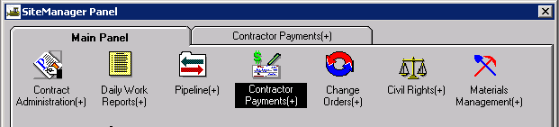
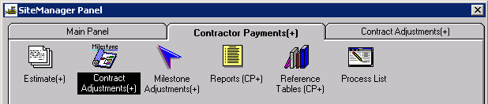
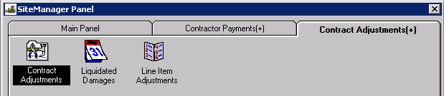

Select the appropriate contract ID from the list from the Authorized Contract List window.
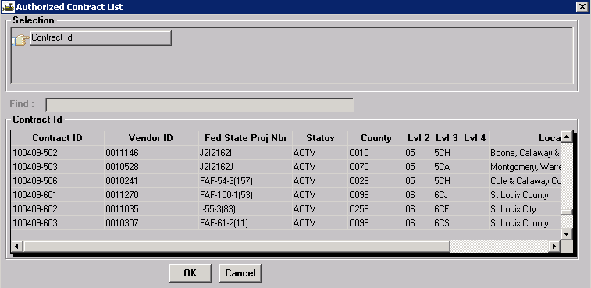
The Contract Adjustment window allows the user to add, modify, or view contract adjustments for all estimates on the contract. The top portion of the window displays all contract adjustments. The bottom portion of the window displays detail information for a selected adjustment. The Project Distribution tab shows what percentage of the contract adjustment is applied to each project on the contract.
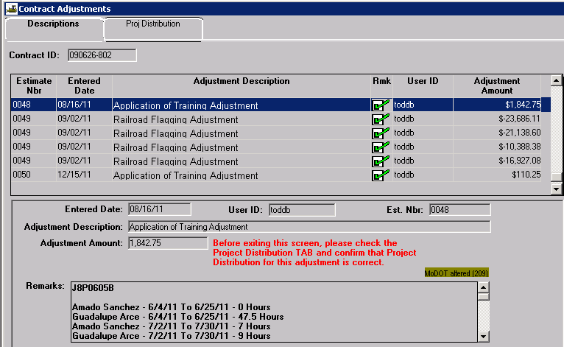
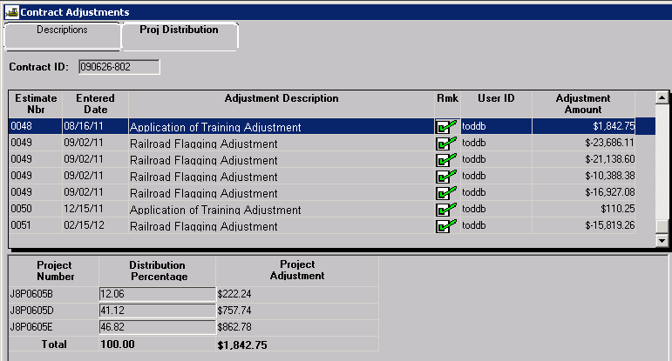
Contract adjustments are created during the estimate generation process. Contract adjustments may be system generated or they can be created by the user. Only First Level Approvers (project manager for Progress estimates) can create these adjustments. System generated contract adjustments can only be viewed.

Creating a User Entered Contract Adjustment
- There must be an existing estimate in “Pending” or “Reject” status in order to create a contract adjustment. Users may also view all contract adjustments for any estimate from this window.
- Open the Contract Adjustments window.
- Select the New icon .
- Select the appropriate adjustment type from the Adjustment Description drop down.
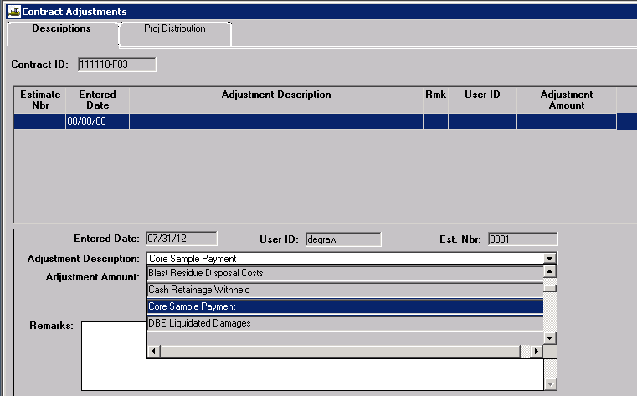
- Enter the appropriate dollar amount in the Adjustment Amount field.
- Enter the reason and/or documentation for the adjustment in the Remarks field. Include references to Special Provisions/Specifications, locations, calculations, etc.
- Select the Save icon.
- Always select the Project Distribution tab, and verify percentages are correct for each project.
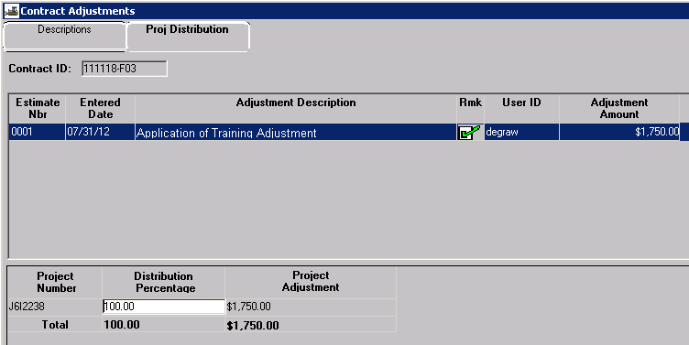
Total Distribution Percentage must equal 100%.

Types of Contract Adjustments used at MoDOT
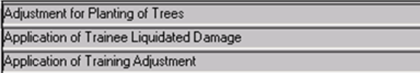
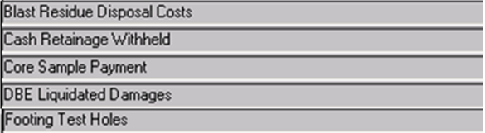
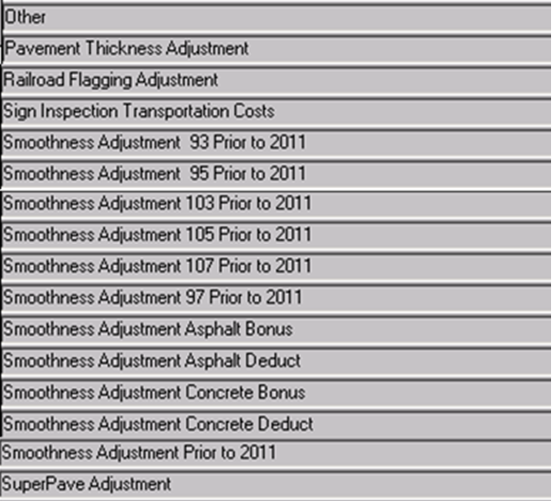
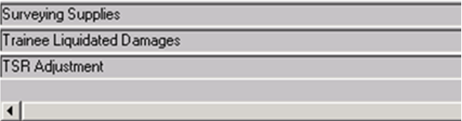

The “Other” adjustment type is used only for special circumstances. DO NOT select “Other” unless directed to do so by the System Administrator or by SM Policy.
Please refer to the SuperPave Adjustment QRG for information on how to determine the dollar value of this type of adjustment.

Important: Although system generated Liquidated Damage Adjustments are visible in the Contract Adjustments window, DO NOT attempt to reverse liquidated damages from this window. Always use the Liquidated Damages icon!
