

Stormwater Pollution Prevention Plan

January 2012

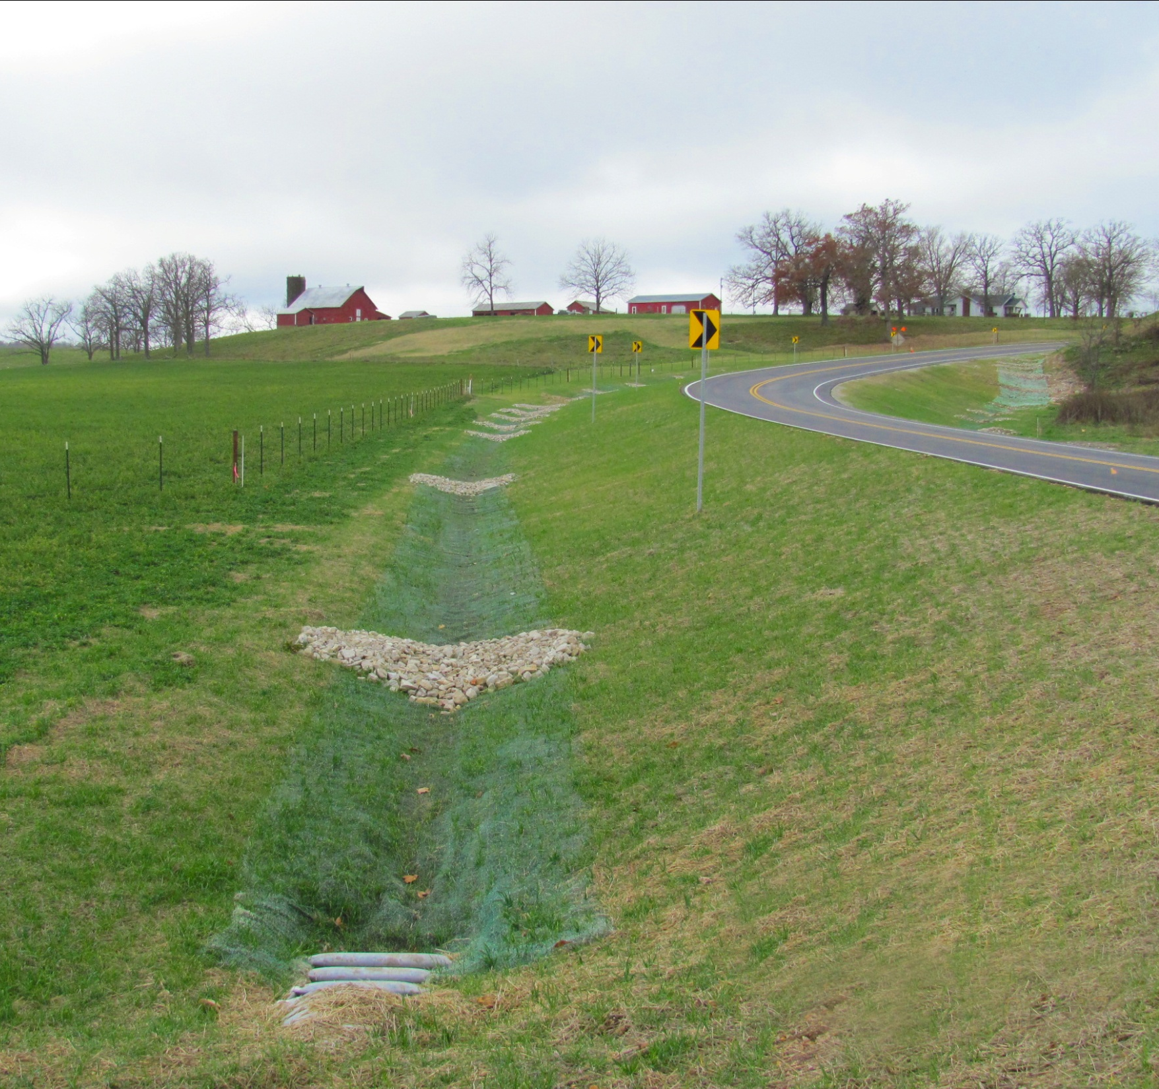

806.8.1. Introduction to the Stormwater Permit and SWPPP 7
806.8.2. Site Description 8
806.8.3. Drainage Areas & HOusekeeping 8
806.8.4. Erosion and Sediment Control 10
806.8.4.1. Construction Requirements 10
806.8.4.2. Non-Structural Control Measures 12
806.8.4.3. Erosion Control Measures 12
806.8.4.3.1. Soil Surface Roughening 13
806.8.4.3.2. Mulching and Crimping 13
806.8.4.3.3. Temporary Berms — Erosion Control 13
806.8.4.3.4. Temporary Pipe Slope Drains 14
806.8.4.3.5. Interception Ditches & Letdown Structures (Including Roadside & Median Ditches) 14
806.8.4.3.6. Temporary Pipes & Temporary Construction Crossings 15
806.8.4.3.7. Energy Dissipaters 15
806.8.4.3.8.1. Temporary Seeding and Mulching 16
806.8.4.3.8.2. Permanent Seeding and Mulching 16
806.8.4.3.9. Fiber Reinforced Matrix (FRM) 16
806.8.4.3.10. Erosion Control Blankets & Turf Reinforcement Mats 17
806.8.4.4. Sediment Control Measures 18
806.8.4.4.1. Sediment Basin 18
806.8.4.4.2. Sediment Trap 19
806.8.4.4.3. Ditch Checks 20
806.8.4.4.4. Silt Fence 21
806.8.4.4.5. Inlet Controls 22
806.8.4.4.6. Temporary Berms — Sediment Control 23
806.8.4.4.7. Compost Filter Berms (Mulch Berms Included) 24
806.8.4.4.8. Brush Pile Checks/Barriers 24
806.8.4.4.9. Straw Bales 25
806.8.5. Disturbed Areas 25
806.8.6. Installation & Removal 26
806.8.7. Dewatering 26
806.8.8. Roadways 27
806.8.9. Amending/Updating the Project Plans 27
806.8.10. Site Inspections and Reports 28
806.8.11. Diamond Grinding & Other Surface Treatments 28
806.8.12. Concrete Washout 29
806.8.13. Turbidity Removal & Advanced Treatment Systems 29

Form 806.8.10 - MoDot land disturbance inspection record 31
FIG. 806.8.1 - (Modot/contractor responsibility guidance) 36
FIG. 806.8.4.1 - (Contiguous/non-contiguous visual reference) 40
FIG. 806.8.9 - (Example Erosion/sediment control site maps) 44
FIG. 806.8.14 - (example mdnr swppp evaluation form) 48
FIG. 806.8.15 - (Imhoff cone & turbidity tube testing procedures) 52

806.8.1 Introduction to the Stormwater Permit and SWPPP

Provisions of the federal Clean Water Act and related state rules and regulations require stormwater permits where construction activities disturb greater than one acre over the life of a project as part of a common plan or sale. MoDOT has a general State Operating Permit, obtained from the Missouri Department of Natural Resources (DNR), which allows for land disturbance activities associated with highway, bridge and compensatory mitigation construction as well as maintenance activities related to the upkeep of these features. The permit stipulates that MoDOT will follow certain erosion and sediment control guidelines and install temporary and permanent erosion and sediment control measures. Locally sponsored federal aid projects that are performed on MoDOT right of way and are using MoDOT’s land disturbance permit are required to comply with MoDOT Standard Specifications, and therefore, must follow this Stormwater Pollution Prevention Plan (SWPPP). When working adjacent to MoDOT right of way, cities, counties and other government entities may already possess their own State Operating Permit and, in that case, must comply with their own SWPPP.

There are instances where contractors may have to obtain their own permits for work involving borrow and excess (waste) disposal areas, and when portable batch plants are used. (See Fig. 806.8.1 for details about the permitting requirements of these scenarios.) Also, in a few rare cases, MoDOT may require contractors to obtain their own individual State Operating Permit for land disturbance activities even though the project is being constructed on MoDOT right of way. These unique situations will normally be Design/Build projects that are funded by MoDOT, but totally managed by the contractor. MoDOT will coordinate with DNR whenever one of these Design/Build projects commences.

The purpose of the SWPPP is to ensure the design, implementation, management and maintenance of Best Management Practices (BMPs) reduce the amount of sediment and other pollutants in stormwater discharges associated with the land disturbance activities, comply with the Missouri Water Quality Standards, and ensure compliance with the terms and conditions of the general permit.

The following documents were used in the preparation of this SWPPP:

- Best Management Practices for Erosion and Sediment Control, (Report No. FHWA-FLP-94-005) published by the United States Department of Transportation (1995)
- Stormwater Management for Construction Activities: Developing Pollution Prevention Plans and Best Management Practices, (Document number EPA 832-R-92-005) published by the United States Environmental Protection Agency (1992).
- Protecting Water Quality: A field guide to erosion, sediment and stormwater best management practices for development sites in Missouri.
- Missouri Standard Specifications for Highway Construction (most recent edition)
- Missouri Department of Transportation Engineering Policy Guide
- Menu of BMPs – United States Environmental Protection Agency –
(http://cfpub.epa.gov/npdes/stormwater/menuofbmps/index.cfm?action=min_measure&min_measure_id=4)

A typical MoDOT project involves the implementation of many documents, processes, and standard operating procedures. These various processes and procedures are of such detail that it is impossible to include in this brief summary of BMPs. Pollution from stormwater can be reduced by the implementation of the BMPs, construction techniques, and site management measures that are articulated in this document. However, pollution from stormwater will also be reduced by the issuance of Change Orders, Letters/Memos of Notification, Order Records and Contractor Performance Reports. Changes that occur as a result of directives to contractors will usually be documented by Document Records and other various products and reports produced by a computer program called Site Manager. Lastly, a Semi-Final Inspection Report can serve to identify post-construction measures that will ensure permit compliance and water quality protection.

In addition to these contract management tools, MoDOT conducts annual stormwater permit compliance training for construction site inspectors, resident engineers, designers and other personnel, including contractors and consultants. The information distributed in this class goes above and beyond the scope of this Statewide SWPPP document. Many effective BMPs and construction techniques are discussed during this training, but may not yet appear in this document.

These and other unique MoDOT tools must be considered elements of a SWPPP because they all result in implementation of measures that cause or caused a resultant action to occur on a construction project.

806.8.2 Site Description
EPG 237.1 Plan Details describes the information that is to be included in all plans that are used by contractors to construct MoDOT projects. All projects are constructed from a set of design plans that are generated by MoDOT designers or consultants. The plans show all existing topographic features, buildings, roadways and drainages, as well as right of way limits.
The plans contain sufficient information to be of practical use to contractors and site construction workers to guide the installation of BMPs in the interim and final stages of construction. Site plans are always on location at active MoDOT job sites, usually in the possession of MoDOT’s construction inspector or the contractor superintendent. In the early stages of construction these plans will usually include hand written notes showing the locations of temporary and in some cases, permanent BMPs.
Contract plans shall include erosion and sediment control measures that are sufficient to protect streams, lakes, wetlands and private land adjacent to MoDOT right of way, and the location of most of these controls will be depicted on the plan sheets. The exact location of the controls that are shown on plan sheets will be determined in the field by the engineer or inspector. Temporary erosion control measures shall be coordinated with permanent erosion control measures to assure economical, effective and continuous erosion control. Construction of permanent erosion control measures that may contribute to the control of siltation, shall be accomplished at the earliest practicable time.

806.8.3 Drainage Areas & HOusekeeping

In compliance with the Missouri Clean Water Law (Section 644.051), neither MoDOT nor MoDOT's contractors shall pollute any waters of the state, or place, cause, or permit to be placed, any water contaminant in a location where it is reasonably certain to cause pollution of any waters of the state. To comply with this law, proper preventive measures and good housekeeping shall be maintained on job sites. Job site litter, construction debris and sanitary waste should be controlled. All litter shall be placed in appropriate containment receptacles. The use of portable toilets may be necessary to control sanitary waste in some situations. If used, these facilities shall be adequately placed and maintained so as not to cause a safety or environmental concern. If hazardous waste is generated or encountered on a job site, the MoDOT Environmental Section, (573) 526-4778, should be informed immediately to assure proper handling and compliance with environmental regulations. Also, neither MoDOT nor MoDOT's contractors shall discharge water contaminants into any waters of the state, which reduce the quality of these waters below the state's water quality standards. These water quality standards include the following (MO 10 CSR 20-7):

(a) Waters shall be free from substances in sufficient amounts to cause the formation of putrescent, unsightly or harmful bottom deposits or prevent full maintenance of beneficial uses.

(b) Waters shall be free from oil, scum and floating debris in sufficient amounts to be unsightly or prevent full maintenance of beneficial uses.

(c) Waters shall be free from substances in sufficient amounts to cause unsightly color or turbidity, offensive odor or prevent full maintenance of beneficial uses.

(d) Waters shall be free from substances or conditions in sufficient amounts to result in toxicity to human, animal or aquatic life.

(e) Waters shall be free from physical, chemical or hydrologic changes that would impair the natural biological community.

(f) Waters shall be free from used tires, car bodies, appliances, demolition debris, used vehicles or equipment and solid waste as defined in Missouri’s Solid Waste Law, Section 260.200, RSMo, except as the use of such materials is specifically permitted pursuant to Section 260.200–260.247.

MoDOT personnel or contractors hired by MoDOT shall comply with these and any other federal, state, and local laws and regulations controlling pollution of the environment. To ensure that these general criteria are met, the following guidelines will be observed:

1) Machinery shall be kept out of the waterway as much as possible.

2) Fuel, lubricants, debris and other water contaminants shall not be stored in areas that are subject to contact with water (such as adjacent to stream banks) or where contaminated runoff from the storage areas can enter waters.

3) Refueling and maintenance (e.g., oil changing) of machinery shall not take place in, or directly alongside, any water body.

4) Clearing of vegetation/trees shall be kept to the minimum required to accomplish the activity.

5) Riparian areas and banks shall be restored to a stable condition through recontouring and revegetation of the area, as necessary, as soon as possible (normally within three working days of final contouring).

6) Work shall be conducted during low flow whenever possible.

7) Wetland areas shall be avoided to the extent practical.

8) Work shall conform to all conditions that are part of the USACOE Section 404 permit and the ancillary MDNR Section 401 Water Quality Certification.

EPG 127.19 Section 404 Clean Water Act for Bridge Demolitions provides a detailed explanation of the process that is followed whenever a stream or drainage channel may fall into USACE jurisdiction.

806.8.4 Erosion and Sediment Control
(MO Specifications Division 800)

Water pollution control measures shall be required of all contractors MoDOT hires. The contractor shall exercise best management practices throughout the project to control water pollution. Construction of permanent drainage facilities and other activities, which may contribute to the control of siltation, shall be accomplished at the earliest practicable time. This work shall consist of furnishing, installing, maintaining, and removing temporary control measures as shown on the plans (see MoDOT Standard Plan 806.10) or as ordered by the engineer. The control of water pollution will be accomplished through the use of berms, slope drains, ditch checks, sediment basins, energy dissipaters, seeding and mulching, silt fences, and other erosion and sediment control devices or methods. Pollutants such as chemicals, fuels, lubricants, bitumens, raw sewage, or other harmful materials shall not be discharged from the project. No work shall be started until the erosion control timetable and methods of operation have been approved.

Temporary control measures shall be coordinated with permanent control measures to assure economical, effective and continuous erosion and sediment control. Temporary erosion and sediment controls must be kept in place and maintained until revegetation, rock blanketing, paving, or another form of stabilization has occurred to an extent sufficient to prohibit the formation of gullies by runoff.

Materials required for erosion control measures shall meet the standards of the following Missouri Standard Specifications for Highway Construction sections:

Section
Lime and Fertilizer 801
Mulching 802
Seeding 805
Geotextile Construction and Geotextile 624 & 1011

806.8.4.1 Construction Requirements

The engineer may limit the surface area of erodible earth material exposed by clearing and grubbing, or excavation, borrow, and fill operations, and may direct the contractor to provide immediate permanent or temporary erosion control measures to prevent contamination of adjacent streams or other watercourses, wetlands, lakes, ponds, and other water impoundments. Such work may involve the construction of temporary berms, dikes, dams, sediment basins, slope drains, and the use of temporary seeding and mulching, or other erosion and sediment control devices or methods as necessary.

The contractor shall be required to incorporate all permanent erosion control measures into the project at the earliest practicable time. Temporary erosion and sediment control measures shall be used to correct conditions that develop during construction which were not foreseen during the design stage. Temporary controls shall also be used when needed prior to installation of permanent erosion control measures or when needed temporarily to control erosion that develops during normal construction practices, but are not associated with permanent control measures on the project.

When practical, clearing and grubbing operations shall be scheduled and performed so that border, perimeter, or outlet BMPs to control runoff from disturbed areas will be installed or marked for preservation before general site clearing. A limited amount of clearing (enough to gain access to the area) may be permissible to enable the installation of outlet and perimeter controls. Stormwater discharges from disturbed areas, which leave the site, shall pass through an appropriate impediment (BMP) prior to leaving the site. The surface area of erodible earth material exposed at one time by clearing and grubbing, by excavating, by fill, or by borrow, shall be minimized to limit runoff. The engineer may limit the total acreage of erodible earth material to be exposed at one time as determined by an analysis of project conditions. In such cases the engineer will identify specific BMPs and controls that have been, or will be installed in order to exceed the specified maximum disturbed acreage threshold.

The engineer will limit the area of clearing and grubbing, excavation, borrow, and embankment operations in progress commensurate with the contractor's ability to keep the finish grading, mulching, seeding, and other erosion control measures current. Should seasonal limitations make such coordination unrealistic, temporary erosion control measures shall be implemented as directed by the engineer.

Unless otherwise approved, construction operations in rivers, streams, wetlands, and impoundments shall be restricted to those areas which must be entered for the construction of temporary or permanent structures. Rivers, streams, wetlands, and impoundments shall be promptly cleared of all falsework, piling, debris or other obstructions placed therein or caused by the construction operations.

Frequent fording of live streams or wetlands with construction equipment is not permitted. Temporary bridges or other structures shall be used wherever an appreciable number of stream crossings are necessary. All temporary fills and structures placed in streams, wetlands, or impoundments will be removed and the site returned to natural or intended contours prior to completion of construction. Unless otherwise approved, mechanized equipment shall not be operated in live streams except as may be required to construct channel changes and temporary or permanent structures. If a Section 404 permit is applicable for a project, its requirements and/or conditions shall be followed.

Site-specific erosion and sediment controls above and beyond MoDOT standard specifications shall be discussed with the contractor at a preconstruction conference. Special conditions may be developed which can include limitations on the amount of surface area that can remain unprotected at one time or special water quality or stream protections requirements.

The location of all local material pits (other than commercially operated sources) and all excess material areas shall be subject to the approval of the engineer (material in this case refers to soil and rock). Construction operations shall be conducted and pollution control measures implemented so that erosion will not result in water pollution.

Concrete batch plants that are located on MoDOT right of way are not covered under the MoDOT State Operating Permit. Operators of concrete batch plants that are located on or off of MoDOT right of way will be responsible for obtaining all appropriate permits directly from the DNR.

With respect to the State Operating Permit requirements, borrow and excess (waste) disposal sites located immediately contiguous with MoDOT right of way or owned by MoDOT can be covered by this permit. For borrow and excess disposal activities not located on or contiguous with MoDOT right of way, the borrow or excess disposal operator will be responsible for obtaining all appropriate permits, including a land disturbance permit directly from the DNR for sites greater than one acre. For a visual reference of what may qualify as a contiguous borrow or excess disposal area, please see Fig. 806.8.4.1.

In the event of a conflict between these requirements and pollution control laws, rules, or regulations of other federal, state, or local agencies, the more restrictive laws, rules, or regulations shall apply.

806.8.4.2 Non-Structural Control Measures

Protection of existing vegetation is an important component of erosion and sediment control. Prior to commencement of grading, design plans will show areas that are to remain undisturbed. Maintaining natural vegetation in certain areas during construction serves to reduce sediment from sheet flow, and slow the flow of water that travels through the area. These areas of excess right-of-way provide the same benefit to water quality as would many types of structural controls such as sediment basins or sediment traps. Deposited material may or may not be removed from the area of excess right of way depending on MoDOT's future plans for the area.

Vegetated filter strips along the shoulder, or within the median of MoDOT highways serve as excellent sediment capture devices particularly in areas where the density of grass and other herbaceous vegetation can filter the water. In most cases vegetative filter strips (permanent vegetative cover) are used in concert with other BMPs (such as silt fence). However, there may be unique situations where vegetative filter strips can suffice as standalone features. If vegetated filter strips are used, they must be located within MoDOT right of way or easement; vegetation on an adjacent property cannot be used as a MoDOT BMP.

Other Non-Structural BMPs such as seeding, mulching, stabilized construction entrances, flocculants and chemical additives are discussed elsewhere in this document.

806.8.4.3 Erosion Control Measures
(MO Specifications - Special Provisions)

Best management practices shall be used by contractors to assure that eroded sediment from MoDOT right of way does not migrate off MoDOT property and onto adjacent land or into streams and drainage channels.

The following are commonly used erosion control BMPs that may be used individually or in combination with other practices, such as the sediment control devices discussed in EPG 806.8.4.4 Sediment Control Measures, to assure effective erosion control and prevent off site delivery of pollutants. Other practices that are not listed here, or have not been identified or invented at the time of the preparation of this SWPPP, may be used if their performance is equivalent or better than the practices listed below.

806.8.4.3.1 Soil Surface Roughening

Surface roughening is a temporary erosion control BMP that will reduce runoff velocity and erosion potential by increasing infiltration and sediment trapping. This practice is intended for areas which have been cleared and grubbed and are awaiting application of temporary or permanent seed, or installation of other structural controls such as ditch checks, sediment traps, or sediment basins. The practice is NOT intended to serve as a stand-alone best management practice and is only to be used as a short-term (2-3 weeks), sequential practice as the grading and seeding proceeds.

Where backslopes are unlikely to be mowed or maintained due to steepness and lack of access, surface roughening can be a permanent measure. In these situations seed and mulch may be applied directly to the roughened seed bed. This will aid in the establishment of vegetative cover and will minimize destructive compaction by heavy equipment. There are three common methods of surface roughening (tracking, grooving, stair stepping) that can be employed depending on the soil type, slope and potential maintenance concerns for the project.

- Tracking involves the use of tracked construction equipment (dozer, high lift, etc.) vertically tracking up and down slopes in order to create horizontal depressions, perpendicular to the runoff path, on the soil surface. These depressions reduce stormwater velocity and the potential for concentrated runoff, which typically leads to rill formation. Tracking can lead to significant soil compaction, which does help lock soil particles in place; however, it is also undesirable for root production and grass growth. Due to this fact, care should be taken in deciding which slopes to track. Tracking is typically recommended for sandy soils, where risk of excessive compaction is reduced.

- Grooving involves the creation of a series of ridges and depressions that run along the contour of a slope. The grooves can be created using a variety of implements such as a disks, harrows, chisel plows, loader teeth, etc. The grooves should be no more than 3 inches deep and no more than 15 inches apart.

- Stair-stepping involves creating stair steps to reduce runoff velocity and encourage sedimentation on steeper slopes that will not be mowed. The stairs should be cut such that the vertical step does not exceed 1 foot. The horizontal step should be longer than the vertical step and sloped inward toward the vertical step face to promote sedimentation.

806.8.4.3.2 Mulching and Crimping

Application of mulch without seed may be used as a temporary best management practice if approved by the engineer. This temporary stabilization practice is most applicable in late fall or early winter when grass seed would have little or no opportunity to germinate. Straw mulch should be applied with a mulch blower, or by hand, and must be anchored (crimped) immediately after spreading to prevent windblow. Application rates will vary based on the percent slope. Bark mulch and/or wood chips do not require crimping. The engineer will determine whether or not the wood chip mulch may remain in place, be cultivated or be modified for permanent seeding.

806.8.4.3.3 Temporary Berms — Erosion Control

A temporary berm is a temporary ridge of compacted soil, with or without a shallow ditch, constructed at the top of fill slopes or transverse to centerline on fills. The purpose of these ridges is to divert storm runoff from small areas away from steep slopes and direct this water to temporary outlets where the water can be discharged with minimum slope erosion. These ridges are used temporarily at the top of newly constructed slopes to prevent excessive erosion until permanent controls are installed and/or slopes are stabilized. They are also used transverse to grade to divert runoff to stabilized slope drains. Weekly (and post-rainfall) monitoring will be necessary to identify breeches in all temporary berms used as BMPs.

Type A Berms for erosion control may be specified for use at the end of each day’s operations on embankments to divert stormwater away from project slopes and toward stabilized drop down structures/pipes or stormwater detention areas, sediment capture devices, etc. They will be constructed to specified dimensions (see MoDOT Standard Plan 806.10) and machine compacted with a minimum of one pass over the entire width of the berm with a dozer tread, grader wheel, etc. Type A Berms can be used until grading operations cease and final contours are achieved. Removal will usually occur just before the application of seed and mulch or other soil stabilization measures.

Type B Berms are constructed on the top of fill slopes and are intended to direct runoff water into a temporary slope drain. These temporary diversion structures are specified when embankment operations are shut down over extended periods of time (i.e., winter), and will be constructed to specified dimensions (see MoDOT Standard Plan 806.10). The top width of these berms may be wider and the side slopes flatter on transverse berms to allow equipment to pass over these berms with minimal disruption. Operation and maintenance concerns are limited to ensuring that the majority of runoff water is directed into the inlet of the slope drain. Removal of Type B Berms will normally occur when base rock is installed, prior to paving.

806.8.4.3.4 Temporary Pipe Slope Drains

A temporary pipe slope drain (see MoDOT Standard Plan 806.10) is used to carry water down slopes to reduce erosion and may consist of half-round pipe, metal pipe, plastic pipe, or flexible rubber pipe. Temporary slope drains are usually required on fill slopes at approximately 500-foot intervals or as directed by the engineer. These structures are installed after the fill slope has reached its intended elevation and final grade.

All temporary slope drains will be adequately anchored to the slope to prevent disruption by the force of the water flowing in these drains. The inlet end will be properly constructed to channel water into the temporary drain. The outlet ends will usually have some means of dissipating the energy of the water to reduce erosion downstream. Where scour at the outlet is of lesser concern due to the physical characteristics of the ditch there shall still be sediment capture devices in the ditch or drainage outlet downgrade from the slope drain outlet. Unless otherwise specified, all temporary slope drains will be removed when no longer necessary due to the slopes being stabilized or the routing of runoff down permanent letdown structures. Upon removal of temporary slope drains, the site will be restored to match the surroundings.

806.8.4.3.5 Interception Ditches & Letdown Structures (Including Roadside & Median Ditches)

Interception ditches and letdown structures are typically permanent erosion control BMPs that capture stormwater run-on or runoff and transport it down slopes through stabilized channels. These channels are typically constructed in a “V”, “U”, or trapezoidal shape to concentrate water flow down the center of the structure in order to minimize the risk of break over points and flanking. They are typically lined with stone (riprap), erosion control blankets, turf reinforcement mats, or other product which is self-adjusting and capable of withstanding concentrated, erosive flows. In some instances, these ditches and letdowns may be constructed as concrete or asphalt gutters; however, these types of rigid channel liners do not allow for water infiltration and more often than not, do not have built-in energy dissipation, which can exacerbate erosion at their outlets. In addition, due to their rigid nature, concrete and asphalt-lined drainage courses often undermine and experience section loss, which leads to system failure. There are alternative BMP technologies available (ScourStopTM, FlexamatTM, etc.) that give a degree of rigidity, if desired, to help armor the channel, or a portion of the channel more susceptible to erosion, while still allowing permeability for vegetative growth and water infiltration, as well as self-adjustment to prevent system failure.

When designing and implementing interception ditches and letdowns, as well as roadside and median ditches, it is important to take into consideration drainage area, soil type, slope and ditch shape in order to determine if the shear stresses within the ditch will be of a high enough value to warrant a liner beyond just vegetative cover. Depending on the location of the ditch, driver safety must also be taken into consideration when choosing an appropriate ditch liner.

806.8.4.3.6 Temporary Pipes & Temporary Construction Crossings

A temporary pipe is a conduit used temporarily to carry water under a haul road, silt fence, etc. Temporary pipes should be installed in the same manner as permanent pipe is installed on the project to assure that the water does not cause erosion around the pipe. If applicable, material to backfill the pipe should be placed in six-inch lifts and mechanically compacted, although a compaction test is not required. As additional erosion protection, temporary pipes can also be used to collect site run-on and covey it across disturbed areas on the job. Care should be taken to assure the outlet of the temporary pipe is stabilized and adequate energy dissipation is available so as to not cause erosion of the receiving area.

Temporary pipes can also be used to convey normal and expected high flows at temporary stream crossings, preventing the contractor's equipment from coming into direct contact with the water when crossing active streams as discussed in EPG 806.8.4.1 (Construction Requirements). Any temporary structures used to facilitate construction (e.g. temporary crossings, temporary work pads) will be constructed of clean rock fill that is of sufficient size to be non-erodible under normal stream flow and also easily recoverable upon project completion. Temporary stream crossings will be sufficiently piped to allow for continuous and relatively unimpounded stream flow. The pipes will be placed to match the existing stream grade, which will allow for unimpeded aquatic life passage through the project area. Upon project completion, any temporary structure(s), including pipes and other materials, shall be completely removed and the area will be restored and stabilized. (Note: Temporary stream crossings can act as conduits for sediment to make its way to streams, because they usually cause a gap in perimeter BMPs along streambanks. If possible, stormwater runoff should be diverted away from these structures; otherwise other BMPs must be employed to adequately protect the waterbody.)

806.8.4.3.7 Energy Dissipaters

An energy dissipater is a physical structure that is intended to reduce the erosive energy that is typically encountered down grade from a pipe or culvert. As such, these BMPs are normally permanent. Erosive energy from intense flows may also be encountered in median ditches or road ditches. Energy dissipation may be accomplished by the installation of large boulders, wood pilings, engineered concrete structures or other means approved by the engineer, following construction of the ultimate drainage channel or device. Unlike ditch checks and rock dams, energy dissipaters are NOT intended to impound water and sediment. Energy dissipaters must be constructed in a fashion such that the water that flows through, over or around the structure is equally distributed in the discharge channel and does not exacerbate or cause a resultant erosion problem.

806.8.4.3.8.1 Temporary Seeding and Mulching
(MO Specifications Sections 802 & 805)

This work shall consist of preparing and fertilizing a seedbed, furnishing and sowing of seed, and mulching. The purpose of temporary seeding and mulching is to produce a quick ground cover to reduce erosion in disturbed areas that are expected to be redisturbed at a later date.

Seeding and/or mulching will be a continuous operation on all cut and fill slopes, waste sites, and borrow areas during the construction process. Designated, disturbed areas shall be seeded and mulched when and where necessary to eliminate erosion. In designated areas seeding and/or mulching shall be done as soon as possible after completion of the earthwork, not to exceed 14 days (7 days on slopes steeper than 3:1), weather permitting.

Temporary mulch placed over temporary seed mixtures shall be applied in accordance with the provisions of Sec 802.2.1 of the Missouri Standard Specifications. Fertilizer shall be applied at the rate specified for permanent seeding. Lime will usually not be required for temporary seeding but will be applied according to governing specifications when a permanent seed mixture is used.

806.8.4.3.8.2 Permanent Seeding and Mulching
(MO Specifications Sec 805)

Permanent seeding and mulching following the temporary seeding will be performed according to the Missouri Standard Specifications Sec 805 and will be permitted during the favorable seeding seasons only.

806.8.4.3.9 Fiber Reinforced Matrix (FRM)

Fiber Reinforced Matrix (FRM) is a hydraulically applied (spray-on) erosion control product that bonds to, and blankets bare soil. According to manufacturers, FRMs lock in moisture and nutrients to promote seed germination. Since these products are applied through spray-on application, they can conform to the contours of a slope and therefore can be applied to rough seedbeds. These products can be applied to all soil types on any slope and can be used in place of any of the erosion control blankets (ECBs) discussed in EPG 806.8.4.3.10 below. However, these products are only to be used as slope protection, and are not designed to withstand concentrated flows within ditches, drainages or streams. It is important when using these products to apply them according manufacturer’s specifications and to assure there is complete surface coverage on the affected area to prevent potential failure due to improper application. Manufacturer recommended application rates are summarized in the table below. Examples of FRMs include products such as Flexterra® Flexible Growth MediumTM, EcoFlexTM and Flex Guard®.

Slope Condition | Application Rate (lbs/Acre)
< 3H:1V | 3000
> 3H:1V and < 2H:1V | 3500
>2H:1V and < 1H:1V | 4000
>1H:1V | 4500
To ensure product quality and performance, all FRMs must meet the following specifications:

Table 1: Minimum FRM Performance and Physical Requirements Property |  | Required Value
Thermally Processed Fiber by Weight |  | 75% ± 10%
100% bio-degradable Crimped Interlocking Fibers |  | 5% ± 2%
Cross-linked Hydro-Colloidal Polymer Tackifiers and Activators |  | 10% ± 2%
Moisture Content |  | 10% ± 3%
Organic Matter |  | 90% minimum
Color |  | Colored to contrast application area, shall not stain concrete or painted surfaces.
FRM Property | Test Method | Required Value
Physical
Mass Per Unit Area | ASTM D6566* | 12.0 oz/yd2 minimum
Thickness | ASTM D6525* | 0.22 inch minimum
Ground Cover | ASTM D6567* | 99% minimum
Wet Bond Strength | ASTM D6818* | 9 lb/ft
Water Holding Capacity | ASTM D7367 | 1500 % minimum
Flexural Rigidity (wet) | ASTM D6575* | 5 oz-yd maximum
Endurance
Functional Longevity | ASTM D5338 | Minimum of 12 months
Performance
Cover Factor | MoDOT Approved Large Scale Testing | 0.01 maximum
% Effectiveness | MoDOT Approved Large Scale Testing | 99% minimum
Cure time | MoDOT Approved Large Scale Testing | 98% Effective 2 hours after application
Vegetation Establishment | ASTM D7322* | 800% minimum
Environmental
Ecotoxicity | EPA 2021.0 | 96-hr LC50 > 100%
Effluent Turbidity | MoDOT Approved Large Scale Testing** | 100 NTU Maximum
Biodegradability | ASTM D5338 | 100% Minimum

806.8.4.3.10 Erosion Control Blankets & Turf Reinforcement Mats

Erosion control blankets, erosion stabilization mats, and turf reinforcement mats are designed to reinforce vegetation. The added reinforcement allows the vegetation to withstand higher flow velocities and can be an alternative to rip rap applications.

Erosion control blankets are typically used to prevent sheet, rill, or gully erosion. As such they may be used on slope areas with concentrated flow or in channels. Since both Erosion Stabilization Mats and Blankets have a life expectancy (longevity) they are considered to be "temporary" erosion control measures.

Slopes should be stabilized as soon as possible after grading work is completed. Erosion control blankets or turf reinforcement mats should be considered for most slopes steeper than 3:1; depending on soil types. Protecting slopes from erosion requires several actions that must be taken together. No single approach will be successful, especially if the slope is long, steep, or has highly erodible soils.

Mats and blankets will be installed as soon as possible after final grading. Removal is not necessary or required seeing as how the material will decay and or break down on its own.

Prior to installation of blankets or mats the ground should be smooth, with no large rocks, vegetation or rills on the surface. Areas where blankets are to be used shall be properly prepared with topsoil or soil conditioning, and fertilized if required, and seeded before blankets are placed. The blankets shall be placed smoothly but loosely on the soil surface without stretching. Blankets at the top of the slope should be trenched in beyond the crest of the slope so as to avoid undercutting. Blankets and mats should be inspected at the same frequency as all other erosion control items. Malfunctions must be repaired in a timely manner or else slope shaping, grading and reinstallation will be required.

Products meeting the requirements outlined within the tables below each have their own physical description that can be obtained from the manufacturer. Providing the physical description of all ECBs or TRMs would be unnecessary and redundant for the purposes of this SWPPP.

Guidelines for Erosion Control Blankets (ECBs)
MoDOT  ECB Type | Netting | Longevity | Slopes | Soils
Type 1 | Single Net, Quickly Degradable | 45 – 60 Days | 3:1 or Flatter | Clay
Type 2 | Single Photodegradable Net | 12 Months | 3:1 or Flatter | Sandy
Type 3 | Double Photodegradable Net | 12 – 18 Months | 2:1 or Flatter | Clay
Type 4 | Double Photodegradable Net | 24 Months | 2:1 or Flatter | Sandy
Type 5 | Double Photodegradable Net | 36 Months | 1:1 or Flatter | Any

Guidelines for Turf Reinforcement Mats (TRMs)
Type 1 Turf Reinforcement Mat
• Channels: Calculated Shear Stresses of 3.5 lbs/ft2 to 6 lbs/ft2
Type 2 Turf Reinforcement Mat
• Channels: Calculated Shear Stresses of 6.1 lbs/ft2 to 8 lbs/ft2
Type 3 Turf Reinforcement Mat
• Channels: Calculated Shear Stresses of 8.1 lbs/ft2 to 10 lbs/ft2
Type 4 Turf Reinforcement Mat
• Channels: Calculated Shear Stresses of 10.1 lbs/ft2 to 14 lbs/ft2
(Note: Use Erosion Control Blanket for Calculated Shear Stresses up to 3.5 lbs/ft2 and use Turf Reinforcement Mat for Calculated Shear Stresses of 3.5 lbs/ft2 or greater.)

MoDOT has an approved products list (APL), which includes erosion, sediment and stormwater management BMPs. At this time, this list has not been authorized for public use, but MoDOT personnel can access this internal list to find qualified ECBs and TRMs for each of the category types described in the tables above. Additional products may be added to the APL by contacting the MODOT Construction and Materials Research Section at (573) 526-4316 and submitting appropriate evaluation material from the Erosion Control Technology Council (http://www.ectc.org).

Products that have been approved by the Texas Transportation Institute (TTI) are also preapproved. A listing of these may be found at
http://www.txdot.gov/business/doing_business/product_evaluation/erosion_control.htm

806.8.4.4 Sediment Control Measures

806.8.4.4.1 Sediment Basin

A sediment basin is a large sediment capturing device that can be constructed through excavation, or by constructing a dam across a low drainage swale. Sediment basins can be temporary or permanent. Both permanent and temporary basins, with expected prolonged use, should be constructed with rock riprap placed in inlet and outlet areas with defined side slopes (see MoDOT Standard Plan 806.10). Temporary sediment basins intended for short-term use do not have to be constructed according to the MoDOT standard plan, but will always have stabilized outlets. Sediment basins are constructed to trap and store sediment from erodible areas in order to protect properties and stream channels below the installation from excessive siltation. These structures trap and store sediment that occurs in spite of temporary erosion control measures.

Sediment basins are required (unless infeasible due to site constraints) when large disturbed areas (>10 acres) concentrate flow to one discharge point, but they should be considered for any disturbed area, 5 acres or greater, which drains to one discharge point. The area where a sediment basin is to be constructed shall be cleared of vegetation to enable removal of sediment. The inlets of these sediment basins shall be constructed with a wide cross-section and minimum grade to prevent turbulence and allow deposition of the soil particles. When the depth of sediment reaches 1/3 of the depth of the structure in any part of the pool, all accumulation shall be removed. Discharges from the basin shall not cause scouring of the receiving area or stream.

The location of sediment basins will be shown on the plans. Sediment basins will be of sufficient size to contain a volume of at least 3,600 cubic feet per each acre of disturbed area which enters the basin. Where the use of a sediment basin of sufficient size as described above is impractical, other similarly effective BMPs or system of BMPs must be employed to prevent sediment from leaving MoDOT right of way.

Sediment basins shall be installed at the time of clearing and grubbing, and will normally remain in service until all disturbed areas draining into the structure have been satisfactorily stabilized. Once vegetative or other stabilization is achieved, the engineer will determine whether the sediment basin is to remain as a permanent feature. When use of the sediment basins is to be discontinued, all excavations are to be backfilled and properly compacted, fill material removed, and the existing ground restored to its natural or intended condition.

When accumulated sediment is removed from individual BMPs, the excavated material shall be disposed of in locations where sediment will not again erode into the construction areas or into natural waterways.

806.8.4.4.2 Sediment Trap

A sediment trap is a temporary sediment collection structure that is used for sediment control purposes. If properly maintained, the life expectancy of these structures can be approximately 2 years. When practical, sediment traps should be installed prior to land disturbance activities. In situations where long-term maintenance issues are absent, and permanent vegetation has established, sediment traps may be left in place as a permanent structure as long as there is no threat to the natural or human environment.

Sediment traps may be constructed of rock (as in the MODOT Standard Drawing) or other non-erodible material sufficient to temporarily impound water, or may be a simple excavated pit. They are usually placed down grade of a drainage structure or ditch outlet to prevent sediment from leaving MoDOT right of way. Sediment traps may also be constructed by placing a rigid, blocking structure (wood, steel, concrete) across the inlet or upstream opening of a pipe or culvert. This device can be referred to as a culvert block sediment trap (CBST). When using this device, heavy sediment particles will settle in front of the structure and clearer water will pass over the device and through the pipe.

Around larger, more permanent streams, sediment traps should be placed parallel to the stream at each ditch outlet. They will be in place prior to clearing and grubbing operations and shall remain in place until adequate stabilization to prevent erosion (vegetative cover, rock, concrete, etc.) is established upgrade of the structures.

Sediment traps may be dewatered through a single riser pipe, over a stabilized spillway (rock-lined, lined with erosion control blanket or turf reinforcement matting, vegetated), or, where applicable, allowed to filter through the interstices of a constructed rock barrier.

The location of sediment traps will be shown on the inspector's site plans. Accumulated sediment shall be removed from the trap when sediment has accumulated to 1/2 the height of the structure, or if an excavated pit, 1/2 of the original depth. Accumulated sediment removed from the sediment traps shall be disposed of in locations where sediment will not again erode into the construction areas or into natural waterways. Discharges from the sediment trap shall not cause scouring of the receiving area or banks or bottom of the receiving stream.

Traditional rock sediment traps will be constructed in accordance with Standard Plan 806.10 and Standard Specification 806.60. Estimated quantities for each trap located on the project will be shown to the nearest cubic yard.

806.8.4.4.3 Ditch Checks

There are two types of ditch checks that can be used – Type I and Type II. These sediment control structures are used when the road ditch has been "cut" to its final dimensions, before the application of seed and mulch.

Type I Ditch Checks may be used where drainage areas are 1 acre or less, ditch slopes are 2 percent or less and expected ditch flow volumes are small (see MoDOT Standard Plan 806.10). These thresholds may be exceeded at the approval of the engineer in emergency situations where appropriate materials are unavailable or weather conditions prohibit installation of more desirable structures.

Type II Ditch Checks are specified where drainage areas are 50 acres or less, ditch slopes are 10 percent or less, and expected ditch flow volumes are high (see MoDOT Standard Plan 806.10). For scenarios that exceed the criteria established above, a combination of Type II ditch checks and erosion control blankets (ECBs) or turf reinforcement mats (TRMs) are utilized. (Note: ECBs or TRMs may be designed into and utilized in any ditch or drainage regardless of the criteria outlined in this article.)

Type I and II ditch checks shall be placed and constructed according to the plans shown in the Standard Plans for Highway Construction, Section 800. In some cases local conditions may dictate some deviation from the dimensions and shape that are shown in the Standard Plans; however, deviations from Standard Plans must still ensure that sediment capture is occurring.

Ditch checks shall be checked for sediment accumulation after each significant rainfall. Sediment shall be removed when it reaches 1/2 of the original height, or before. Sediment removal will include removal and disposition in a location where it will not erode into construction areas or watercourses. Regular inspections shall be made to ensure that the center of the check is lower than the edges. This will ensure that water overflow will be directed into the middle of the roadway ditch. Erosion caused by high flows around the edges of the ditch check shall be identified in routine inspections and shall be corrected so as to protect backslopes and inslopes.

Type I Ditch Checks are temporary measures and include the following devices:
Geotextile Silt Fence (staked)
Straw Bales (staked)
Dura Check Sediment Control Panel®
Compost Filter Berms (< 2’(H) x 4’(W))
Fiber Rolls, Straw Wattles, Sediment Logs, Landlok BioLog, Compost Filter Socks (Filtrexx Ditch Chexx, Channel Soxx, Silt Soxx) – (embedded and staked and > 6” in diameter if NOT used in combination with ECBs or TRMs as a channel liner beneath)

Type II Ditch Checks include the following devices:
Rock Ditch Checks
Sand Bags
Triangular Silt Dike®
EnviroBerm® Porous Sediment Control System (In combo with ECB or TRM)
GeoRidge/GeoRidge Biodegradable (Nilex) (In combo with ECB or TRM)
Compost Filter Berms (2’(H) x 4’(W))

Fiber Rolls, Straw Wattles, Sediment Logs, Landlok BioLog, Compost Filter Socks (Filtrexx Ditch Chexx, Channel Soxx, Silt Soxx) – (staked & > 8” in diameter if used in combination with ECBs or TRMs as a channel liner beneath)

Each type of ditch check (particularly the tubular/cylindrical/triangular products) will have specific directions for installation. In all cases care shall be exercised so as to install the device according to manufacturer specifications. Effectiveness may be compromised if not installed correctly.

Ditch checks shall remain in place until the engineer directs that they be removed once adequate stabilization (vegetative cover, rock, concrete, etc.) upgrade of the structures has been achieved. Upon removal, the contractor shall remove and dispose of any excess silt accumulations, grade and dress the area to the satisfaction of the engineer, and establish stabilization on all bare areas. In rare cases, rock ditch checks may remain in place permanently, and resultant accumulated sediment shall be allowed to develop vegetative cover as a permanent feature of the right of way. Similarly, biodegradable structures and their accumulated sediment may be allowed to remain in place if the engineer determines that removal will destabilize the ditch.

806.8.4.4.4 Silt Fence
(MO Specifications Sections 624 & 1011)

Use of a silt fence consists of furnishing, installing, maintaining, and removing a geotextile barrier fence designed to remove suspended particles from water passing through the fence. Silt fence is a temporary sediment control measure. Materials used for silt fences must meet certain requirements.

There are several construction requirements for silt fences. Fence construction shall be adequate to handle the stress from hydraulic and sediment loading. Geotextile at the bottom of the fence shall be buried. The trench shall be backfilled and the soil compacted over the geotextile. The geotextile shall be spliced together as indicated on the standard drawings (see MoDOT Standard Plan 806.10).

As a general rule silt fence should not be used around median inlets.

Post spacing shall not exceed 8 feet for wire support fence installations or 5 feet for self-supported installations. Posts shall be driven a minimum of 24 inches into the ground. Where rock is encountered, posts shall be installed in a manner approved by the engineer. Closer spacing, greater embedment depth and/or wider posts shall be used as necessary in low areas and soft or swampy ground to ensure adequate resistance to applied loads.

When support fence is used, the mesh shall be fastened securely to the up-slope side of the post. The mesh shall extend into the trench a minimum of 2 inches and extend a maximum of 36 inches above the original ground surface. When self-supported fence is used, the geotextile shall be securely fastened to fence posts.

When silt fence is used as a perimeter sediment control device it must be installed at the time of clearing and grubbing, and must be maintained for as long as necessary to contain sediment runoff. All silt fences shall be inspected as part of MODOT’s routine inspections and at least daily during prolonged rainfall. Any deficiencies shall be corrected within seven days following the engineer's notification to the contractor.

In addition, a daily review of the location of silt fences should be made in areas where construction activities have changed the natural contour and drainage runoff to ensure that the silt fences are properly located for effectiveness. Where deficiencies exist, additional silt fences shall be installed as approved or directed by the engineer.

Sediment deposits shall be removed and disposed of when the deposit approaches 1/2 the height of the fence or sooner. If required by heavy sediment loading, a second silt fence shall be installed as directed by the engineer. Installation of a second silt fence will normally preclude sediment cleanout or repair to the original silt fence. In such cases the damaged silt fence will be removed at project close out when other temporary BMPs are removed.

The silt fence shall remain in place until areas that drain to the fencing are stabilized and the engineer directs that it be removed. Upon removal, the contractor shall remove and dispose of any excess silt accumulations, grade and dress the area to the satisfaction of the engineer, and establish vegetation on all bare areas. Biodegradable silt fence (such as some of the products shown below) need not be removed. If the engineer determines that silt fence shall remain in place for a period of time after the job is closed out, arrangements will be made by MoDOT Construction personnel for the contractor or MoDOT Maintenance personnel to remove the fence once the area is sufficiently stabilized.

The engineer may substitute perimeter silt fence by any of the following commercial (and in the case of compost filter berms) non-commercial products.
Sediment STOP (North American Green)
Terra-Tubes (Profile Products)
Straw Wattles (Earth-Savers)
Compost Filter Socks/Berms
Triangular Silt Dike
Curlex Sediment Logs, Curlex Straw Wattles (American Excelsior)

806.8.4.4.5 Inlet Controls

Storm drain (median or curb) inlet protection measures prevent soil and debris from entering storm drain inlets. Temporary inlet protection is implemented at existing inlets prior to land disturbance, and new inlets are protected and as they are brought on-line. Effective storm drain inlet protection must be provided throughout the project until all sources with potential for discharging to an inlet have been paved or stabilized. At that time inlet controls can be removed.

As the conditions or operations change during a project, the sediment control BMP protecting the storm drain inlet may need to be modified to ensure proper effectiveness for sediment capture. Limiting the amount of sediment entering a storm sewer will reduce the need to clean out pipes at the end of the project.

The following items are considered “prequalified” for use as inlet protection:
Rock Ditch Checks
Sand Bags
Triangular Silt Dike®
Fiber Rolls, Straw Wattles, Sediment Logs
Compost Filter Socks
Filtrexx Ditch Chexx, Channel Soxx, Silt Soxx
Compost Filter Berms
Landlok BioLog
Big Red Curb Inlet Protector
Silt Saver Inlet Filter
Dandy Products (Bag, Sack, Pop, Curb, Curb Bag, Curb Sack)
Wooden, steel or other barricades

(Note: Item selection may vary depending on the type and design of inlet to be protected.)

Each type of inlet control device (particularly the tubular/cylindrical/triangular products) will have specific directions for installation. In all cases care shall be exercised so as to install the device according to manufacturer specifications. Effectiveness may be compromised if not installed correctly.

During construction, elevated curb inlets and median inlets, as well as excavations around inlets, may serve as "riser pipes" as long as they are sufficiently higher than the existing grade. Sediment that accumulates at the base of the riser pipe following stormwater events shall be removed when it reaches 1/2 of the original height of the riser pipe. Once the desired grade has been achieved and the inlet becomes flush to that grade, subsequent inlet protection is required.

806.8.4.4.6 Temporary Berms — Sediment Control

Type C berms are specified at the toes of spill slopes around bridge construction operations and will usually be constructed to the specified dimension (see MoDOT Standard Plan 806.10). However, dimensions may deviate from those shown on the standard drawings based on site limitations. Also, the straw layer or erosion control blanket may be removed if the character of the rock material is sufficient to prohibit contaminated water from reaching the stream. Installation will generally precede land disturbance activities, unless some clearing is necessary in order to gain access to the site. Type C Berms must be installed above the regulatory "ordinary high water mark" and will be installed at the location specified by the engineer. The structure may be permanent or temporary depending on the ultimate desired use of the right of way beneath the bridge. If the Type C Berm is removed, material may be used for bank stabilization, or other construction use. Bank stabilization will be in accordance with Section 404 permit. Type C Berms shall be checked for sediment accumulation after each significant rainfall. Sediment shall be removed when it reaches 1/2 of the original height or before. Sediment removal will include removal and disposition in a location where it will not erode into construction areas or watercourses.

(Note: Oftentimes temporary stream crossings are used in proximity to Type C berms. These crossings can cause gaps in the berm for equipment passage, which could potentially be a conduit for sediment delivery to the waterbody. Use caution when using these two practices in the same location and assure adequate protection of the waterbody. Refer to EPG 806.8.4.3.6 (Temporary Pipes & Temporary Construction Crossings) for more information.)

Type A Berms may be used as a temporary perimeter control structure where slopes are less than 2% and permanent vegetation is present on the downgrade side of the structure. They will be constructed to specified dimensions (see MoDOT Standard Plan 806.10) and will be machine compacted with a minimum of one pass over the entire width of the berm with a dozer tread, grader wheel, etc. When used as a perimeter control BMP, weekly (and post-rainfall) monitoring will be necessary to identify breeches. Removal of Type A Berms will occur when grading operations cease and final contours are achieved. Removal will usually occur just before the application of seed and mulch or other soil stabilization measures.

806.8.4.4.7 Compost Filter Berms (Mulch Berms Included)

A compost filter berm is a temporary dike of compost or a compost product that is placed perpendicular to sheet flow runoff to control erosion in disturbed areas and retain sediment. It can be used in place of a traditional sediment and erosion control tool such as silt fence. As such these berms are installed at the time of clearing and grubbing and will remain in place throughout construction. Composts used in filter berms are made from a variety of feedstocks, including municipal yard trimmings, food residuals, separated municipal solid waste, biosolids, wood chips, and manure.

Compost filter berms are generally placed along the perimeter of a site, or at intervals along a slope, to capture sediment from sheet flow. A filter berm can also be used as a check dam in small drainage ditches as described in EPG 806.8.4.4.3 Ditch Checks.

Post-construction removal is not required because, by definition, they are biodegradable and temporary. However, unvegetated berms are often broken down once construction is complete and the compost is spread around the site as a soil amendment or mulch.

806.8.4.4.8 Brush Pile Checks/Barriers

Brush pile checks or barriers are considered to be a temporary BMP that is effective during clearing and grubbing operations. Tree tops, limbs, stumps and other vegetation, when placed in a "non-jurisdictional" drainage swale, can effectively impound gravel, soil and other eroded materials that otherwise may be carried off of MoDOT right of way during runoff periods. To be effective, brush piles should be compressed by clearing equipment at the time of installation. Initial inspections following rainfall will determine their ability to impound water and sediment. Like other BMPs, brush piles should be inspected every seven days as well as following heavy rains to ensure that they are functioning as intended. Enhanced sediment capture may be achieved by additional compaction, application of filter fabric or vegetative material, or installation of additional supportive measures such as sediment basins and sediment traps.

If the brush pile is intended to serve as a longer term sediment control structure for an extended period of time beyond the clearing and grubbing stage, clean out and maintenance equivalent to that required for Type I and Type II ditch checks is required.

After land disturbance has been completed, removal should be discussed before heavy equipment leaves the site. In rural situations, and where maintenance issues are absent, the brush pile may be abandoned and left to decompose on its own.

806.8.4.4.9 Straw Bales
(MO Specifications Sec 802)

(Note: The use of straw bales as sediment control devices should be limited and other, more durable and effective BMPs should be considered.)

Bales of straw can be used as a temporary means of controlling pollution and erosion. The straw bales obstruct the flow of water allowing deposition of sediment and/or diversion of water. Other foliage may be substituted for straw in accordance with Sec 802.2.1 of the Missouri Standard Specifications.

This method is typically used at the bottom of embankment slopes to divert runoff from sheet flow and trap sediment, as a ditch check (Type I – See requirements in EPG 806.8.4.4.3 Ditch Checks) in small ditches and drainage areas, and on the lower side of the cleared areas to catch sediment from sheet flow. When used to trap sediment or divert runoff, the bales must be braced from behind. When used as a ditch check, embedment is required. Straw bales are most effective in areas where there is overland flow (runoff that flows over the surface of the ground as a thin, even layer). It is not effective in areas where there is a large volume of runoff.

The integrity of straw bales must be maintained for as long as they are necessary to contain sediment runoff. All straw bales shall be inspected as part of MODOT’s routine inspections and at least daily during prolonged rainfall. Any deficiencies shall be corrected within seven days.

In addition, a daily review of the location of straw bales should be made in areas where construction activities have changed the natural contour and drainage runoff to ensure that the straw bales are properly located for effectiveness. Where deficiencies exist, additional straw bales or other BMPs shall be installed as approved or directed by the engineer.

Sediment deposits shall be removed and disposed of when the deposit approaches 1/2 the height of the bale or sooner. If required by heavy sediment loading, a second set of straw bales shall be installed as directed by the engineer.

The straw bales shall remain in place until areas upgrade of the devices are stabilized and the engineer directs that they be removed. Upon removal, the contractor shall remove and dispose of any excess silt accumulations, grade and dress the area to the satisfaction of the engineer, and establish vegetation on all bare areas.

806.8.5 Disturbed Areas

Project plans that are discussed in EPG 806.8.2 Site Description will identify those areas that will be cleared and graded as part of the highway development project. Areas that are not to be disturbed are also shown on project plans. Such areas are also staked in the field.

Seeding and/or mulching will be a continuous operation on all cut and fill slopes, excess material (waste), and borrow areas during the construction process. All disturbed areas shall be seeded and mulched when and where necessary to eliminate erosion. Seeding and/or mulching shall be done as soon as possible after completion of the earthwork and preparation of the seedbed, not to exceed 14 days (7 days on slopes steeper than 3:1 or if the slope is greater than 3% and greater than 150 feet in length), weather permitting. The 14-day (7-day) requirement for stabilization may only be exceeded if other measures such as sediment basins, check dams, sediment fences, and mulch have been installed to eliminate the potential for sediment loss.

806.8.6 Installation & Removal

The contractor shall be required to incorporate all permanent erosion control measures into the project at the earliest practicable time. As stated in EPG 806.8.4.1 Construction Requirements, when practical, border, perimeter, or outlet BMPs to control runoff from disturbed areas shall be installed or marked for preservation before general site clearing. A limited amount of clearing may be permissible to enable the installation of outlet and perimeter controls. Stormwater discharges from disturbed areas, which leave the site, shall pass through and appropriate impediment prior to leaving the site. Temporary erosion control measures shall be used to correct conditions that develop during construction which were not foreseen during the design stage. Temporary erosion control shall also be used when needed prior to installation of permanent erosion control measures or when needed temporarily to control erosion that develops during normal construction practices, but are not associated with permanent control measures on the project.

Temporary BMPs should be removed from the project when areas they are protecting have reached final stabilization in accordance with the permit. Oftentimes engineers and/or contractors may desire to leave all temporary BMPs in place until project completion and then have one mass removal. Though this practice is not ideal, due to increased vulnerability, it is acceptable if the BMPs are continuously inspected and maintained in accordance with the permit until their removal. Also, if the engineer determines that some BMPs shall remain in place for a period of time after the job is closed out, arrangements will be made by MoDOT Construction personnel for the contractor or MoDOT Maintenance personnel to remove the BMPs once the area(s) they are protecting are sufficiently stabilized.

806.8.7 Dewatering

Dewatering of ponds, lakes, coffer dams, pits or excavations associated with pier construction shall be discussed at the preconstruction conference, and articulated in a written plan. This plan may be amended at a later time if changes are necessary.

Sec 107.10.2 requires a dike or barrier to be placed between the excavation and the stream to prevent sediment from reaching the watercourse. The structural BMPs that are identified in EPG 806.8.4.4 Sediment Control Measures are usually sufficient to remove sediment and drill cuttings prior to discharge of return water. Land application of the pumped water is a viable option when percolation into the subsurface results; however, caution shall be used to ensure that the pit water discharge does not cause the formation of gullies in cases where pumping exceeds percolation.

With the possible exception of drilled shafts in large rivers such as the Missouri or Mississippi, return water shall not be discharged without treatment by BMPs that are approved by the engineer. The amount of return water that is pumped and subsequently discharged should be recorded in the project records and expressed as gallons per minute for the duration of the pumping activity.

806.8.8 Roadways

In order to ensure that sediment is not transported into a situation where it can be delivered off-site, stabilized construction entrances should be used when construction equipment is frequently crossing or entering paved roadways. Stabilized construction entrances should be built with rock of sufficient size to cause mud and dirt to fall off of the tires of the construction equipment. Geotextile fabric may be necessary for placement below the stabilized entrance in some soil conditions to prevent the rock entrance from subsiding into the soil. In muddy situations, the voids between the rocks will always fill up with soil particles and as such, additional stone will need to be applied periodically and when repair is required.

The purpose of the stabilized entrance is to reduce the amount of sediment that will be transported onto the driving surface. However, the driving surface at the point of the active crossing cannot remain clean without additional measures such as sweeping or grading.

Because it is impossible to eliminate all trackout of soil particles, inspections should ensure that sediment control measures downgrade from the area of trackout are in good operating condition, especially inlet controls.

On projects where there is one primary construction entrance/exit and a large volume of equipment is expected to pass through this point, a more structural BMP may be appropriate to handle the volume of sediment. If this is the case, rumble strips, cattle guards, or wheel wash stations may be employed to effectively remove sediment. In these situations, routine maintenance will be needed to remove accumulated sediment from beneath and/or around these structures. If a wheel wash system is used, wash water should be channeled to a constructed sediment trap for treatment. Just as with other sediment traps, once installed, the location of the trap will be shown on the inspector's site plans. Accumulated sediment shall be removed from the trap when the accumulation reaches 1/2 the height of the structure, or if an excavated pit is used, 1/2 of the original depth.

When accumulated sediment is removed from these BMPs, the material shall be disposed of in locations where sediment will not erode into the construction areas or into natural waterways.

806.8.9 Amending/Updating the Project Plans

Erosion control plans are prepared by MoDOT designers and/or consultants and will show the final structural erosion controls that are envisioned upon completion of final grading. These plans usually will not be changed unless directed by the engineer. Interim erosion control measures at the start of the project shall be amended and updated as appropriate during the term of the land disturbance activity. The engineer shall require modifications to the erosion controls whenever the;
- Design of the construction project has changed in a fashion that could impact the quality of stormwater discharges;
- MoDOT inspections indicate deficiencies in individual BMPs;
- MDNR notifies MoDOT of erosion control deficiencies on site;
- Erosion controls are determined to be ineffective in significantly minimizing or controlling erosion and sedimentation;
- MDNR determines violations of Water Quality Standards have occurred.

(Note: Example erosion and sediment control site plans can be found in Fig. 806.8.9.)

806.8.10 Site Inspections and Reports

The resident engineer or inspector is responsible for environmental matters on MoDOT projects. As such, the engineer or inspector shall routinely inspect the condition of erosion and sediment controls and, if allowable due to right-of-way constraints, the receiving streams shall be inspected for off-site sediment deposits for 50 feet downstream of project outfalls. Inspections are to be conducted at a frequency of once every 7 calendar days or within 48 hours following significant rainfall. A significant rainfall is defined as an event that causes runoff to occur on the job site. If rainfall is not sufficient to cause runoff, inspection reports may not be completed until the next required 7-day inspection. The engineer or inspector will ensure that rainfall measurements are made for the job site and routinely monitor weather forecasts to recognize when predicted weather may threaten the construction site and when runoff has occurred. The engineer or inspector will keep a log of all inspections made on the project. Refer to Form 806.8.10, MoDOT Land Disturbance Inspection Record.

Areas of the project that meet the final stabilization requirements (i.e., 70% vegetative cover over 100% of the area, rock covered, paved, etc.) can be inspected once per month. Areas of the job that have achieved interim stabilization may be inspected once per month if a written request is submitted to and approved by the regional MDNR office.

The engineer or inspector shall notify the contractor within 24 hours if any controls are found to be improperly installed, in disrepair, or are not functioning at the desired level of effectiveness. Any deficiencies noted are to be corrected within seven calendar days; however, the engineer and other MODOT inspectors may require immediate attention and issue various directives by other means discussed in EPG 806.8.1 Introduction to the Stormwater Permit and SWPPP. Directives to the contractor shall be noted in project records, which shall be available for review by DNR upon request. In instances where weather conditions make it impossible to correct deficiencies within 7 days, the engineer or inspector will document site conditions in the inspection reports. This documentation will include a written description and pictures illustrating the adverse conditions. As soon as weather and site conditions become favorable, corrections to deficient BMPs shall be made.

MoDOT performs environmental compliance training for construction site inspectors, resident engineers, designers and other personnel, including contractors and consultants, to ensure that erosion control inspections are being conducted in a consistent fashion statewide. The individual who performs the training is organizationally located in MoDOT’s Environmental Section and does not have supervisory authority over the construction personnel who perform inspections. However, the same individual who performs training has the responsibility of performing statewide audits of construction sites to ensure that SWPPPs are being followed to the extent that off-site contamination does not occur. The individual usually will visit every construction site at least once per year and meet with MoDOT resident engineers, inspectors or contractors to evaluate the land disturbance elements of the project and to ensure consistency of inspections. In cases where deficiencies are identified, the resident engineer or inspector has the responsibility to see that the deficiencies are corrected.

(Note: There are scenarios associated with the use of borrow and excess (waste) disposal areas, as well as portable batch plants, when the contractor may be responsible for site inspections. Please refer to Fig. 806.8.1 for inspection responsibilities in these scenarios.)

806.8.11 Diamond Grinding & Other Surface Treatments

Although diamond grinding, grooving, and other pavement surface and bridge deck treatments is not a land disturbance activity, the fine material that is removed from the driving surface will become suspended in discharge water and has the potential to contaminate nearby streams if not sufficiently managed. The following shall be considered the minimum requirements for performing this work within the project limits in addition to Sec 622of the Missouri Standard Specifications for Highway Construction and EPG 622.2.1 Construction Inspection for Diamond Grinding of Existing Portland Cement Concrete Pavement.

The contractor shall submit to the engineer for approval in writing prior to the pre-construction meeting, the best management practices (BMP’s) to be used to protect the environment, including the method of disposal whether on right of way or off-site.

The preferred BMP for slurry management is land application on MoDOT right of way. When slurry is dispersed on the right of way, BMP’s shall be installed to keep slurry residue from entering drainage structures, from entering any waterways and from leaving the right of way.

Prior to starting work, slurry or residue “no discharge zones” will be identified by the engineer with respect to the contractor’s approved BMP and residue disposal plan. Special provisions and restrictions will apply when operating in proximity to streams, wetlands, sensitive species habitat and in karst (landscapes with caves) and groundwater recharge areas.

The engineer may suspend operations during periods of rainfall or during freezing temperatures.

806.8.12 Concrete Washout

Concrete washout BMPs should be established in designated areas for all projects where concrete production or delivery is occurring. Inspectors should ensure that concrete washout is not occurring in non-designated areas of the project site. These washouts are used to contain residual concrete, concrete associated liquids and the wash water from cleaning trucks, hoppers and chutes. Washout BMPs can be non-leaking clay or plastic lined pits, a straw bale enclosure lined with plastic, a storage tank or prefabricated BMP or other structure approved by the engineer or inspector. These designated washouts should be located at least 50 feet away from storm drains, ditches, streams or other water bodies. Washouts should be monitored like other BMPs to ensure there are no leaks and that they are operating effectively. They should be cleaned out when they reach 75% of their design capacity. Care should be taken to ensure these structures do not overflow during storm events.

Upon completion of concrete washout on the project, the engineer or inspector should ensure proper disposal of washout materials. Washout liquids can be allowed to evaporate or be pumped out and properly disposed of. They cannot be discharged into storm drains, ditches, streams or other water bodies. Dried concrete can be broken up and used as clean fill on the project, recycled, or properly disposed of by other means.

806.8.13 Turbidity Removal & Advanced Treatment Systems

Water clarification and the removal of turbidity will usually require the addition of flocculants, polymers, polyacrylamides (PAM), chitosan and other chemicals that cause soil particles to bind together, become heavy and settle to the bottom of a sediment trap or sediment basin.

Since settling of flocculated soil particles requires very slow moving (still) water, chemical additives should never be introduced into an outfall BMP where water leaves MODOT right of way. In all cases where chemical additives are used to reduce turbidity it is essential to include a sediment basin or sediment trap and a ditch liner or ditch check apron that prohibits additional erosion on the downgrade side of the ditch check.

The following Advanced Treatment Systems are pre-approved for use in MODOT projects where turbidity removal is required:

Terratubes

Gel logs and Gel flats that are installed directly in a ditch, pipe or culvert upgrade from a sediment basin or sediment trap.

Chitosan or PAM treated ditch checks (i.e. fiber rolls, wattles, or compost logs) that have been installed upgrade from a sediment basin or sediment trap.

Chitosan or PAM treated rock ditch checks that have been treated installed upgrade from a sediment basin or sediment trap.

Geo ridge ditch checks with attached chitosan or PAM bags, installed upgrade from a sediment basin or sediment trap.

Addition of granular PAM or chitosan directly into a ditch, upgrade from a sediment basin or sediment trap.

Erosion control blankets and turf reinforcement mats that have been inoculated with PAM or chitosan, and installed upgrade from a sediment basin or sediment trap.
Chemical Stabilizers
Chemical stabilizers, also known as soil binders or soil palliatives, provide temporary soil stabilization. Various products are sprayed onto the surface of exposed soils to hold the soil in place and minimize erosion from runoff and wind. These materials are easily applied to the surface of the soil, can stabilize areas where vegetation cannot be established, and provide immediate protection.
Use chemical stabilizers alone in areas where other methods of stabilization are not effective because of environmental constraints, or use them in combination with vegetative or perimeter practices to enhance erosion and sediment control.
Closely follow the manufacturer's recommended application procedures to prevent the products from pooling and creating impervious areas where stormwater cannot infiltrate.
Inspect chemically stabilized areas regularly for signs of erosion, and if necessary, reapply the stabilizer.

Form 806.8.10

*NEW* -- MoDOT Land Disturbance Inspection Record

MISSOURI DEPARTMENT OF TRANSPORTATION
LAND DISTURBANCE INSPECTION RECORD
Inspection Date: ____________ Inspection Record No.: ______

Project Number: ____________ County: ______________ Route: ____________

Inspection Type: Weekly ____ Post-Runoff ____ Complaint ____ Final ____
(Total Precip (in.) ____/Precip Duration (hrs) ____)

Total Disturbed Acreage on the Project ____ Total Authorized Acreage on the Project ____

Land Disturbance Inspection Checklist
 |  | Yes | No | N/A
1 | Current and updated SWPPP/site map on site and a copy given to the contractor?
2 | Permit public notification sign(s) posted at project’s main entrance(s) and visible to the public?
3 | Are perimeter protection BMPs properly installed, maintained and depicted on the site map?
4 | Are outfall (concentrated discharge) protection BMPs properly installed, maintained, functioning as intended and depicted on the site map?
5 | Are BMPs in place to protect streams, wetlands and other environmentally sensitive areas from pollutants?
6 | Are all other erosion and sediment control BMPs properly installed and maintained according to SWPPP and depicted on the site map?
7 | Disturbed areas stabilized in accordance with permit within 14 days (7 days on slopes >3:1)?
8 | Is trackout controlled at project entrance/exit points?
9 | Are active stormwater inlets properly protected?
10 | Are dewatering operations effectively removing pollutants from the water?
11 | Does the project have a dewatering plan?
12 | Are litter, construction debris, fuels, lubricants and other construction chemicals controlled?
13 | Have all temporary BMPs that are no longer necessary been removed and removal depicted on the site map?
14 | Have all deficiencies from the last report been corrected in 7 days? If not, provide an explanation of adverse site conditions and attach photo evidence.
15 | Other:

Explanation of checklist items identified above:

Describe areas where land disturbance activities have temporarily or permanently ceased. (Excluding weather shutdowns) Describe how these areas have been or will be stabilized.

Additional recommendations/notes:

Has the job reached final stabilization in accordance with the permit? Yes No

Inspector Name: ______________________ Inspector Signature: __________________________ Date: _______

RE Name: ___________________________ RE Signature: _______________________________ Date: _______

Distribution: Contractor (Hard Copy or Electronic )
Save to V:\Contract Information Archive & keep hard copy with inspector

MoDOT Land Disturbance Inspection Record (Rev. 1/2012)

fig. 806.8.1

MoDOT/Contractor Permitting & Inspection Responsibility Guidance Associated with MoDOT Construction Projects

Land Disturbance Permitting & Inspection Responsibility Guidance Associated with MoDOT Construction Projects

Land Disturbance (LD) on MoDOT Right-of-Way (ROW)
- All LD on MoDOT ROW exceeding 1 acre is permitted by, and must comply with the MoDOT state operating permit for LD and the MoDOT SWPPP
- Weekly and post-runoff inspections are performed by MoDOT inspectors
- BMP maintenance is done by the contractor as directed by the MoDOT engineer and/or inspector

Borrow & Excess (Waste) Disposal Areas Contiguous (Directly Abutting) with a MoDOT Active Project’s ROW
- Borrow and excess material disposal areas located contiguous with MoDOT active project ROW can be permitted by, and therefore would have to comply with the MoDOT state operating permit for LD and the MoDOT SWPPP
- Contractor is responsible for preparing and providing erosion control plans for these borrow or excess disposal areas. Plans (site maps) are a required part of the site SWPPP
- Weekly/post-runoff inspections and maintenance of BMPs will be performed by the contractor, with quality assurance oversight from the MoDOT engineer and/or inspector

Note: If desired, the contractor can obtain their own operating permit and SWPPP for these contiguous areas and adhere to the next item below.

Borrow & Excess (Waste) Disposal Areas *Not* Located On or Contiguous with MoDOT ROW
- Contractor must obtain their own operating permit for LD, their own SWPPP and develop their own erosion control plan (site maps)
- Weekly and post-runoff inspections and maintenance of BMPs are performed by the contractor

Reference Notes for this sheet:

- MoDOT’s state operating permit number for LD is MO-R100007

- Only projects exceeding 1 acre of LD over the life of the project must comply with permit requirements and the SWPPP. However, regardless of disturbed acreage totals, no project can cause pollution to waters of the state or violate Missouri Water Quality Standards.

- The MoDOT SWPPP is comprised of a statewide general narrative document, project-specific plans (site maps) and all project documentation and correspondence regarding compliance with the MoDOT state operating permit and SWPPP.

- If the project is operating under the MoDOT permit and SWPPP, MoDOT must provide the contractor with a copy of the permit and MoDOT SWPPP, which will include updated site maps as BMPs are added, removed, or modified.

- A copy of the MDNR permit notification sign must be posted at the job’s main entrance and must be viewable from the public roadway.

Permit Requirements for Concrete and Asphalt Plants

Portable Concrete and/or Asphalt Plants *Not* Located On or Contiguous with MoDOT ROW
- Contractor must obtain MO-G490000 state operating permit to cover this industrial activity and generate their own SWPPP for LD, industrial runoff and wastewater treatment as outlined in the permit

Note: The MO-G490000 permits both the industrial activity (concrete/asphalt production) and any LD associated with that activity

Portable Concrete and/or Asphalt Plants Located On or Contiguous with MoDOT ROW
- Contractor must obtain MO-G490000 state operating permit to cover this industrial activity
- Since MO-G490000 permits both industrial activity and LD, the contractor can utilize the MoDOT SWPPP to account for the LD portion of the facility; however, amendments must be made to the MoDOT SWPPP to cover the industrial activities as outlined in and required by the permit. These amendments will need to include identifying the features of the plant and process specific BMPs on site maps.
- Contractor will be responsible for all required inspections and maintenance of the facility as required in the permit, with quality assurance oversight from the MoDOT engineer and/or inspector

Note: The contractor will need to provide MoDOT with a copy of all appropriate permits and/or environmental clearances that have been obtained by the contractor for borrow areas, excess disposal areas and portable plants located on or contiguous with MoDOT right-of-way.

Questions regarding this guidance document can be directed to:

Nate Muenks
Senior Environmental Specialist
MoDOT Environmental & Historic Preservation Section
601 West Main Street
Jefferson City, MO 65101
Phone: (573) 751-2790
Fax: (573) 522-1973
nathan.muenks@modot.mo.gov

fig. 806.8.4.1

Visual Reference for Contiguous/Non-Contiguous Borrow & Excess Disposal Areas

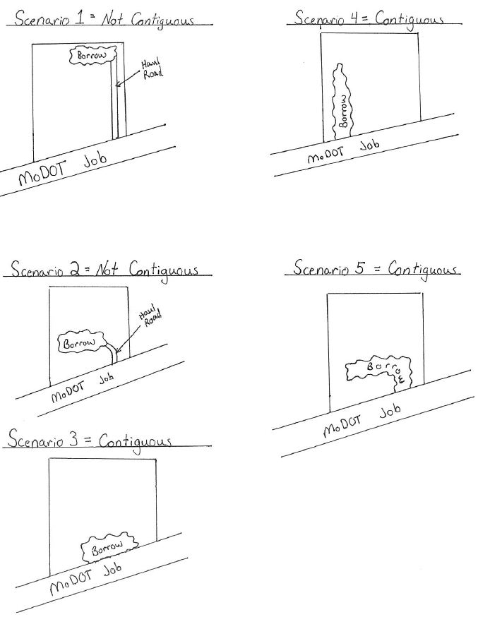

fig. 806.8.9

Example Erosion/Sediment Control Site Plans

(Note: Notice the legend, color coding, indemnifying statement and the date of installation and removal of BMPs. Don’t forget to label outfalls!)

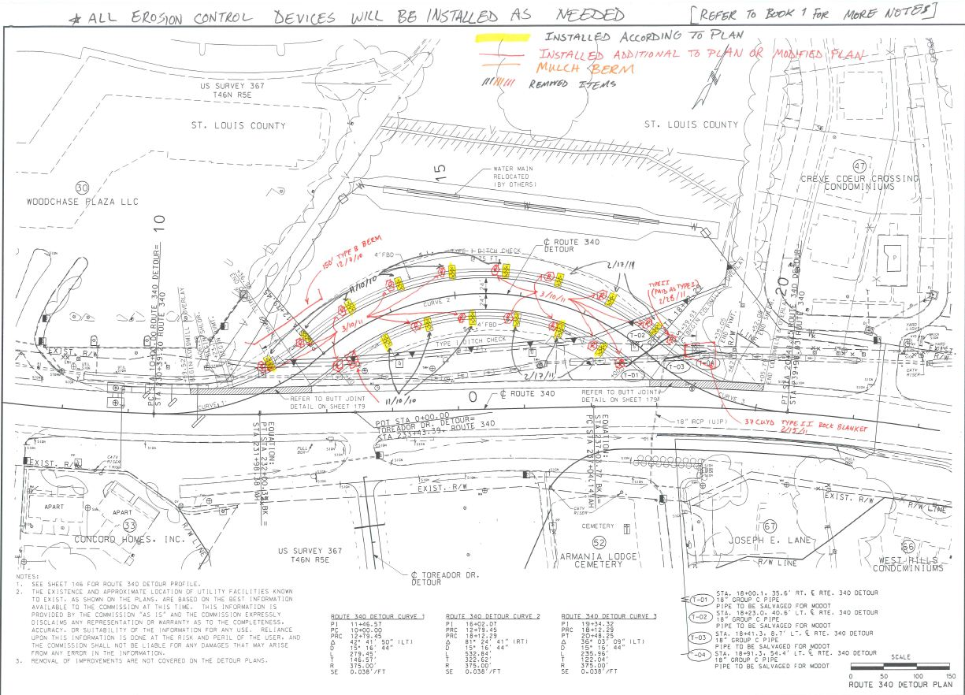
SAMPLE
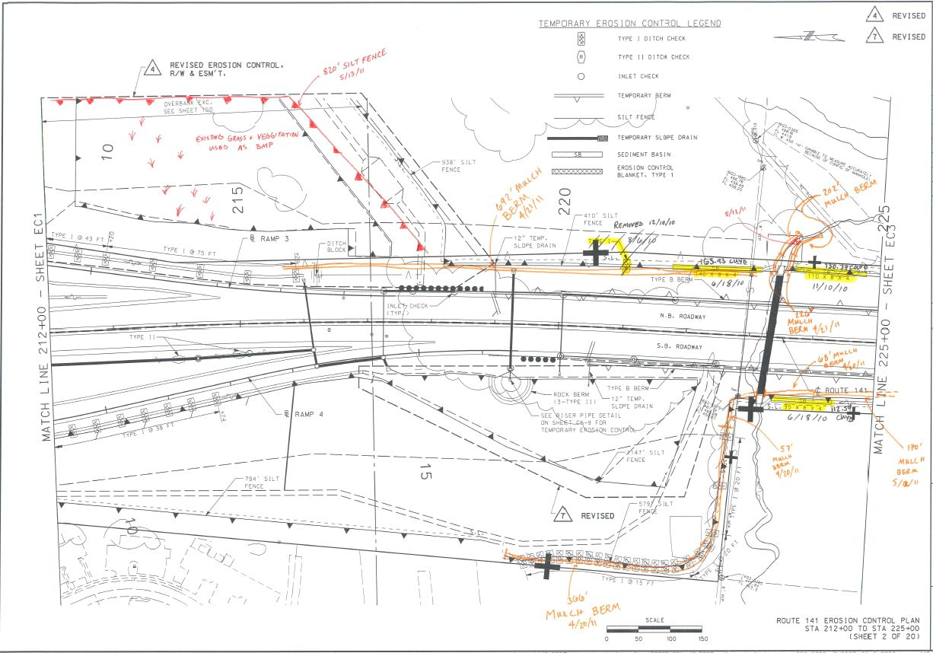
SAMPLE

fig. 806.8.14

Example of a MDNR SWPPP Evaluation Form

(Note: The following form is used by MDNR to evaluate project SWPPPs, including MoDOT projects. Notice in the “Comment” section it has been identified whether the items they are looking for are located within this written statewide SWPPP, need to be covered on the project specific erosion and sediment control plans (a.k.a., the site maps), or they should be found in both.)

SWPPP Evaluation
Missouri Department of Natural Resources

FACILITY INFORMATION | PREPARED BY:
Name of Facility:  MO #: MO-R10  COUNTY | __________________ ________________  (Name) (Date)
SWPPP Component | Yes | No | Comments
Facility identified. |  |  | Site Map
All outfalls identified |  |  | Site Map
All pollutant sources, storm water and non-storm water identified. (porta-pottys, fuel tanks, staging areas, waste containers, chemical storage areas, concrete cure, paints, solvents, other hazardous waste, storage of construction materials, etc.) |  |  | Site Map
Contains a physical description of the best management practices (BMP’s) both temporary and permanent. This should include how off site vehicle tracking will be addressed. |  |  | Narrative SWPPP
Explains site and physical conditions that must be addressed for effective use of the BMP’s |  |  | Narrative SWPPP
Describes BMP installation/construction procedures, including typical drawings. |  |  | Narrative SWPPP/Standard Drawings
Describes operation and maintenance procedures for the BMP’s chosen. Include a schedule for maintenance. |  |  | Narrative SWPPP
States whether the BMP is temporary or permanent. |  |  | Narrative SWPPP
Describes or shows where, in relation to other site features, the BMP’s are to be located. |  |  | Site Map
Details when the BMP will be installed in relation to each phase of the land disturbance procedures to complete the project and what site conditions must be met before the removal of the BMP’s if the BMP’s are not permanent. Includes a time schedule for this implementation. |  |  | Narrative SWPPP & Contractor Communications
States temporary stabilization details should areas be left undisturbed for more than 14 days. |  |  | Narrative SWPPP
States bench marks to be referenced for proper installation, as well as operation and maintenance of drainage course changes. Work in defined drainages or watercourses and their associated wetlands may require a permit from the U.S. Army Corps of Engineers pursuant to Section 404 of the federal Clean Water Act. |  |  | Narrative SWPPP
Discusses solid and hazardous waste management including trash containers. |  |  | Narrative SWPPP
Discusses proper sanitation methods (i.e. portable toilets). |  |  | Narrative SWPPP
Explains how the storage of construction materials will be kept away from drainage areas. |  |  | Narrative SWPPP
Describes the outlet control devices to be used. |  |  | Narrative SWPPP/Site Map
The SWPPP shall require a sedimentation basin for each drainage area with 10 or more acres disturbed at one time. The sediment basin shall be sized to contain a volume of at least 3600 cubic feet per each disturbed acre draining thereto. Accumulated sediment shall be removed from the basin as needed to ensure the minimum volume of 3600 cubic feet is maintained. Discharges from the basin shall not cause scouring of the banks or bottom of the receiving stream. The SWPPP shall require the basin be maintained until final stabilization of the disturbed area served by the basin. |  |  | Narrative SWPPP
SWPPP Component | Yes | No | Comments
Where use of a sediment basin of this size is impractical, the SWPPP shall evaluate and specify other similarly effective BMPs to be employed to control erosion and sediment delivery. These similarly effective BMPs shall be selected from appropriate BMP guidance documents authorized by this permit. The BMPs must provide equivalent protection.  The SWPPP shall require both temporary and permanent sedimentation basins to have a stabilized spillway to minimize the potential for erosion of the spillway or basin embankment. |  |  | Narrative SWPPP, Basins to be Shown on Site Map
The SWPPP shall be amended when appropriate. Field implementation shall match narrative and illustrated depictions. |  |  | Update Narrative SWPPP & Site Maps
The SWPPP shall contain a site inspection form and inspection log for use during weekly inspections or during storm water events. Inspections shall be performed once every 7 days or within 48 hours after a storm event that causes storm water runoff to occur on site. Qualified personnel shall perform inspections and authorized persons shall sign reports. The site inspection shall include (at a minimum): inspector’s name, date of inspection, observations relative to the effectiveness of the BMPs, actions taken or necessary to correct the observed problem, and listing of areas where land disturbance operations have permanently or temporarily stopped. The inspection report shall be signed by the permittee or by the person performing the inspection if duly authorized to do so. Copies of inspection reports shall be maintained for three years from the date permit coverage expires. |  |  | Narrative SWPPP EPG Form 806.8.10 (MoDOT Land Disturbance Inspection Record) & Inspection Records
The SWPPP shall indicate the portions of the project for which each operator has control over day-to day activities. |  |  | Site Map
Contractors shall be notified of the provision of the SWPPP and a copy shall be provided to all contractors or sub-contractors involved with pre-stabilization activities. A provision must be included to notify all applicable contractors of changes made to the SWPPP. |  |  | Narrative SWPPP/Cover at PreCon
The owner as well as all relevant contractors and sub-contractors shall sign the SWPPP. |  |  | Contracts/Specs Say Environmental Laws will be Followed
SITE MAP
In addition to the narrative portion of the SWPPP, a site map shall be included. The site map shall be a maximum of 1”= 200 feet. Applicable topographic lines shall be shown. The site map shall include:
Drainage patterns and slopes anticipated before and after major grading activities are completed. |  |  | Site Map
Show offsite materials, waste, borrow or equipment storage area, surface waters. |  |  | Site Map (Only if Possible)
Boundary lines for land disturbance activities. |  |  | Site Map (Typically Slope Limits)
Existing and planned streets, buildings, lots, utilities, geographic features, buffer strips and waterways. |  |  | Site Map (Always on Our Plans)
All outfalls labeled. |  |  | Site Map
All BMP’s both temporary and permanent. |  |  | Site Map
All sedimentation basins. |  |  | Site Map
The map shall include a legend, which describes all symbols used. Whenever symbols fail to satisfactorily convey the requisite information, notes shall be used. |  |  | Site Map (See Fig. 806.8.9 Maps)
Comments:

fig. 806.8.15

Imhoff Cone & Turbidity Tube Testing Procedures

(Note: The current MoDOT state operating permit for land disturbance does not require sampling of either settleable solids or turbidity.)

Imhoff Cone Testing Procedure for Settleable Solids
(Developed by the Nebraska WEA, http://www.ne-wea.org/LabManual/settleable_solids.htm)
Procedure
- Fill an Imhoff cone to the one-liter mark with a well mixed sample.
- Allow sample to settle in the Imhoff cone for 45 minutes.
- Gently stir the sample with a glass rod to release the suspended matter clinging to the sides of the Imhoff cone.
- Let sample settle for an additional 15 minutes.
- At this point, one hour has passed. Record the volume of settleable solids (in milliliters/Liter/hour) in the Imhoff cone.
Note: Do not include any floating solids or any voids in the settled solids as settleable matter.

Turbidity Tube Testing Procedure for Turbidity
(Developed from the SOP for Turbidity Measurements Using Turbidity Tube, Rev. 1, Utah DEQ, DWQ, 2011, as well as Myre, E., & Shaw, R. (2006): The Turbidity Tube: Simple and Accurate Measurement of Turbidity in the Field, Michigan Technology University, Michigan )

Procedure:
- Collect a water sample in a large, clean container (bucket/jug/jar). Be careful not to include sediment from the bottom of the body of water.
- Rinse the tube with the water that is going to be tested and pour it out.
- Stir or swirl the water sample in the container vigorously until it is homogenous, introducing as little air as possible.
- Place your head 10 to 20 centimeters directly over the tube so that you can see the viewing disk while the sample is being poured into the tube.
- Slowly pour water into the tube. Try not to form bubbles as you pour. If bubbles do form: Stop pouring and allow any bubbles to rise and the surface of the water to become still.
- Keep slowly adding water until the pattern on the disc becomes hard to see.
- Watch the viewing disk closely and add water even more slowly. Stop pouring as soon as the pattern on the disk can no longer be seen. If you can still see the viewing disk pattern when the tube is full: Record the turbidity value as less than the final measuring mark. (Example: If your tube is full and your highest mark is 5 NTU, write down that the turbidity is “<5 NTU”.)
- Read the turbidity from the scale on the side of the tube. Remember: If your turbidity tube does not have turbidity values marked on the tube side, simply measure the water level with a ruler or tape measure and find the corresponding turbidity value in the table on the following page. Clean the tube and disk.

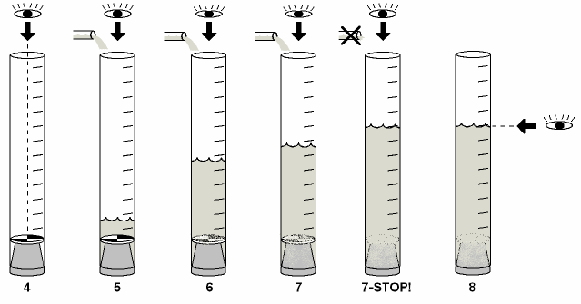
Schematic of turbidity measurement using a Turbidity tube (Myre and Shaw, 2006)
Length-to-Turbidity Conversion Chart
The following table provides the turbidity values (in NTU) that correspond to different lengths measured above the viewing disk. These values can be used to mark the turbidity tube directly or to convert measured values to turbidity units.

