Quick Reference Guide -- Subcontracts
This article is intended to guide the user in the creation of a subcontract in SiteManager.
Log on to the system and navigate to Contract Administration – Contractor Management – Subcontracts.
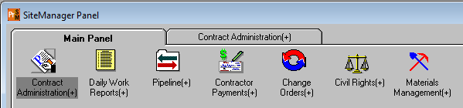
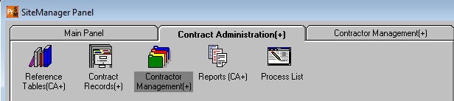
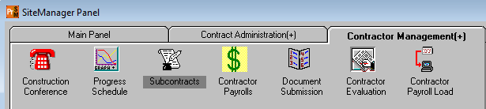

Important Information Regarding Subcontract Process
The contractor will submit DBE commitments at the time of bidding. These commitments can be for DBE suppliers and/or haulers as well as DBE subcontractors, and will be passed into the system as numbered DBE subcontracts (see below). Do NOT delete these subcontracts; they are to be left in the system.
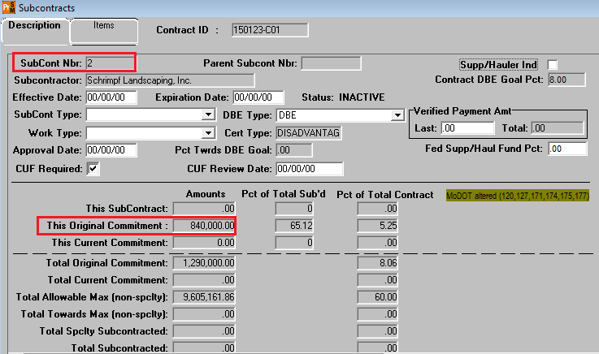
The DBE submittal commitment form will be in the executed contract and will show the line items and dollar amount the contractor will be using to meet the DBE goal. The total amount for each DBE being utilized to meet the DBE goal will be passed into SiteManager as a separate subcontract and the amount shown in “This Original Commitment” for each subcontractor, material supplier, and trucker/hauler.
For subcontractors, the line items for the total dollar amount shown on the DBE submittal commitment form must be included on the Request to Subcontract (C-220). Project office personnel will enter the line items shown on the C-220 into SiteManager on the Items tab (See pages 6-7 of this QRG). It is acceptable for the contractor to add additional line items to the C-220 so long as the line items on the DBE Commitment submittal form are also included. If the contractor is adding line items, the “This Subcontract” field amount in SiteManager will be greater than “This Original Commitment.”
DBE subcontracts for suppliers/haulers that are passed into SM will be left as is, except when the DBE Type field contains something other than “DBE” (e.g., MBE, WBE, MWBE, or OTH). In this case, select “DBE” from the drop down list. The Supp/Haul Ind check box should also be selected.
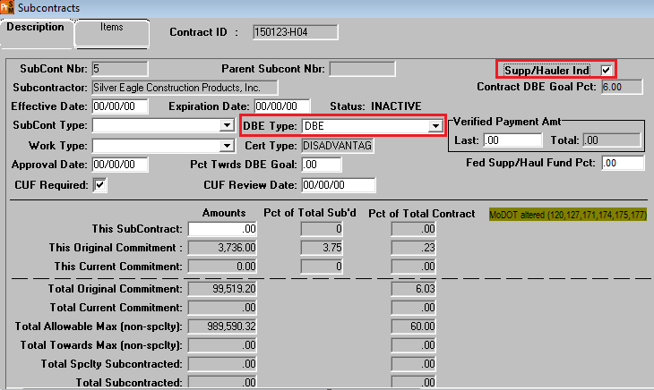
When a Request to Subcontract (Form C-220) is received from the prime for a DBE subcontractor whose information has been passed into the system, open the subcontract in SiteManager and verify the DBE Type. If it is something other than “DBE” (as noted above), change it to DBE. Select the appropriate “SubCont Type” and “Work Type” from the drop downs. If the following message appears when selecting “Work Type,” select OK and continue. Save changes, then click the Items tab and add the contract items as described in the “Items Tab” heading of this article.
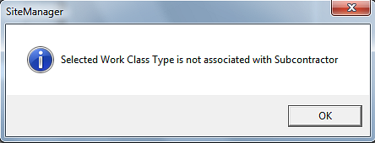

CUF Required
To determine if DBE subcontractors and supplier/haulers are performing a Commercially Useful Function (CUF), the project office must conduct CUF interviews as outlined in EPG Category 146.3. The CUF interview must be done on all DBEs, regardless of whether or not the DBE is being used to meet the contract specified DBE goal. The CUF Required check box will automatically select. Once the CUF interview is performed, the “CUF Review Date” should be entered.
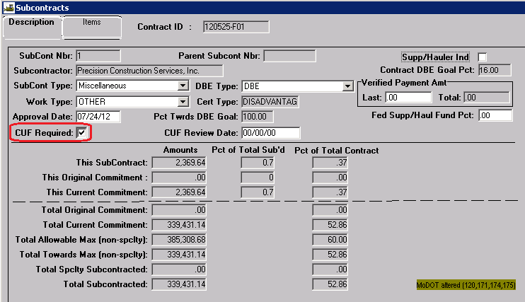
CUF review forms should be saved in PDF format in the following path for your district and org code: V:\Contract Information Archive\District\Office (ORG) \Contract ID \Civil Rights\CUF

When a Request to Subcontract (Form C-220) is received for a non-DBE subcontractor or for a DBE subcontractor whose information was not passed into SiteManager because they are not being utilized by the prime contractor to meet the contract DBE goal, proceed as directed below.

Description Tab
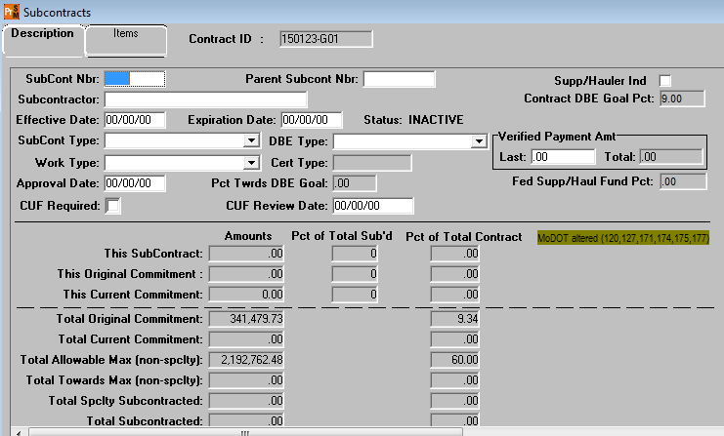
Contract ID: Select Services – Choose Keys to select contract.
SubCont Nbr: If DBE commitments have been passed into SiteManager, number the contract using the next available number. Otherwise, begin numbering with “1” -- do NOT enter subcontract numbers with leading zeros.
Parent SubCont Nbr: If this is a second tier subcontract, i.e., a subcontractor hired by a previously approved subcontractor, perform a search and select the first tier subcontractor.
Supp/Hauler Ind: Do not check this box. MoDOT does not subcontract with suppliers or haulers. (This box may be automatically checked as a result of a DBE commitment. If so, leave it checked.)
Subcontractor: Perform a search and select the appropriate subcontractor (vendor) from the list. Verify the subcontractor’s Vendor Id on the Request to Subcontract Work (Form C-220) with the Search Window if the subcontractor’s name does not appear exactly as it does on the Form C-220. Any vendor listed as “Subcontractor,” “Prime,” or “Expired Prime” may be selected.
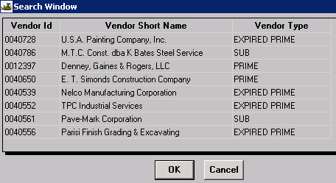
Effective Date/Expiration Date: Skip these fields. When a Save is performed, the Notice to Proceed Date will be automatically entered in the Effective Date field, and the subcontractor Status will change to “ACTIVE.”
Remarks Bubble : Verify the contractor/subcontractor’s insurance by reviewing the MoDOT Contractors report in Cognos. To access this report, navigate to the Constructruction and Materials SharePoint site, click the Contract Administration button and click the MoDOT Contractors link located on the right side of the page.
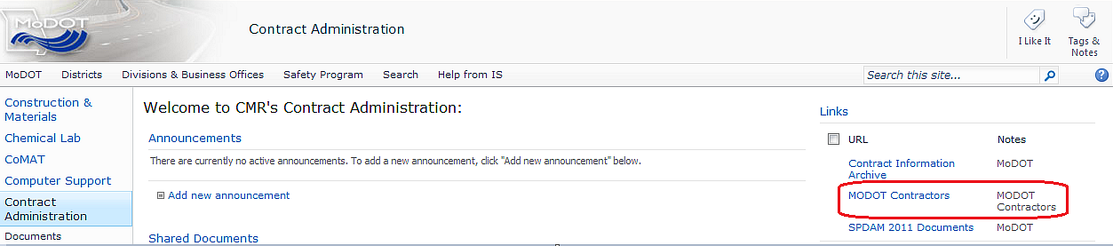
Click “MoDOT Contractors – All” to open the report.
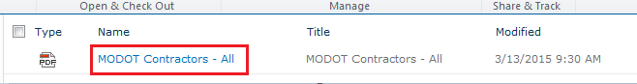
Select “Read Only.”
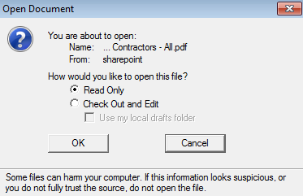

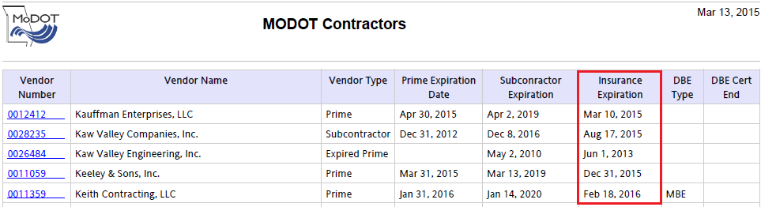
At a minimum, the insurance expiration date for the subcontractor should be entered along with the userid and date the remark was entered.
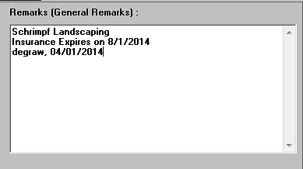
Note: Contact the Construction Contract Administrator at the Division Construction & Materials office if the subcontractor’s name is not available to be selected or if the insurance has expired.
SubCont Type: Select the type that most closely fits.
DBE Type: Select either “DBE” or “NO” from the drop down.
Work Type: Select a work type from the drop down that most closely matches the work the subcontractor will be doing. Because the work types are not associated with each contractor, SiteManager will produce the following message:
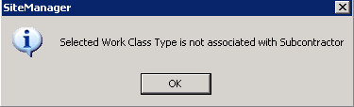
Select OK.
Verified Payment Amt: MoDOT does not use these fields.
Approval Date: Do not enter anything in this field. An approval date will be entered when the subcontract is approved at the District level.
Note: It is possible to receive a subcontract for a non-DBE subcontractor before a DBE contract passed into the system. It is permissible to approve these subcontracts out of order.

Items Tab
Click the New icon to open the Items detail at the bottom of the window.
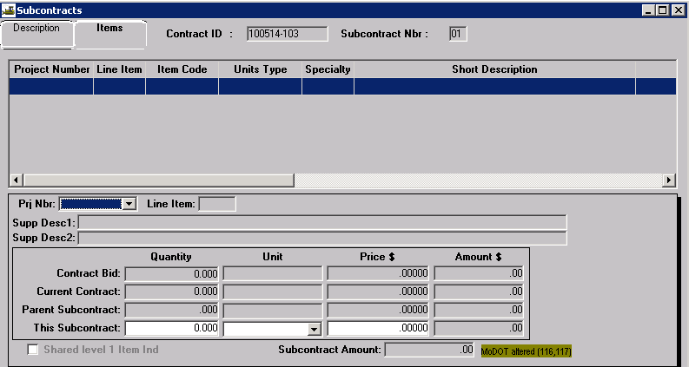
Prj Nbr: Select the appropriate project number from the drop down.
Line Item: Perform a search and select the appropriate line item.
Note: The tab order for this window has been changed. Tabbing will take the user from “Line Item” to “This Subcontract, Unit.” This is necessary so the system will not zero “This Subcontract, Quantity” when the unit is changed to “partial.”
This Subcontract, Unit: The contract unit will be displayed for the line item. Always select the corresponding Partial unit. For example, if the contract item unit is Linear Foot, the user should select Linear Foot (Partial) from the drop down.
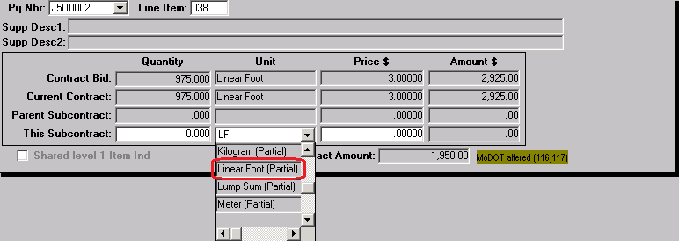
This Subcontract, Quantity: Enter the quantity of the subcontracted item.
This Subcontract, Price: Enter the amount shown on the Request to Subcontract Work (Form C-220) for the subcontract.
This Subcontract, Amount: This field is automatically calculated by the system.
Save the information. Select the New icon and repeat the above steps to add additional items to the subcontract.
Return to the Description tab and select the New icon to enter additional subcontracts.

Modifying Existing Subcontracts
Certain situations may require modification of approved subcontracts.
Additional Contract or Contingent Item Work Added to an Approved Subcontract
Revise the previously approved subcontract in SM for the additional items of work. This will allow the inspector to select the subcontractor as doing the additional work on the DWR Work Items tab. The user shall place a Remark indicating the date of the revision and why the subcontract was revised. No revision of the hardcopy is required.
Routine Increase of Contract Quantity on Subcontracted Items
No modification of the subcontract is required.
Change of Subcontractors for Previously Approved Subcontracted Work Items
In this situation, the user shall modify the existing subcontract removing the item(s) of work not being performed. The user shall add a remark indicating the reason for the revision. No revision of the hardcopy is required. A subcontract shall be added with the items of work to be performed by the new subcontractor. Hardcopies of the new subcontract shall be submitted.

