Contents Page
Introductions ………………………………………………………. 2
Internal/External Login Page Instructions …………….. 3
Create New Request Instructions ………………….……… 6
Request Search Instructions …………………………………. 8

Request for Environmental Review (RER)
Missouri Local Programs
How to Complete the Request for Environmental Review
Why Submit the RER Form?
Every federally funded transportation project must have an environmental NEPA classification.
- Most project receive a categorical exclusion commonly known as a CE
- The form also helps the environmental specialists at MoDOT identify additional clearances that might be necessary.
When Do We Submit the RER Form?
- Submit the RER within 30 days of PE obligation or early in the design phase of the project.
- FHWA must approve the NEPA classification prior to 35% plan completion.
- The Section 106 clearance & NEPA classification must be approved before Right of Way acquisition can begin.
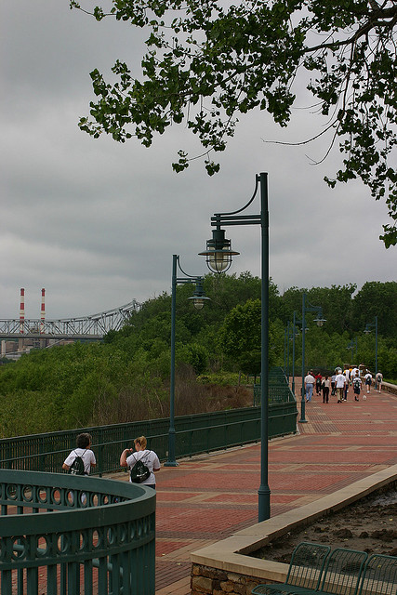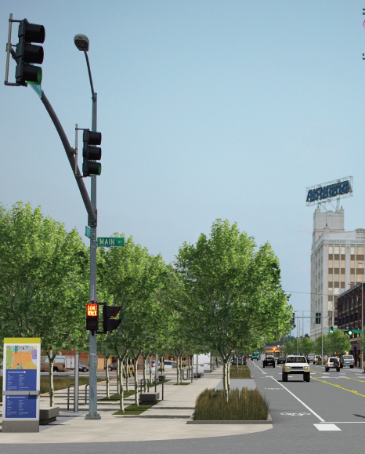
Request for Environmental Review Instructions
MoDOT Employees will login with their system login and password then select “MoDOT” (MoDOT employees do not need to register)

For External Login
- The present RER form link in EPG 136.6 will bring you to the new Login Page. Click on the “Not Registered? Click here to Register” link and complete the registration for your Company, City, or County for the first time access to the RER system.
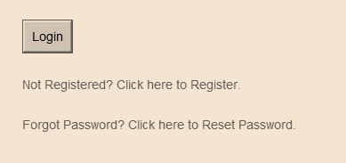

- Enter Company, City, or County Information along with a company email, then create a password for administration access. Click “Continue” to add consultant information.
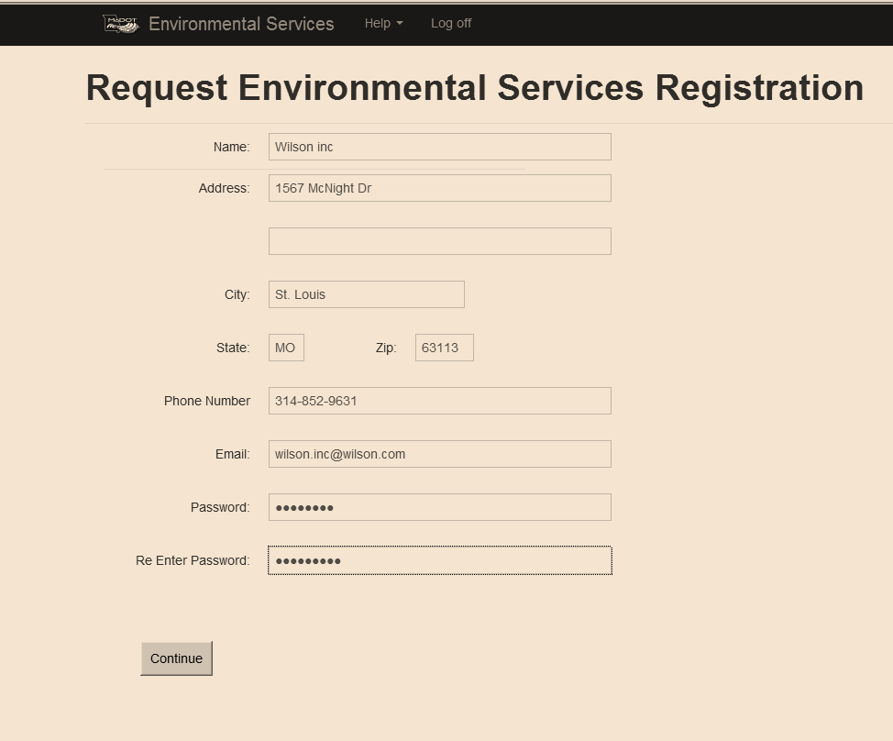

- This is the section that you will add Representatives including the Administer for your Company, City, or County that will have the authority to process LPA projects for submittal to MoDOT. It is required to add Representatives here in order to edit/view/create the RER form. It is required to “Add Project” to each responsible Representative in order to edit/view/create the RER form. (example: John and Jane need to view the same project, then you will want to add this project under both Representatives in order for both to edit/view/create the RER form.)
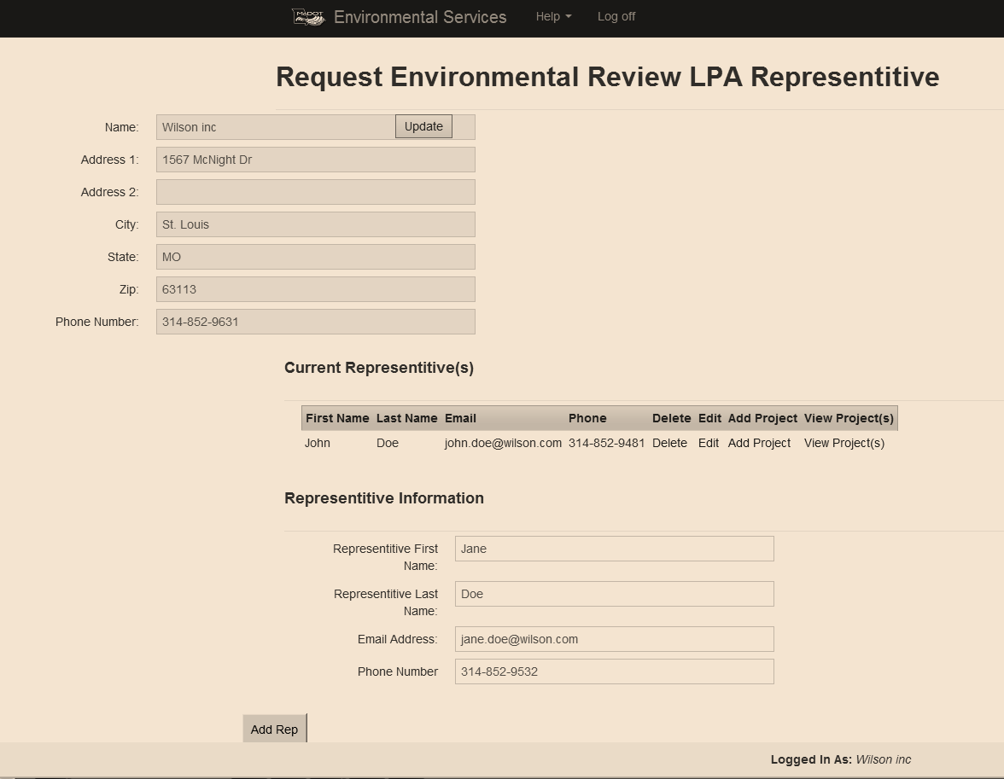

- Once all the Representatives are added to “Current Representatives” the administrator can log off to exit the system. Representatives will use their email address and “Password1” to login. Once “Login” is clicked they will be prompted to change their password.
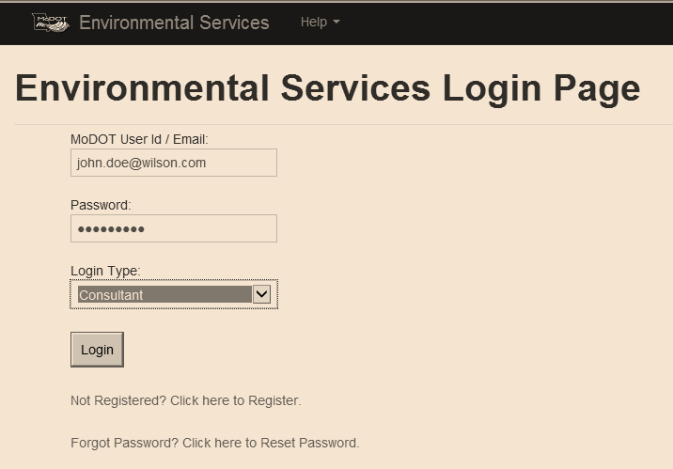

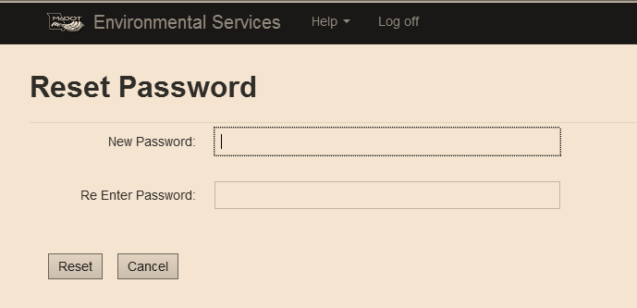

- On successfully changing password, the Rep will need to login one more time and will get the following page. Here you will be able to “Create New RER” or Search projects that you have been assigned to. Any project not assigned to a Representative will not be in search results. Projects will need to be assigned by the administrator. (see page 3)
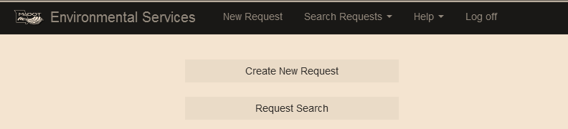

Creating New RER Request
- Enter the Federal Number provided to you without parenthesis to make it 7 characters (example B050(30) enter as B050030). The project number should pop up after the 5th number is entered and can be selected to auto populate some information for you.
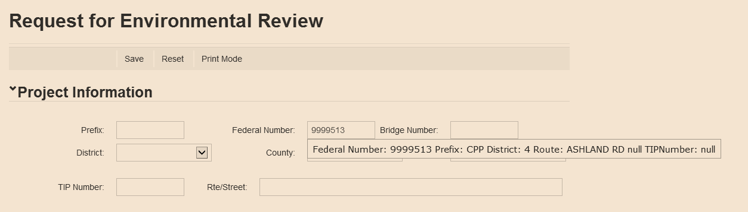

- When the Federal Number is selected:
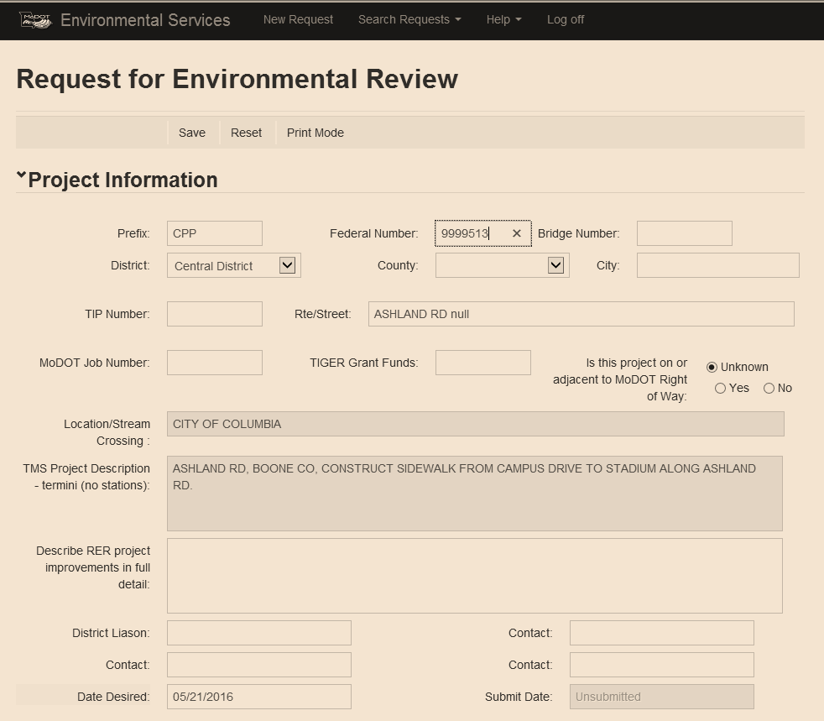

- Please fill in all information correctly.
- County – if there is more than one County associated with the Federal Number, you will need to select “Various” for multiple counties. You can add the counties to the description box as information to the project.
- There are 2 project description boxes – 1st is the pulled information already in system and the 2nd description is for you to enter more detailed information.
- There are multiple required fields that need to be completed before the document will save. The required fields are: County, District Liaison, Acres (Additional R/W, Temp Easement, Permanent Easement), Acres of Tree Clearing, both Bicycle / Pedestrian consideration, and Project is in a FEMA-defined “floodway”.
- At the bottom of the form, there is a Browse button that allows you to select plans, maps, pictures, or any other electronic document. After attaching the documents click the “Save” button to upload the documents. If a form has been submitted an “upload attachment” will need to be clicked in order to upload the documents
- After you have completed the form and saved, it will bring you to the top of the form where you will click “Submit Request to Environmental Services.” This generates an email to the appropriate MoDOT LPA Liaison and Environmental Specialists assigned to your District identifying the project and containing a link to the log on screen.
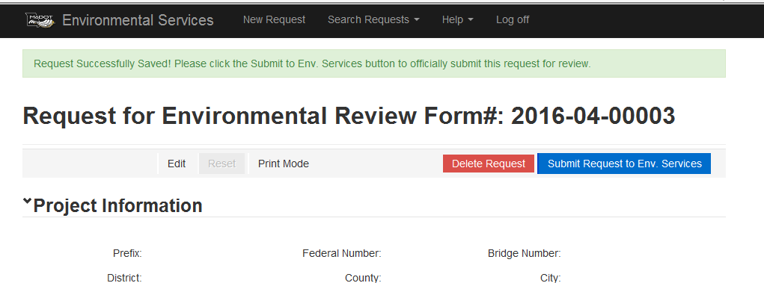

- After RER submittal
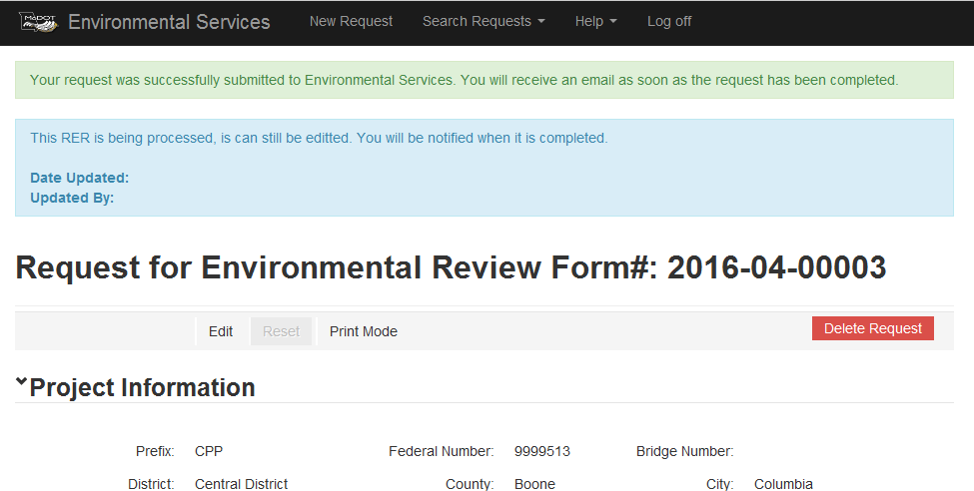

- After the Environmental Specialists have reviewed the RER, the Specialist will click a “Submit to District” button that will send an email automatically back to the “Submitted by” and the District Contacts with a link specifying which RER project was reviewed. (This link will take you to the login screen). Login to the RER system and the form will open.

- There are 3 colors for the review process:
- Yellow – means it has not been looked at
- Blue – means there are issues that need to be completed
- Green – means it is cleared
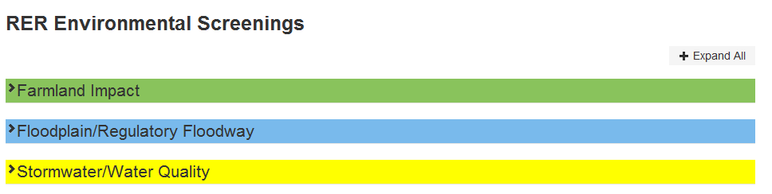
Request Search
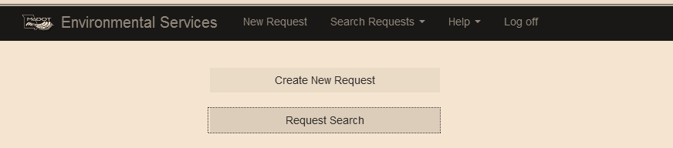
- There are many ways to search for the project you need.
- Request # - is the number that is created when you save a new RER request
- Federal Number – is the 7 digit number that was provided to you (example: B050030)
- District – is the 7 MoDOT District Offices
- County
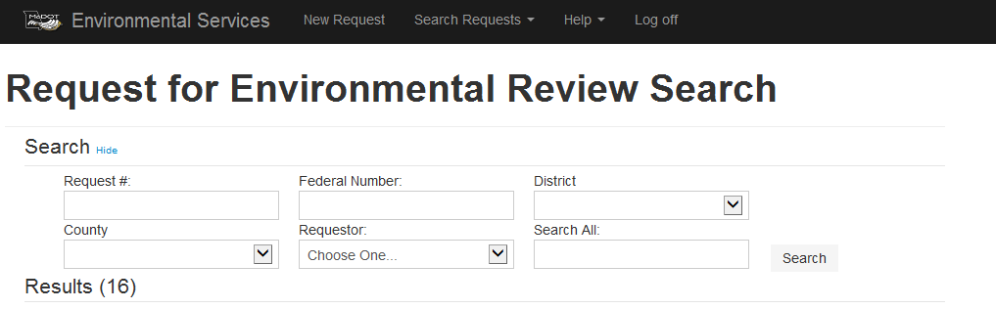
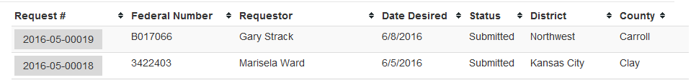

- IF there is ROW, the NEPA Classification Section is where you will find the dates needed for A-Dates (NEPA and SHPO/4(f)). For the A-Date form use the same date for SHPO and 4(f).
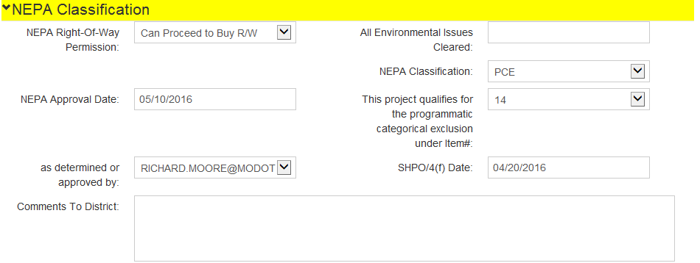
- You will be able to make edits after you have submitted the RER form and before the RER form has been finalized by the MoDOT Specialists assigned to your County. You will need to click the “Edit” button, make the necessary changes, click “Save” and then an edit email will be sent to MoDOT contacts.
- You may contact Richard Moore at (573) 526-2909 or Charlotte Drinkard at (573) 526-4778 if you need further assistance with the new form.

