ADA POST INSPECTION CHECKLIST

Job No. __________ Route ___________ County ________________ Location __________________________________________________

SIDEWALKS
Figures/Examples | Requirements ¹ | YES | NO | NA
 | All sidewalks constructed within the project limits are ADA compliant.
 | - Sidewalks are 5’ or greater in width. Exception, existing sidewalks or where physical restraints exists, sidewalks may be less than 5’ wide, but must be at minimum 3’ or greater in width with 5’ x 5’ level landings provided no more than 200’ apart. (A level landing is defined as a landing with no cross or running slopes greater than 2.0%. Driveways or parking lots may be considered as landings if they meet the requirements of a landing.)
 | - Sidewalk cross slopes are 2.0% or less.
For example, a segment with the maximum allowed running slope of 8.33% would require 5’ x 5’ landing every 30’.  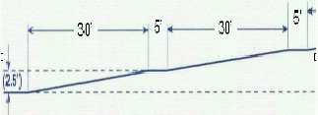 | - Sidewalk running slopes meet any of the following conditions:  - The sidewalk is at the same grade as the roadway, regardless how steep the roadway grade is.  - If the sidewalk is at a different grade than the roadway, yet the running slope of the sidewalk is not greater than 5%.  - If the sidewalk running slope is at a different grade than the roadway and the running slope is greater than 5%, then the sidewalk will be considered a ramp and shall meet the following requirements:  - Maximum grade is 8.33% for any segment.  - Maximum rise for a segment is 30”.  - 5’ x 5’ landings are located between each segment.
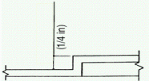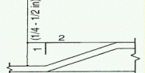 | - Surface Level Criteria - There are no height differentials with a lip greater than ¼” in height. Exceptions, a height differential between ¼” and 1/2'” is acceptable if it is beveled at a 2:1 slope, or a height differential greater than ½” is acceptable if it is ramped with a slope of 8.33% or less.
 | - All utility poles, light posts, traffic posts, fire hydrants, and other manmade vertical appurtenances are located outside of the sidewalk path. If right of way prevents relocation of an appurtenance, the pathway width is at minimum 32” wide and the length of the restricted pathway is no more than 2’.
 | - Utility covers, such as manholes and water meters, have a slip resistant top, as much as possible, and meet changes in level criteria.
 | - Lift holes for manhole/utility covers do not have an opening greater than ½”. Plugging of holes greater than ½” with a material approved by the engineer is acceptable as long as it is flush with the cover surface.
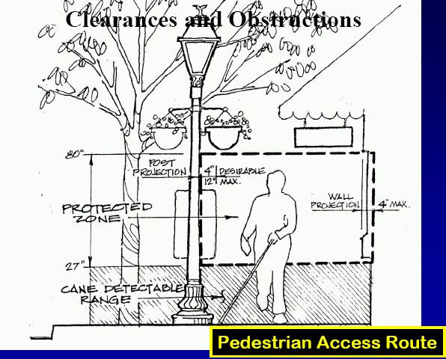 | - There are no horizontal obstructions within the sidewalk pathway. See adjacent figure for examples of what is considered acceptable, specifically:  - Wall projections or signs or other objects attached to posts do not exceed 4” into the pedestrian path between 27” and 80” above the ground. Exception, signs or other objects attached to posts may project into the pedestrian pathway up to 12”, but is not preferred and should be limited to 4” where possible.
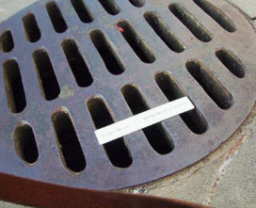  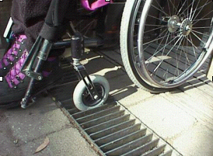  Wrong Installation  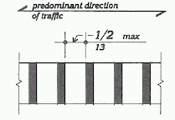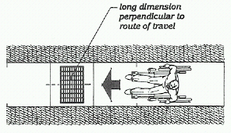 | - If gratings are located in the sidewalk or other walkways paths, the spacing of the gratings is not greater than ½ in. (13 mm) wide in one direction. Gratings with elongated openings are installed so that the long dimension is perpendicular to the dominant direction of travel.

ENTRANCES
Figures/Examples | Requirements ¹ | YES | NO | NA
 | All entrances within the project limits are ADA compliant.
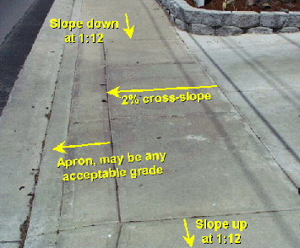 | - A level pedestrian access route (walkway) is provided across commercial and residential entrances, meeting the following criteria:  - The walkway is at minimum 3’ wide.  - Cross slope of walkway is 2 percent or less.  - Walkway is at the same grade as the adjacent roadway.  - The walkway does not have to be marked, but provides a straight line between the adjoining sidewalks or ramps.  - There is not an abrupt transition from the driveway to the roadway for vehicles, i.e., vehicles will not bottom out when driving over the transition.

RAMPS
Figures/Examples | Requirements ¹ | YES | NO | NA
 | All ramps within the project limits are ADA compliant.
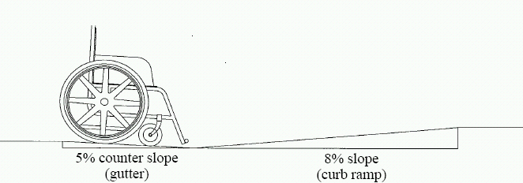 | - General requirements for all ramps are:  - Ramps are present where sidewalks exist.  - The ramp width is the same width as the sidewalk.  - The ramp is not less than 36” wide at the bottom.  - Cross slope of ramp is 2.0% or less.  - Running slope of ramp is 8.33% or less and oriented to path of travel. Exception, ramps being retrofitted into existing facilities where space limitations prohibit the use of a 8.33% slope or less may have slopes and rises as follows:  - A slope between 1:10 and 1:12 is allowed for a maximum rise of 6 inches (150 mm).  - A slope between 1:8 and 1:10 is allowed for a maximum rise of 3 inches (75 mm).  - A slope steeper than 1:8 is not allowed.  - Curb lip height is ½” or less.  - Street and ramp slope break is 13% or less. (See adjacent figure.)  - No drainage or silt problems within ramp or at gutter line at ramp exit.  - No design or maintenance obstructions within the ramp pathway.
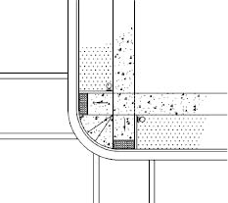  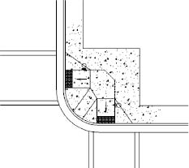  Perpendicular Ramps  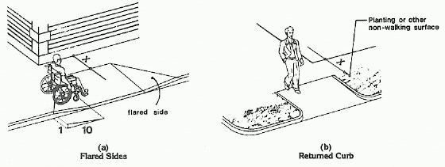 X = 4’  Flared Sides in Pathway Flared Sides Not in Pathway | - Perpendicular ramps meet the following criteria:  - Have at minimum a level 5’ x 5’ landing (not more than 2% cross slope in any direction) at the top of the ramp. Exception, a top landing is not required if the ramp serves only one sidewalk and the ramp is aligned with the direction of travel of that sidewalk, i.e., no turning movement required for a person in a wheelchair to align with the running slope of the ramp. A landing is preferred, but may not be able to be constructed because of the steep grade of a sidewalk, making it technically infeasible to construct. For example, an existing sidewalk at a 7% grade with a 6”curb height would require the beginning of a 5’ x 5’ landing to be installed at 35.7’ back from the curb with a ramp at 8.33% running slope. This may be technically infeasible because of limited right of way and/or beyond the scope of the project.  - Flared sides with a slope of 10 percent maximum, measured parallel to the curb line, are provided where a pedestrian circulation path crosses the curb ramp. If the flared sides are not in the pathway, then there is no maximum slope and can be vertical curbs. (See adjacent figure for further explanation.)

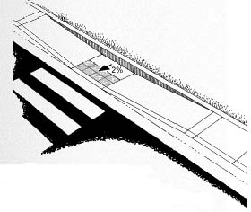 | - Parallel ramps have at minimum a level 5’ x 5’ landing at the bottom of the ramp.
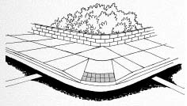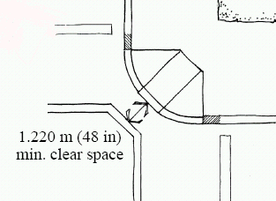 | - Diagonal ramps meet the following criteria:  - Have at minimum a level 5’ x 5’ landing at the top and at minimum a 48” clear space at the bottom of the ramp.  - If a crosswalk is present, the clear space is contained within the crosswalk.  - If the flared sides are within the pedestrian pathway, the slope of the flares are 10% or less.

DETECTABLE WARNINGS (TRUNCATED DOMES)
Figures/Examples | Requirements ¹ | YES | NO | NA
 | Detectable warnings (truncated domes) are properly installed and ADA compliant.
 | - Installed on all ramps at streets, signalized commercial entrances and railroad crossings.
 | - Not installed on ramps at residential, public or non-signalized commercial driveways.
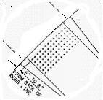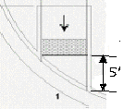 | - The preferred location of the truncated dome surface area is 6”-8” from the face of the curb (gutter line). Exception, on large curb radii one edge of the detectable warnings may be placed at the face of the curb to minimize the distance that the other edge is from the face of the curb; however, neither corner of the detectabe warning may be more than 5’ from the face of the curb line.
 | - The truncated dome surface area is at minimum a 2’ strip that extends the entire width of the ramp, excluding flared sides. Exception, the dome surface area may be stopped 2” from each side of the ramp to aid construction and to prevent the concrete from chipping at the edges.
 | - The truncated domes are aligned on a square grid in the direction of pedestrian travel or installed radial to the grade break.
 | - Detectable warnings are not stamped into concrete and are an ADA approved product.
 | - Detectable warnings contrast visually with the adjoining surface, either light-on-dark or dark-on-light (recommended bright red on concrete and bright yellow on asphalt).

CUT THROUGHS IN ISLANDS OR MEDIANS
Figures/Examples | Requirements ¹ | YES | NO | NA
 | All cut throughs in islands or medians within the project limits are ADA compliant.
 | - The width of the cut through is at minimum 5’ wide. Exception, narrower cut throughs of a minimum width of 3’ are acceptable if there is a 5’ x 5’ passing area within the cut through.
 | - The cross slope is 2% or less. Exception, on steep grades this may not be possible, in which case, the cross slope shall not exceed the grade of the roadway.
 | - The cut through is oriented with the path of travel.
 | - Detectable warnings are installed on the surface of the cut through on each side, located 6”-8” back from the street. If the cut through < 6’ in length, then the detectable warnings cover the entire area.

ACCESSIBLE PEDESTRIAN SIGNALS (PUSHBUTTONS)
Figures/Examples | Requirements ¹ | YES | NO | NA
 | All accessible pedestrian signals (pushbuttons) within the project limits are ADA compliant.
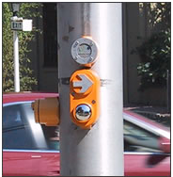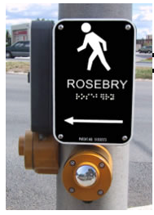 | - Pushbuttons are a minimum 2” across in one dimension, raised (not recessed), contrast visually with the housing or mounting, and have a maximum force of 5 pounds to activate operable parts.
 | - The control face of the pushbuttons is installed to face the intersection and parallel to the direction of the crosswalk it serves.
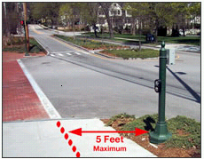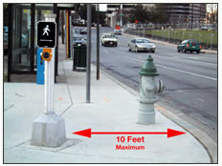 | - The location of pushbuttons for new construction are within a longitudinal distance of 5’ maximum from the crosswalk line, and 30“ minimum to 10’ maximum from the curb line (this measurement is taken from the center of the ramp). For audible pedestrian signal devices only, pushbuttons are a minimum 10’ apart at crossings and a minimum 5’ apart at islands or medians. This minimum distance may be waived for audible pushbuttons in medians and islands.
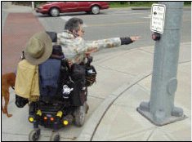 | - Pushbuttons are located no higher than 42” from the ground and within 24” reach from a level paved landing with minimum dimensions of 30” x 48”, and positioned for either forward or parallel approach to the pushbutton. For existing locations, pushbuttons at a height up to 48” and a reach of 25” are acceptable as long as other ADA accessibility criterion is met, i.e., pushbuttons are ADA compliant, level landing provided, within required distances from street and crosswalk.
 | - Where pushbuttons for the visually impaired are installed, tactile signs are to be provided that meet guidelines set forth in the EPG.

CROSSWALKS
Figures/Examples | Requirements ¹ | YES | NO | NA
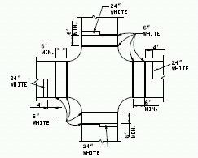 | All crosswalks within the project limits are ADA compliant.
 | - Minimum width of the crosswalk is 6’.
 | - Crosswalk pavement marking is 6” white.
 | - Stop bar is at minimum 4’ from the crosswalk.

¹ Any “NO” answer means that location is ADA non-compliant and needs to be corrected before acceptance of the work, except as follows. Although exceptions listed in the above requirements do not meet MoDOT current policy standards, that criterion does meet the minimum ADA standards and will be accepted as ADA compliant. Where it is technically infeasible to correct deficiencies as part of the current work, those locations will be labeled as non-compliant, “NO”, and added to the transition plan for correction at a later date. (Guidance is provided in the EPG on what may be considered as technically infeasible.) All exception and technically infeasible locations should be discussed with the project manager and/or area engineer prior to acceptance of the work. All exception and technically infeasible locations will be thoroughly documented by the engineer, and that documentation will be retained as part of the final acceptance records.

Inspector Name: _________________________________________________________  Inspector Signature: | Date:
Resident Engineer or Area Engineer Name: ________________________________________  Resident Engineer or Area Engineer Signature: | Date:
Distribution:
- Project Office
- District Permit Office

