QRG: Change Orders – Time Adjustment
This article is intended to guide the user in the creation of either an overall contract time adjustment change order or a milestone time adjustment change order.
Navigate to Change Orders – Change Order Maintenance – Header.
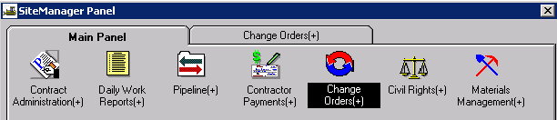
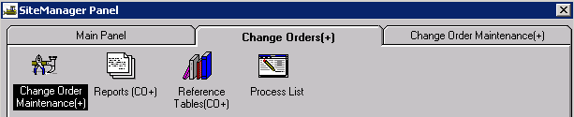
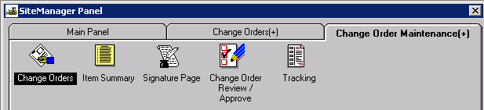

Creating the Change Order Header
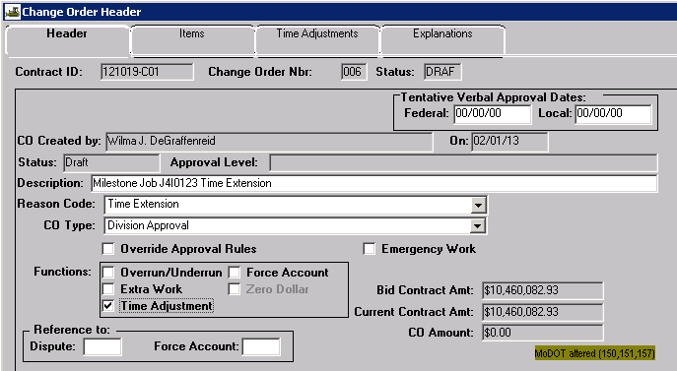
Contract ID: Select Services – Choose Keys to select contract.
CO Number: The system will automatically number the change order.
Tentative Verbal Approval Dates: May be used if it applies.
CO Created By: Automatically entered by system.
On: Date automatically entered by system.
Status: Leave Status as “Draft” until time adjustment and explanation have been entered.
Approval Level: Automatically entered by system based on change order rules.
Description: Enter a description for the change order.
Reason Code: Select “Time Extension” from the drop down list.
CO Type: Time Extension change orders are always Level 3 Approval. Select “Division Approval” from the drop down list.
Override Approval: The user should not have to override a time adjustment change order.
Emergency Work: Do not check.
Functions: Select “Time Adjustment.”
Reference To: Dispute and Force Account: These fields are not used.

Adding the Time Adjustment and Explanation
Select the “Time Adjustments” tab.
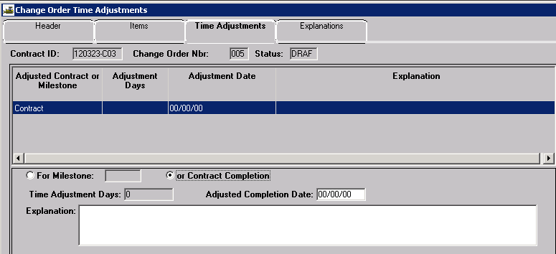
Contract Completion: If the change order is for the overall contract time adjustment, select the “Contract Completion” radio button.

For Milestone: If the change order is for a milestone time adjustment, select the “For Milestone” radio button, then select the appropriate milestone from the drop down.
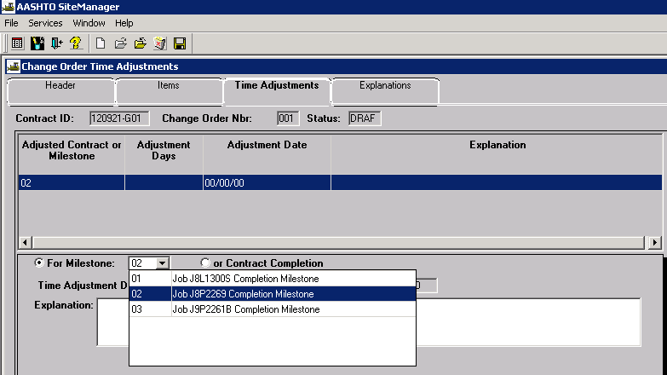
Time Adjustment Days: For Available Time or Calendar Time contracts and milestones, enter the number of days being added to the contract or the milestone. The system will automatically calculate an adjusted completion date.
Adjusted Completion Date: For Fixed Completion Date contracts and milestones, enter the new completion date. The system will automatically calculate the adjusted number of days.
Weighted time tables and examples of proper use for determining time extensions are shown in the following links: Table for Contracts With No Time Exclusion and Table for Contracts With Time Exclusion.
Explanation: Enter a detailed explanation for the time extension.
Note: SL District requires a 2-digit code at the beginning of the explanation for all time adjustment change orders. Please reference St. Louis District Reason Codes for Time Extension Change Orders for proper coding.
Once the information entered has been saved, the information will be displayed in the upper portion of the window.

Changing the Status of a Change Order
Once the time extension and explanation has been added to the change order, return to the Header tab. User may choose to “Calculate Change Order” from the Services drop down menu. The system will calculate Change Order Approval Level 3. Make sure the user-selected CO Type matches the system calculated Approval Level. Remember, ALL time adjustment change orders must be approved at Division level.
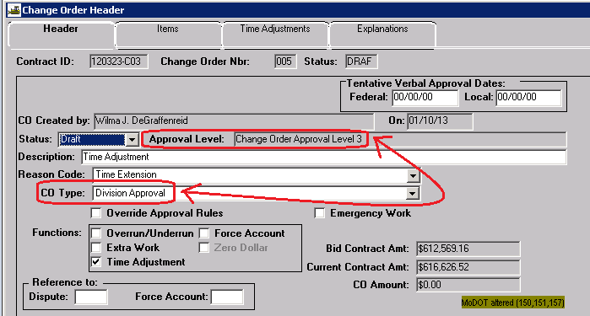
Change the status from “Draft” to “Pending” and save. Make the appropriate selections for each approval level, and then click OK.
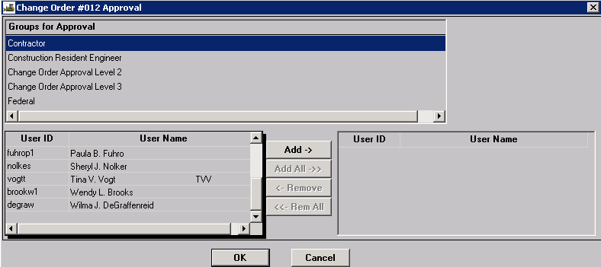

Generating the Change Order Report
Generate the appropriate Cognos report – either “Official MoDOT TIME EXTENSION Change Order Report” or “Official MoDOT MILESTONE ADJUSTMENT Change Order Report” as directed in Change Order Reports QRG.

Saving the Change Order
SM updates the header information each time a change order is generated. Therefore, you must save the report so the header will correctly reflect the contract information at the time of the report was created.
Policy: Change orders shall be saved in .PDF format to the V: drive in the following path for your district and org code: V:\Contract Information Archive\District # \ ORG # \ Contract ID \Change Orders\Pending. (See Note below.) File name should include the change order number placed within the file name so the change orders will sort properly when listed in the folder. See example below:
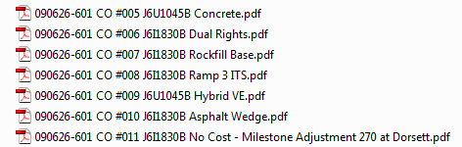

Once the change order is saved, it should be sent as an attachment in an email to the contractor for signature.
Once the change order has been approved at all levels, it shall be saved with all attachments in a single file to V:\Contract Information Archive\District # \ ORG # \ Contract ID \Change Orders\Completed.
Note: When distributing a change order electronically for signature, it should be stored with appropriate attachments in a single file in the “Completed” change order folder and linked from there. (Attachments not normally sent to the contractor should be saved in the “Supporting Documents” folder.”) Once the last digital signature is applied, the process is complete. No further action is necessary on the part of the project office, that is, there is no movement of the document from one folder to another.

