Quick Reference Guide –
Milestones: Incentives/Disincentives and Adjustments
This article is intended to guide the user in the creation of a milestone in SiteManager as well as making estimate adjustments for incentives and/or disincentives.
Milestones are defined as incentives and/or disincentives for significant points in the development of a contract. They are contract requirements that are in addition to the overall contract completion date and/or liquidated damages. For example, your contract will have a specified completion date; however, there may also be an earlier date specified by which a portion of the roadway or a bridge must be open to traffic. This earlier date is a milestone, and specific penalties (disincentives) and/or incentives will apply. Contracts may have multiple milestones. Review your contract for this specific information.
It is helpful to determine what data should be entered in SiteManager prior to entering it by using the Milestone Worksheet.

A user must have either Construction Project Manager or Construction Resident Engineer access to create a Milestone. Log on to SiteManager and navigate to Contract Administration – Contract Records – Milestones.
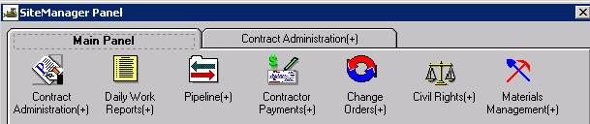
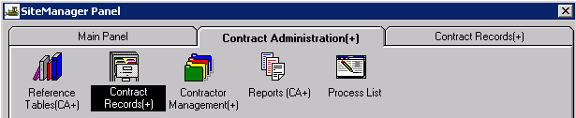
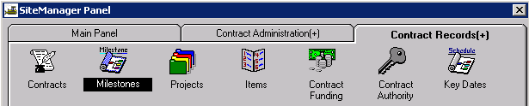

Creating a Milestone
Once the user selects the Milestones icon, the Select Contract window will open allowing the user to select the appropriate contract.
The Milestones window allows a user to create, modify, and delete contract milestones. The user can enter an incentive or disincentive rate for each milestone, and specify either days or hours to be used in calculating the amount to be paid or deducted. The user also enters the dates the milestone work was started and completed.

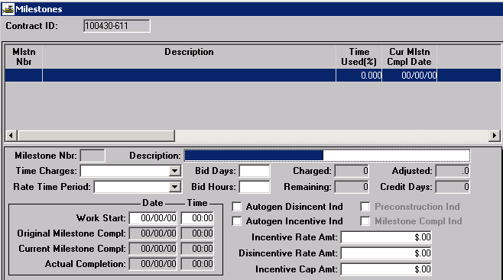
If no milestones have previously been created, the Milestones window will open ready to enter a new milestone. If previous milestones have been entered, the window opens allowing the user to select a previously entered milestone in order to edit it. Select the New icon to create another milestone.
Milestone Nbr: The system will automatically number the milestone once it has been created and saved.
Description: Enter a description for the milestone.
Time Charges: Select Available Time, Calendar Time, or Completion Date from the drop down.
Rate Time Period: Select Days or Hours from the drop down.
Bid Days or Bid Hours: Based on the selection above, one of these fields will be required if Available Time or Calendar Time is selected for Time Charges. Enter the number of days or hours allowed in the appropriate field. A value cannot be entered if Completion Date has been selected for Time Charges.
Note: If the rate set in your JSP is for minutes or an increment of time (i.e., 15-minute increments), select “Hours” and consider each minute or increment of time as an hour. Enter detailed information in the Remarks section, should incentive/disincentive adjustments need to be made.
Charged: Automatically entered by the system. This field should reflect the total number of days charged to the milestone to date, either for Available Time or Calendar Time.
Adjusted: Automatically entered by the system. This field reflects the number of days adjusted by approved milestone time adjustment change orders.
Remaining: Automatically entered by the system. This field should reflect the total days remaining to complete the milestone work on time. This value is calculated by the system [(Bid Days + Adjusted Days) - Charged Days].
Credit Days: Automatically entered by the system. This field will reflect the total number of days credited on the Diary for Available Time milestones for weekends, holidays, weather, etc.
Note: There is currently a known issue with the way the system calculates the above 4 fields. This problem is being investigated in an effort to fix this problem.
Work Start – Date: If the Rate Time Period is “Days,” enter the date work on the milestone actually started.
Work Start – Time: If the Rate Time Period is “Hours,” enter the time work on the milestone actually started. SiteManager uses military time.
Original Milestone Compl: If “Completion Date” has been selected for Time Charges, enter the completion date. If “Calendar Time” has been selected for Time Charges, this date/time is automatically calculated by the system once a Work Start date/time is entered.
Current Milestone Compl: Automatically entered by the system for Calendar Time and Completion Date milestones. This date/time will be the same as the Original Milestone Compl unless there is an approved milestone time extension change order in the system.
Actual Completion: Once work is actually completed on the milestone, enter the date/time. The date/time must be greater than or equal to Work Start Date/Time.
Note: Once an Actual Completion date is entered and saved, the milestone is locked and no changes may be made to it.
Autogen Disincent Ind: Do not check.
Autogen Incent Ind: Do not check.
Preconstruction Ind: We do not use this field.
Milestone Compl Ind: Automatically checked by the system once an Actual Completion date is entered and saved.
Incentive Rate Amt: Enter the dollar amount the contractor is to be paid if work on the milestone is completed early.
Disincentive Rate Amt: Enter the dollar amount the contractor is to be penalized if work on the milestone continues beyond the Current Milestone Compl date/time.
Incentive Cap Amt: If there is an incentive, enter the maximum incentive amount allowed by the contract.
Save the milestone. If another milestone needs to be entered, click the New icon and repeat the above steps.
Example of Calendar Time milestone:
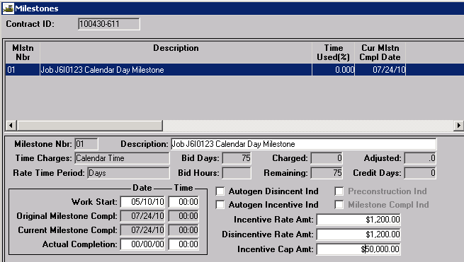
Example of Available Time milestone:
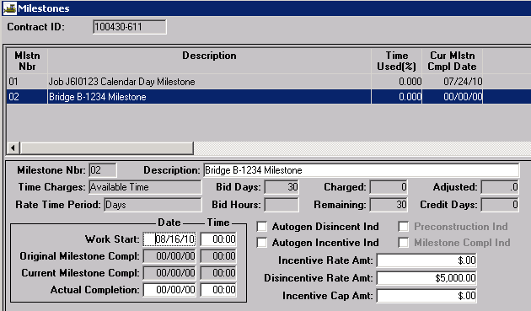
Example of Completion Date milestone:
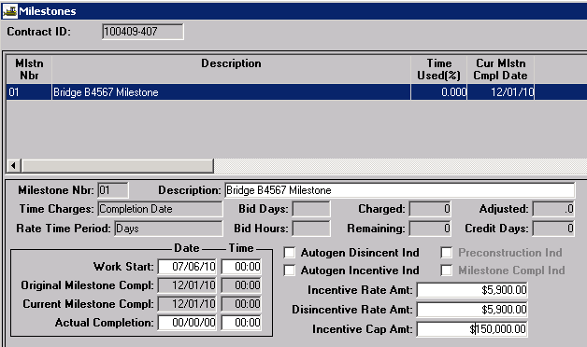

Charging Time for an “Available Time” Milestone
Once work begins on an Available Time milestone, each day must be charged (either a Full Day or No Charge) in the lower portion of the Charge tab of the Diary window.
Note: Do not charge days to Completion Date milestones. It is not required to charge days for a Calendar Time milestone since the completion date is automatically calculated by the system.
Navigate to Daily Work Reports – Diary
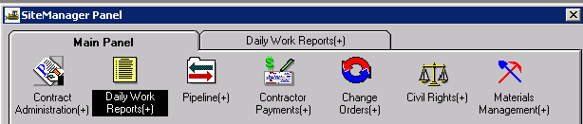
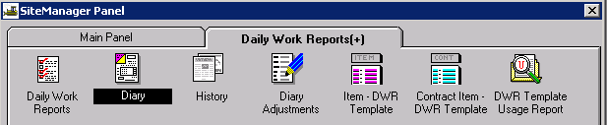
Create or open the diary as appropriate, and navigate to the Charge tab. Place the focus in the lower portion of the window, and click the New icon.

Milestone Description: Select the appropriate milestone from the drop down
Charge Amount: Select the appropriate charge -- either Full Day or None -- from the drop down. MoDOT does not recognize half day charges.
Credit Reason: A reason must be selected if there is no charge for the day.
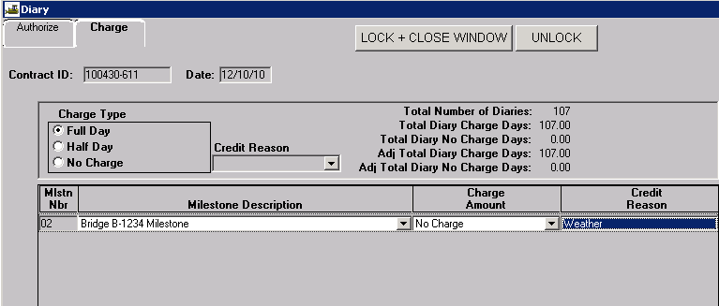
Note: It is possible for the overall contract charge and the milestone charge to be different for a given day. For example, on a completion date contract with an available time milestone, every day will be a Full Day for the overall contract (top portion of the window), but the milestone could have No Charge due to weather, weekend, etc. (bottom portion of the window).

Once an estimate is generated, the number of days charged, days remaining, and the percent of time used will be updated on the Milestones window.
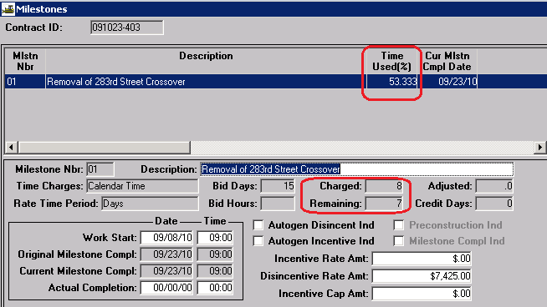

Deleting a Milestone
To delete a milestone, navigate to the Milestones window and select the milestone you wish to delete. Click the Delete icon.
Note: If a saved milestone is deleted, the number for next milestone created will be incremented by 1.
A milestone cannot be deleted if it has an associated record, such as a change order or an estimate adjustment, or if an Actual Completion date has been entered.

Milestone Adjustments
Incentives or disincentives are applied to a milestone from the Milestone Adjustments panel. Modification is limited to the incentives or disincentives that are associated with an unapproved estimate. All milestone time adjustments must be made by change order. Refer to Change Orders - Time Adjustment Quick Reference Guide for instructions.
Navigate to Contractor Payments – Milestone Adjustments – Incentives or Disincentives. 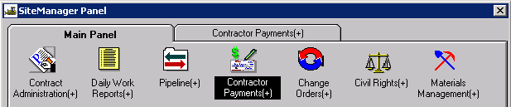
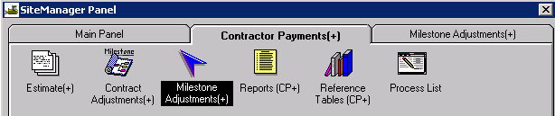
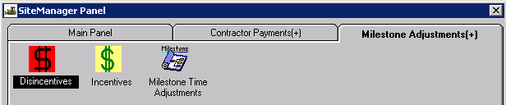
Select the appropriate contract ID and milestone number. For the selected contract, all milestone incentive or disincentive information will be displayed. Click the New icon to enter new incentive and/or disincentive adjustments.
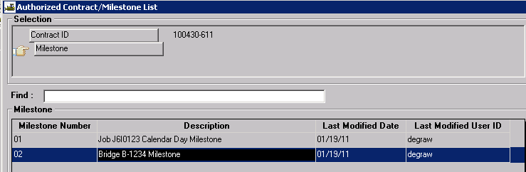
If no incentive or disincentive data exists for the selected milestone, the following message will appear:
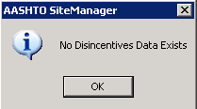
Click OK and the milestone adjustment window will open.
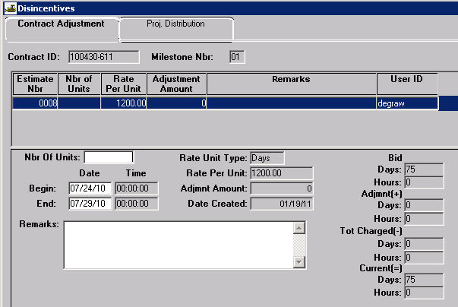 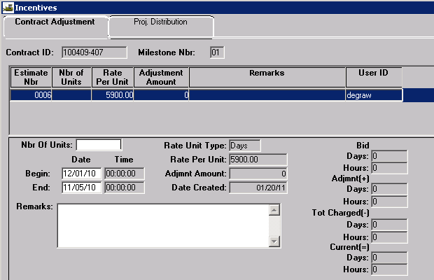
Disincentives Window Incentives Window
Nbr of Units: Enter the number of days or hours for which an incentive/disincentive is being charged.
Begin Date/Time: Automatically entered by the system, based on the current milestone completion date.
End Date/Time: Automatically entered by the system, based on the actual milestone completion date as entered in the Milestones window.
Note: The End Date/Time will be earlier than the Begin Date/Time for incentives.
Rate Unit Type: Automatically entered by the system. This is the Rate Time Period selected in the Milestones window.
Rate Per Unit: Automatically entered by the system. This is the user-entered Incentive or Disincentive Rate Amt from the Milestones window
Adjmnt Amount: Automatically calculated by the system.
(Nbr Of Units * Rate Per Unit = Adjmt Amount)
Date Created: Automatically entered by the system.
Remarks: Enter remarks to thoroughly explain the reason for the incentive/disincentive.
Bid Days/Hours: Automatically entered by the system. This is the original number of days or hours entered in the Milestones window
Adjmnt (+) Days/Hours: Automatically entered by the system. This is the number of days or hours that the milestone has been adjusted by change order.
Tot Charged (-) Days/Hours: Automatically entered by the system. This is the number of days or hours charged to the milestone on the Charge tab of the Diary.
Current (=) Days/Hours: Automatically entered by the system. This is the number of days or hours remaining until the completion date is reached.
(Bid Days/Hours + Adjmnt Days/Hours - Tot Charged Days/Hours = Current Days/Hours)
ALWAYS click the Proj Distribution tab. If there are multiple projects on the contract, make sure the milestone adjustment is associated to the appropriate project in the lower portion of the window. The system normally associates the adjustment to the first project in the list. Edit the distribution percentage to the correct project as necessary.
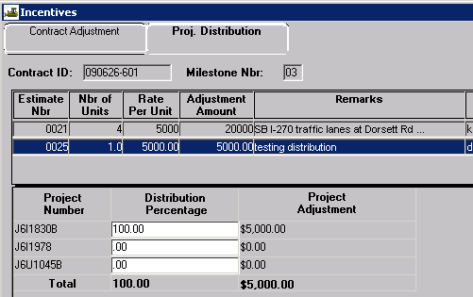
Save the Milestone Adjustment.
Any incentive or disincentive amounts will be shown on the Estimate Summary in SiteManager as well as on the official Estimate Summary for Contract report in ReportNet.
