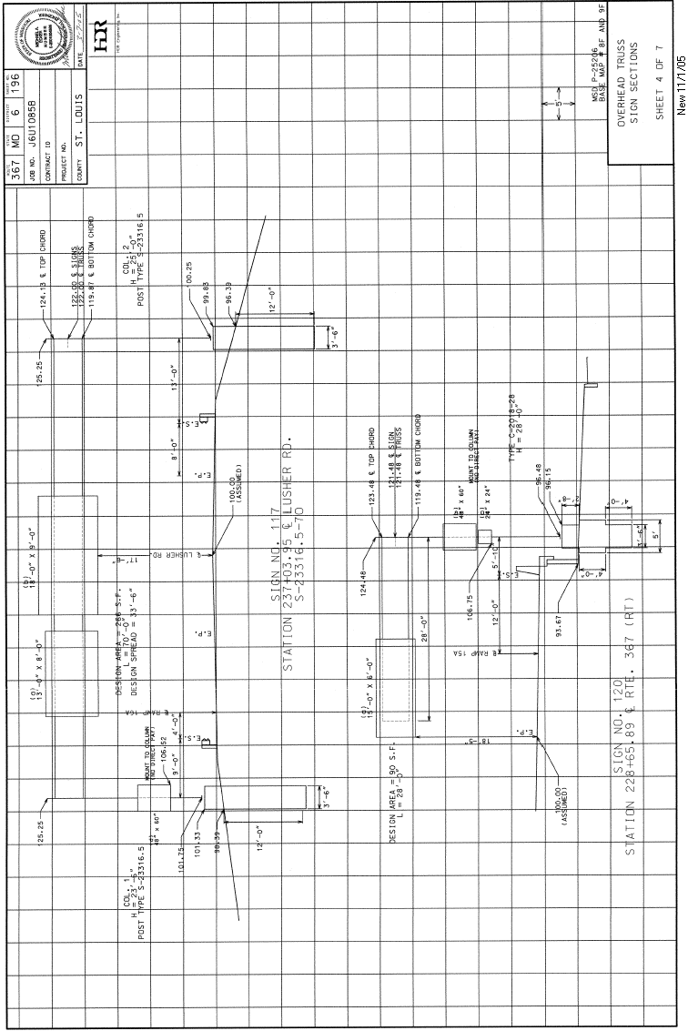
Figure 903.14.15.1 Example Cross-Section, Tubular Supports

