Quick Reference Guide – for ROUTINE
Adobe Digital Signatures (Within MoDOT)

Version 02/10/2011

These instructions are based on Adobe Acrobat Pro 7.0.5 and may not be applicable to other versions.

0) This guide will be used as many times as necessary, once the user has gone through the Quick Reference Guide “for an INITIAL Adobe Digital Signature”.

1) This process assumes that a person is authorized to sign documents based on the person’s title, or the person has been delegated to sign documents for the authorized person.

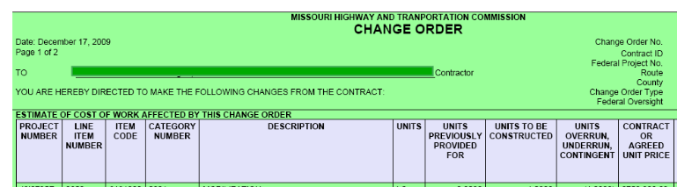
2) Open the PDF document in Adobe Pro. (Part of an example PDF page is shown above. This example is a Change Order, but digital signatures may be applied to any PDF file.) Look at the signature area of the document. If the document has this symbol next to the place you would sign, then use steps 3 through 7 of the Quick Reference Guide – “Routine Adobe Digital Signature Contractor”, If the symbolis not there, then read on and follow the instructions below.

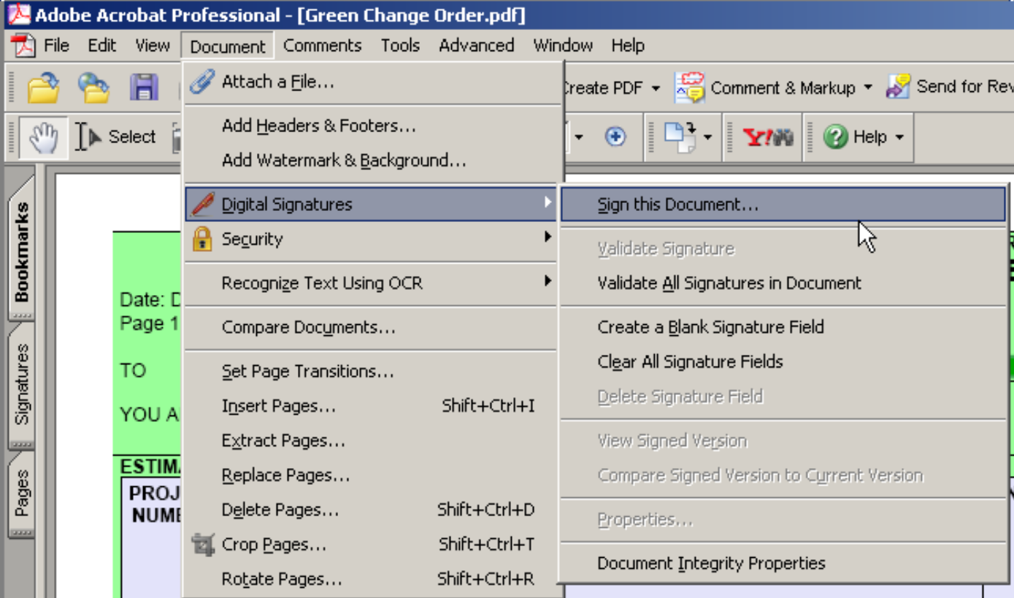
3) Select - Document – Digital Signatures – Sign this Document - from the menu.

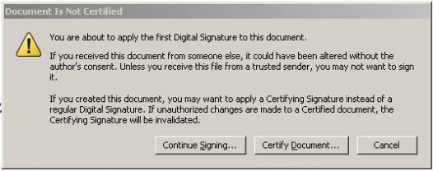
4) This may be displayed. Click “Continue Signing.”

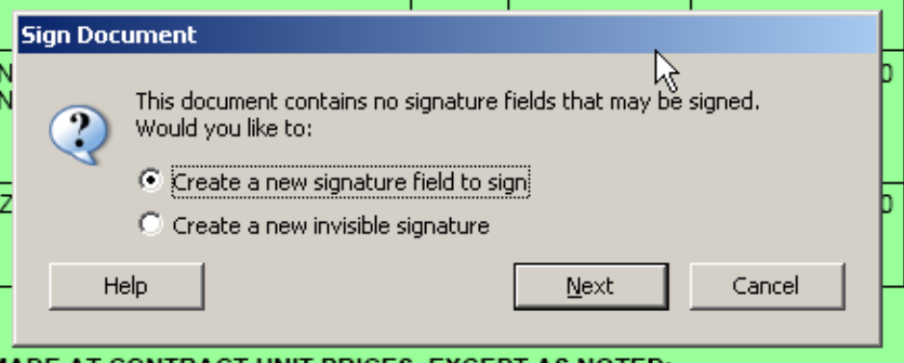
5) This will be displayed. Click Next. (Leave the default of “Create a new signature field to sign”.)

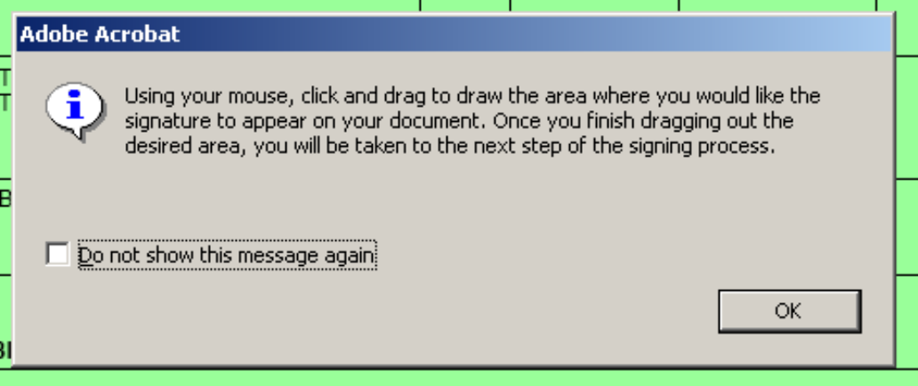
6) This will remind you that you will need to designate a location on the page for the digital signature. Once you are familiar with the process you can suppress this notification by checking the box that says, “Do not show this message again.”

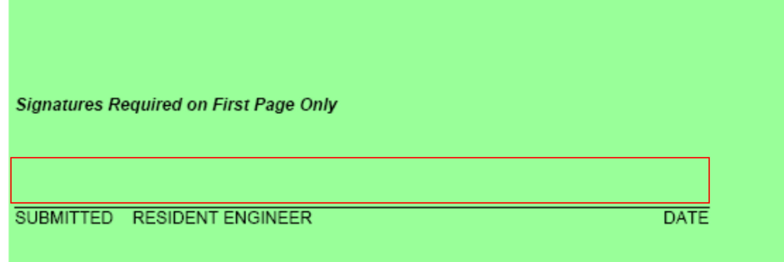
7) Select the area where you want the digital signature to appear. On a Change Order PDF, define the full area of the Change Order signature line that applies to the signature you are attaching. The selection area will appear as a dashed line rectangle. Make the rectangle about the same size as the red outline shown above.

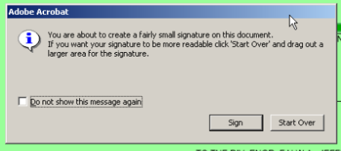
8) You may get this pop-up. If you are satisfied that you selected the correct area, click “Sign”, otherwise click “Start Over” to repeat step 7. If you do not want this notification in the future, check the “Do not show this message again” box.

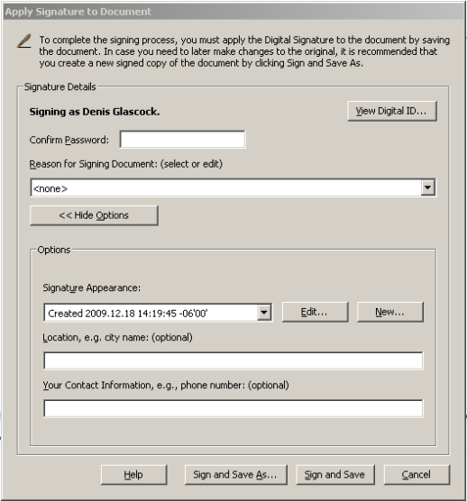
9) When you release the mouse button, this window should pop-up. Enter the password that you gave the Digital Signature process during the initial set up. If the options are not showing, click Show Options. With Options showing, under Signature Appearance, select the Signature Appearance that you created from a scanned image of your signature, from the pull-down list, then click Sign and Save.

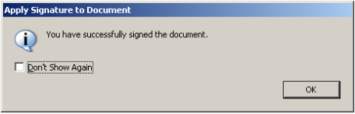
10) This may pop-up. You can mark “Don’t Show Again” if you want.

11) The document will look something like this in the area where it was digitally signed.

