QRG – SuperPave Adjustments
Please read Step 4, Sections a and b very carefully!
- SuperPave Adjustments shall be calculated using the approved Excel Spreadsheet. The spreadsheet is located at V:\Excel2Oracle\Asphalt\Inspection Reports\Reports Master Spreadsheets.
- There are two separate SuperPave Adjustments possible; the first is for SuperPave Volumetrics and a second adjustment for the Tensile Strength Ration (TSR). Both adjustments are calculated and recorded on the spreadsheet, but are independent of each other and must be entered separately. They must be entered as “Contract Adjustments.”
Note: There may not always be a TSR adjustment associated with each SuperPave volumetric adjustment.
Shown below is an example pay factor spreadsheet, with the two adjustment amounts marked:
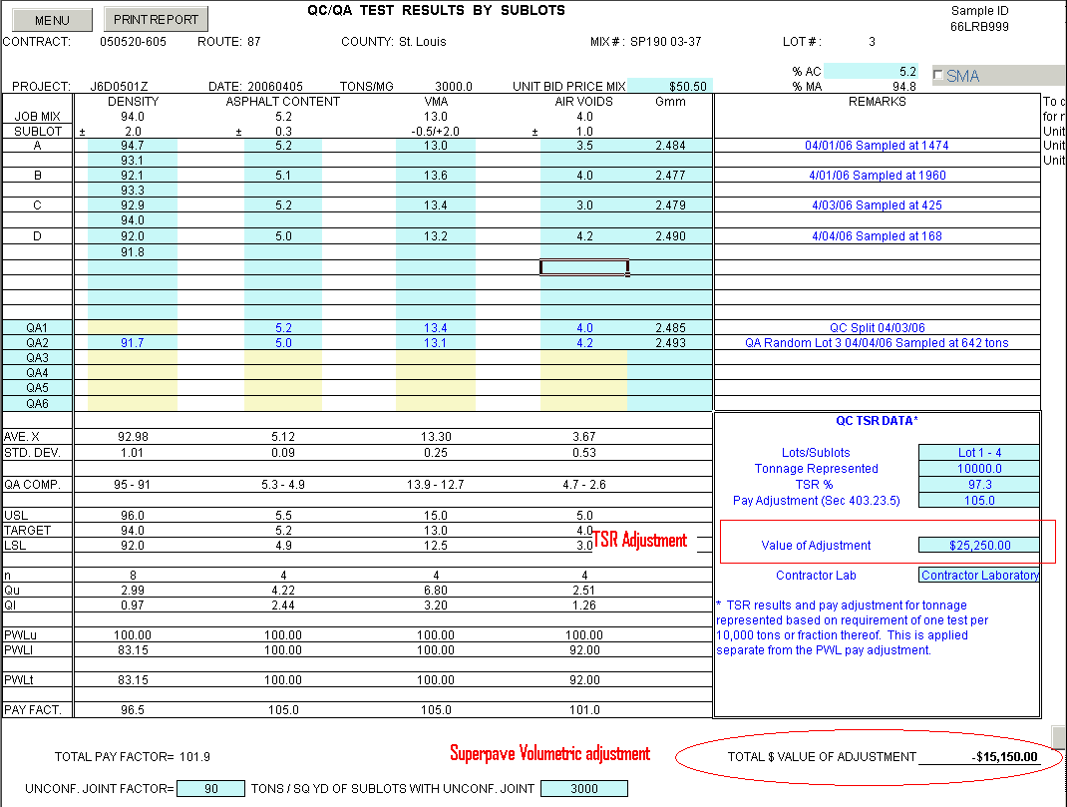
- This spreadsheet will be considered the documentation record for both the Volumetric and the TSR adjustments. The Excel To Oracle process creates a copy of the spreadsheet on the V:\ drive. The project office is responsible to send either an electronic copy or a hard copy to the contractor.
- If multiple lots are processed for one estimate period, then:
- The total dollar value for all “bonus” SuperPave Volumetric adjustments placed during an estimate period may be combined to create one bonus contract adjustment on the estimate. The total dollar value of all “deduct” SuperPave Volumetric adjustments placed during an estimate period may be combined into one deduct contract adjustment for the estimate. DO NOT COMBINE THE TOTAL DOLLAR VALUE FOR BONUS and DEDUCTS.
- The total dollar value for all “bonus” TSR adjustments placed during an estimate period may be combined to create one bonus contract adjustment on the estimate. The total dollar value for all “deduct” TSR adjustments placed during an estimate period may be combined to create one deduct contract adjustment on the estimate. DO NOT COMBINE THE TOTAL DOLLAR VALUE FOR BONUS and DEDUCTS.
- Both adjustments will be documented in SiteManager by entering a contract adjustment associated to the appropriate “Adjustment Description.”
- Examples of both the SuperPave Volumetric contract adjustment and the TSR contract adjustment are shown below:

SuperPave Volumetric Contract Adjustment Examples
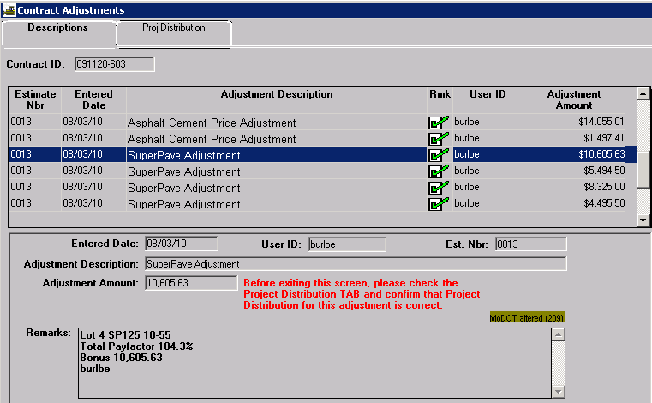
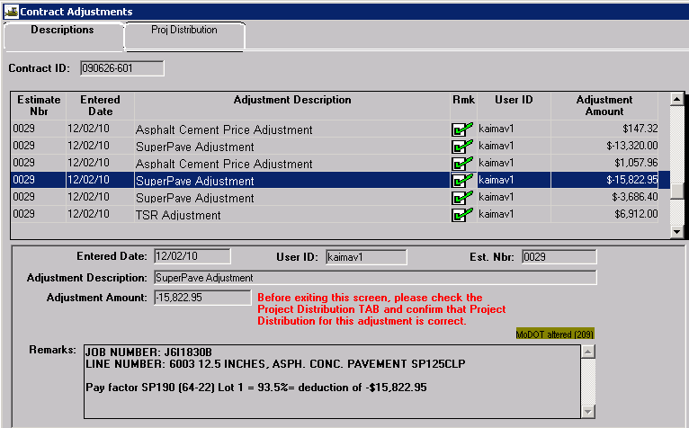

TSR Contract Adjustment Example
