QRG: Change Orders – Value Engineering
Contractors may submit Value Engineering Change Proposals or Practical Design Value Engineering Change Proposals. If accepted, a change order must be generated to incorporate the changes. This article is intended to guide the user in the creation of a value engineering change order.
Navigate to Change Orders – Change Order Maintenance – Header.
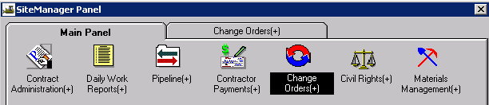
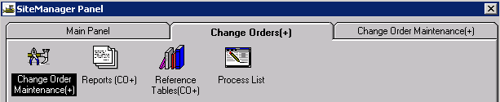
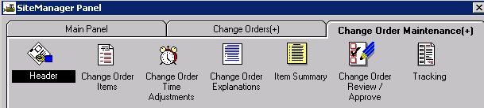

Creating the Change Order Header
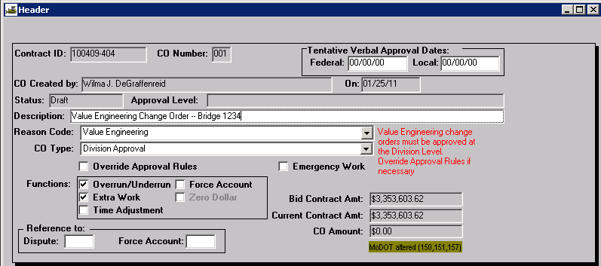
Contract ID: Select Services – Choose Keys to select contract.
CO Number: The system will automatically number the change order.
Tentative Verbal Approval Dates: May be used if it applies. Rush Change Orders may use these fields.
CO Created By: Automatically entered by system.
On: Date automatically entered by system.
Status: Leave Status as “Draft” until all items and explanations are entered. After all items and explanations have been entered, return to the header and save it as “Pending.” The change order will then be forwarded to the users you select as approval levels.
Approval Level: Automatically entered by the system.
Description: Enter a brief description of the change order.
Reason Code: Select Value Engineering from drop down list.
CO Type: All value engineering change orders must be approved at Division level. Select Division Approval from the drop down. The Construction & Materials Liaison Engineer assigned to the user’s District must approve Level 3 VE Change Orders.
Override Approval: SiteManager approval rules may force higher or lower levels of approval than what is necessary. When this occurs, the user should override the approval levels to make sure the value engineering change order is forced to Change Order Level 3.
Emergency Work: Check if this applies.
Functions: Select both Overrun/Underrun and Extra.
Reference To: Dispute and Force Account: These fields are not used.

Adding Change Order Items
Navigate to the Change Order Items icon. The Change Order Items window has two tabs – Change Order Item tab for items already on the contract and New Contract Item tab for adding contingency items.
Note: There should no line numbers on this change order that are not related to Value Engineering.

Change Order Item Tab
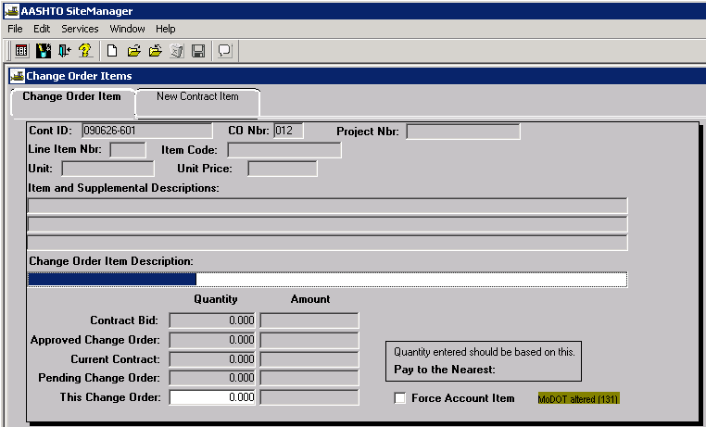
Always select Services - New CO Item to choose the item you wish to change. Make changes as necessary to existing line items.
Change Order Item Description: Automatically entered by the system.
This Change Order Quantity: The quantity of the change. You cannot enter a quantity of zero for a change order item. Underruns must be entered as negative amounts.

New Contract Item Tab
Click the New Contract Item tab to add a new line item for value engineering.
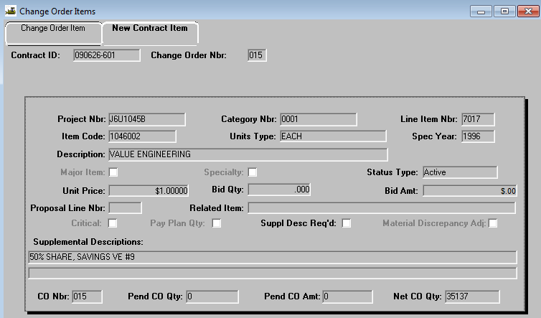
Project Nbr: Select the appropriate project number from the drop down list.
Category Nbr: For funding purposes, select the appropriate category number from the drop down list.
Line Item Nbr: The first instance of a new line item number for the New Contract Item will begin with 5001 for the first project in the contract. If multiple projects are associated to the contract, the line numbering will begin with 5101 for the second project, 5201 for the third project, 5301 for the fourth project and so on. New contract Line Item Numbers shall be sequential per project, regardless of the category.
Item Code: Perform a search and select item code 1046001 (Lump Sum) or 1046002 (Each) or type item code field. The Description will be “Value Engineering.”
Major Item: Check if it applies.
Specialty: Do not check.
Unit Price: Enter $1.00.
Proposal Line Nbr: Do not enter anything in this field.
Related Item: This list is not populated.
Critical: Do not check this box.
Pay Plan Qty: Do not check this box.
Supplemental Descriptions: Enter a remark/additional description in the Supplemental Description fields; e.g., 50% Share Value Engineering, and the next line 5030 50% Share Value Engineering #4
Return to the Change Order Item tab.
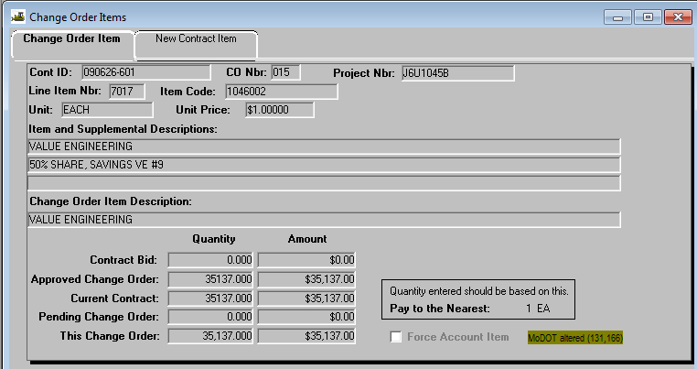
This Change Order: Enter the value engineering quantity. This quantity * $1.00 unit price will be the total dollar value.

Adding Change Order Explanations
There are two ways to add change order explanations.
You may navigate to the Change Order Explanations icon,
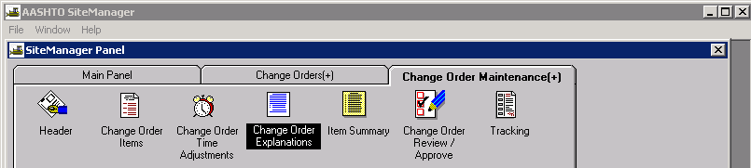
or you may access the Change Order Explanations window from the Services menus of the Change Order Items window.
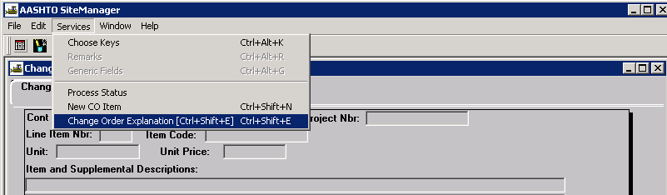

Either option will open the Change Orders Explanations window as shown below.
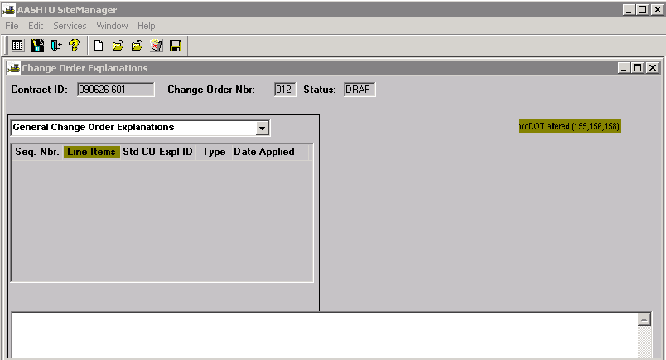
Due to the way MoDOT’s reporting software works, a change order explanation cannot be associated to multiple line items. Therefore, Change Order Explanations must be assigned to specific line items. Select "Explanations Applied to Specific Items" from the drop down list. This will open the Change Order Line Items panel on the right side of the window.
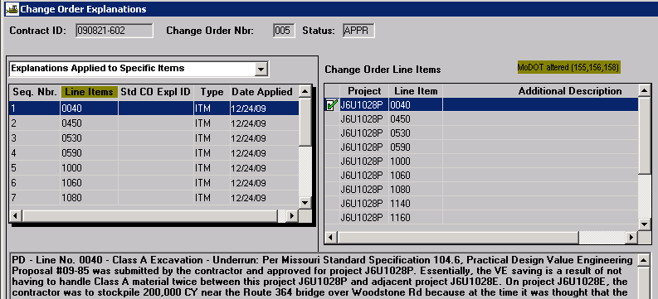
Explanations must begin with the following: Reason Code - Line Number - Description - Overrun or Underrun: Reason. For example: VE - Line No. 0040 – Class A Excavation - Underrun: Begin typing the reason....
The standard reason codes to be entered for value engineering change orders will be either PD (Practical Design Value split 25/75) or VE (Value Engineering split 50/50). Definitions and examples for the codes may be found at the following link: Change Order Codes
Note: The change order reason must specifically state the change order is being executed in accordance with Section 104.6 of the Missouri Standard Specifications for Highway Construction.
The system will assign a sequence number as shown in the left hand window. Once the explanation has been typed in the lower window, it should be associated to the appropriate change order line item in the right hand window by double clicking the line number. A green check mark will appear once the explanation is associated to a line number.
When a change order reason affects multiple line items, a detailed description of the change must be entered for the first line item. All subsequent line items must then be entered. However, the same level of detail is not required and can reference back to the first line item reason. For example:
VE - Line No. 0020 - Class A Excavation - Overrun: Per Missouri Standard Specification 104.6, the contractor submitted a Value Engineering Proposal henceforth known as VE No. 2. The proposal is to eliminate the Aggregate Base, Stabilized Permeable Base and Edge Drains and substitute 12 inches of Rock Fill Base. This proposal was reviewed by MoDOT's Pavement Engineering experts and met their approval. The Value Engineering proposal was approved August 3, 2010. In order to install 12 inches of rock fill, additional Class A Excavation will be generated.
VE - Line No. 0040 - Compacting in Cut - Underrun: Same as Line No. 0020.
VE - Line No. 0060 - Stabilized Permeable Base (4 In. Thick) - Underrun: Same as Line No. 0020.
VE - Line No. 0070 - Type 5 Aggregate for Base (4 In. Thick) - Underrun: Same as Line No. 0020.

Changing the Status of the Change Order
Once all items and explanations have been added to the change order, the user must navigate back to the Header. User may choose to “Calculate Change Order” from the Services drop down menu to make sure the system calculated approval level is Change Order Approval Level 3. If not, select Override Approval Rules.
Change the status from “Draft” to “Pending” and save. Make the appropriate selections for each approval level, and then click OK.
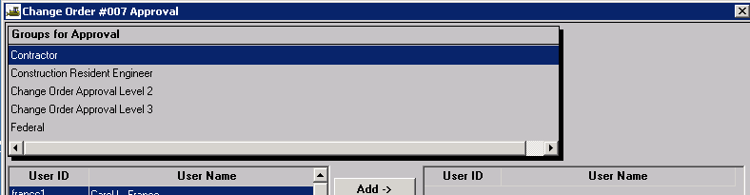

If the approval levels have been overridden, the user will be required to make the appropriate selections for both “Groups for Approval” and users as noted below. Once the selections have been made, click OK.
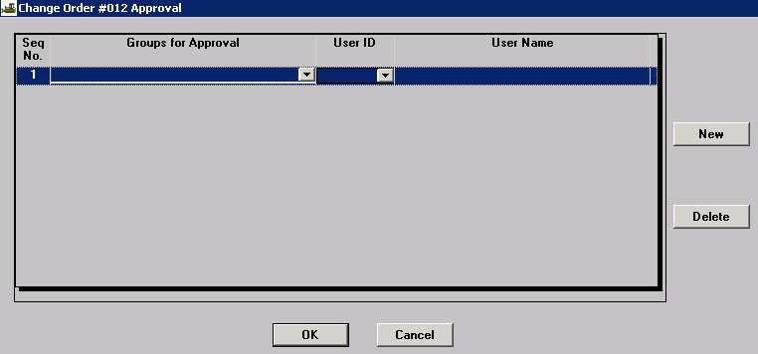

Printing the Change Order
Print the Change Order report as directed in the Change Order Reports Quick Reference Guide.

Saving the Change Order
Save all change orders in .PDF format to the V: drive in the following path for your district and org code: V:\Contract Information Archive\District # \ ORG # \ Contract ID \Change Orders\Pending. (See Note below.) File name should include the change order number placed within the file name so the change orders will sort properly when listed in the folder. See example below:
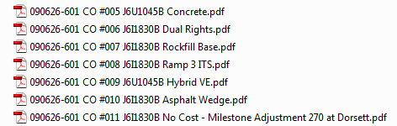

Once the change order has been approved at all levels, it shall be saved with all attachments in a single file to V:\Contract Information Archive\District # \ ORG # \ Contract ID \Change Orders\Completed.
Note: When distributing a change order electronically for signature, it should be stored with all attachments in a single file in the “Completed” change order folder and linked from there. Once the last digital signature is applied, the process is complete. No further action is necessary on the part of the project office, that is, there is no movement of the document from one folder to another.

