Quick Reference Guide – Check for Current Version of SiteManager
Version 12/06/2010
So you want to check to see if you are running the current version of SiteManager. There are two ways to do this.
Option A:
When you launch SiteManager, the following logon window should appear.
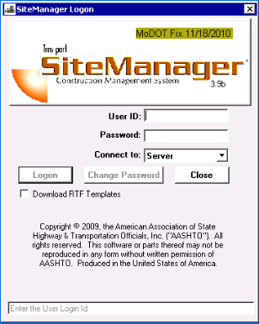
- Verify that the date of the MoDOT Fix is correct, as shown in the green bar near the top of the logon window. The SiteManager administrators can tell you the appropriate date. Send an email to “REDEV” for a relatively quick answer.
- Check the SiteManager version, which is just below the word “SiteManager”. In the example shown; “3.9b”
Option B:
This can be done from within SiteManager anytime you have it running.
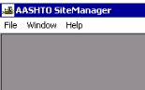
- Open the SiteManager Help screen from the SiteManager toolbar.
- Select "About SiteManager".
- A window will appear with SiteManager information, including the current version ( Release 3.9b) and the date of the customization noted at the bottom of the paragraph (“changes made by MoDOT”). SiteManager works with or without the customization.

Potential Action:
If you do not have the current version of SiteManager loaded on your machine you will need to do so. To do this you will need to:
- Open Windows Explorer
- Navigate to K:\SMUpdate\App\Smapp. Right click on smapp.bat and select Copy
- Right Click on D:\smapp and select Paste
- Drag a shortcut to D:\Smapp\Smapp.bat to the desktop window.
- Start SiteManager from the shortcut created (This will install additional files).
If this does not update your machine to the correct version you will need to contact your District Computer Specialist, Automation Liaison Analyst, or email “REDEV”.

